National Review of Teacher Registration
Consultation Paper
March 2018

You’re invited

On behalf of the National Teacher Registration Review Expert Panel, I invite you to contribute to the National Review of Teacher Registration (the Review).
Agreed by all State, Territory and Commonwealth Education Ministers through Education Council in September 2017, the Review will look at how aspects of the national teacher registration framework, endorsed by Education Ministers in 2011, are currently working. It will also determine, through consultation with stakeholders, potential areas for improvement.
A report detailing the findings and recommendations of the Review will be provided to Education Council later in 2018.
This Consultation Paper provides a brief background of teacher registration in Australia, sets out a series of areas for discussion, and outlines how you can contribute to the Review.
My fellow panel members and I look forward to your input.

Chris Wardlaw PSM
Chair, Expert Panel, National Review of Teacher Registration
March 2018

Introduction

The quality of education has never been so important. In an increasingly globally competitive and technologically dynamic world, parents, teachers, employers and governments are recognising the necessity of preparing young Australians for a future characterised by both change and opportunity.
With this awareness comes a commitment from education sectors and governments to providing a high quality education for young people across the country; that is, an education provided by high-calibre teachers who are well-prepared, highly skilled and trusted to keep learners safe.
Teacher registration is an important mechanism to ensure the quality of the teacher workforce. Registration also provides a critical regulatory function to ensure that only people who have the necessary qualifications and are fit and proper can be employed as teachers.
In 2011, the national framework for teacher registration (the Framework) in Australia, underpinned by the Australian Professional Standards for Teachers (Teacher Standards), was agreed by all State and Territory Education Ministers.
The Teacher Standards, developed and endorsed by Education Ministers in 2011, provide a foundation to support teachers and school leaders, school systems, regulators, education authorities and governments alike. They are designed to guide and strengthen the quality of teaching, while also providing a framework for career progression and ongoing high quality professional learning.
Australian teachers want to be part of a high status profession that values excellence and has the confidence of the community. They also want to be valued for their commitment to growing their expertise and increasing their impact on the learning of the young people in their care.
As with professional standards in other professions, the Teacher Standards provide a quality benchmark. Other mechanisms, such as consistent approaches to teacher registration, provide a vehicle for those standards to be met.
Teacher registration supports the ongoing professionalisation of the teacher workforce and safeguards the quality of the Australian teaching profession. This Review provides an opportunity for all education stakeholders across Australia to reflect on current teacher registration processes and provide valuable feedback, helping to ensure that these processes meet current and future needs.

While the regulatory authorities in each jurisdiction apply the Teacher Standards to their respective registration processes, the language used to describe the elements in each jurisdiction may be different. For the purpose of this document, the most commonly used language is included. Refer to the glossary for further details.

About teacher registration in Australia
All teachers practising in Australian schools must be registered. Registration is the responsibility of teacher regulatory authorities in each jurisdiction, which operate under the relevant State or Territory legislation.
Teacher registration is a mechanism to ensure the quality of the teaching workforce. Registration helps protect learners by ensuring that only fit and proper people, with the appropriate qualifications, are employed as teachers across Australia.

National teacher registration framework
The Framework shapes the current approach to registration in Australia. Endorsed by all Education Ministers in 2011 and implemented in States and Territories, the Framework is underpinned by the Teacher Standards – the nationally agreed statement of what teachers need to know and do.
The Teacher Standards consist of seven standards which teachers will meet at different levels depending on their career stage and level of experience. These are categorised into four career stages: Graduate, Proficient, Highly Accomplished and Lead. The Framework specifically relates to the Graduate and Proficient career stages.
The Framework has eight elements and sets out broad parameters for a national approach to quality assurance and evidence-based requirements for teacher registration, centred around common standards and consistent requirements for teachers to move from provisional to full registration, and to renew their registration.
The interaction between the eight elements of the Framework, the Teacher Standards and pathways to teacher registration is illustrated in Figure 1 below.
Figure 1: Interaction between Teacher Registration and the Teacher Standards
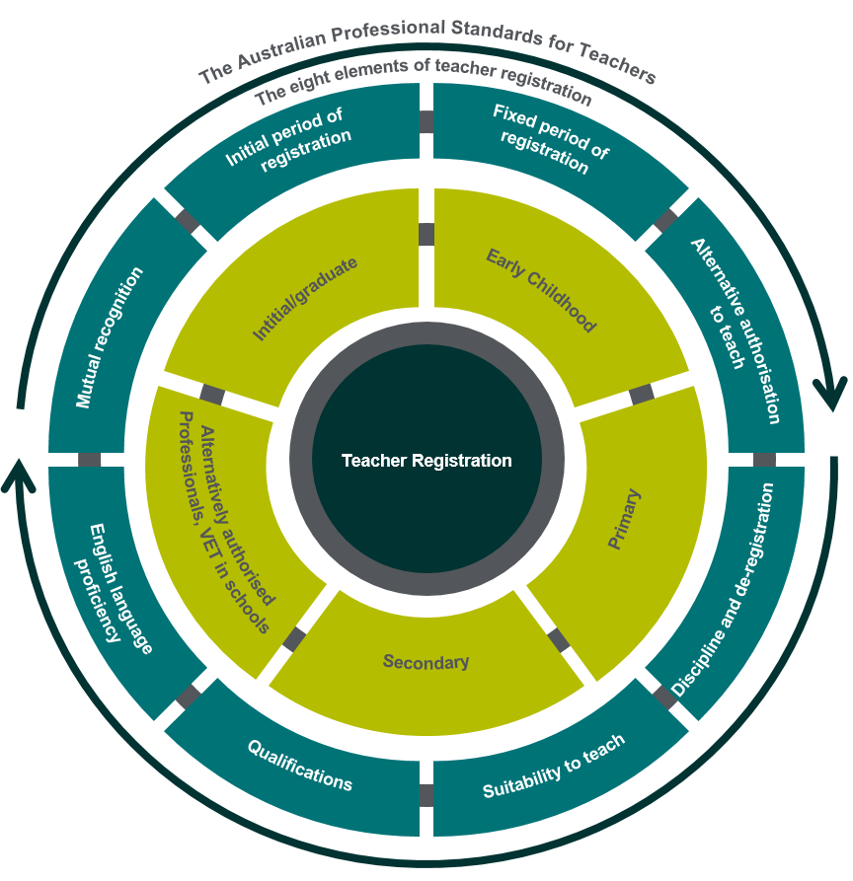

A summary of the eight elements of the Framework is provided in Table 1.

Table 1: Elements of the Framework for national teacher registration
Elements of the Framework for National Teacher Registration
Element | Description
Initial period of registration | A teacher has completed an initial teacher education qualification (thus meets the Graduate career stage of the Teacher Standards) and meets other registration requirements. Commonly referred to as provisional registration. The teacher undertakes workplace learning and development to demonstrate evidence that he or she meets the Proficient career stage.
Fixed period of registration | A teacher has demonstrated that he or she meets the Proficient career stage of the Teacher Standards and suitability to teach. Commonly referred to as full registration. Renewal of registration after fixed period is granted based on meeting minimum requirements for ongoing proficiency against Teacher Standards, recency of practice and professional learning requirements.
Alternative authorisation to teach | Jurisdictions may choose to implement provision for persons who are not eligible for registration to be employed in roles that would otherwise require registration. There are two categories of alternative authorisation to teach: to address workforce shortages e.g. instrumental music or language teachers, and pathways to registration e.g. working towards a teaching qualification.
Sanctions, including withdrawal of registration | There is provision for regulatory authorities to impose sanction or withdraw a teacher’s registration (de-register) if the teacher fails to meet the required standards of personal and professional behaviour or professional performance.
Suitability | Teachers applying for registration are required to be suitable to both work with children and be a teacher, based on an assessment of character and criminal history.
Qualifications | The minimum qualification requirement for registration is completion of at least four years of higher education (fulltime or equivalent) study, including an initial teacher education program accredited in Australia, leading to the achievement of a recognised qualification; or an overseas qualification assessed as equivalent.
English language proficiency | To be registered, a teacher must be able to demonstrate achievement of a level of professional proficiency in spoken and written English, demonstrated through specified assessment instruments.  English language proficiency assessment is not required for registration where the four years of required higher education study have been undertaken in English in Australia, New Zealand, the United Kingdom, the United States of America, Canada and the Republic of Ireland.
Mutual recognition | Mutual recognition allows a person who is registered to practise as a teacher in one jurisdiction to be registered in another jurisdiction based on that registration.
Appendix 2 provides an overview of the Framework.
Stages of teacher registration
There are two main stages of teacher registration:
1. The initial period of registration, also referred to as provisional registration. A teacher who has completed an accredited initial teacher education program or equivalent overseas qualification (indicating they meet the graduate career stage of the Teacher Standards) and meets other registration requirements can apply for this initial period of registration.
2. The fixed period of registration, commonly referred to as full registration. This is achieved when a teacher has demonstrated they meet the proficient career stage of the Teacher Standards and all other registration requirements.
Figure 2: Stages of teacher registration and Australian Professional Standards for Teachers
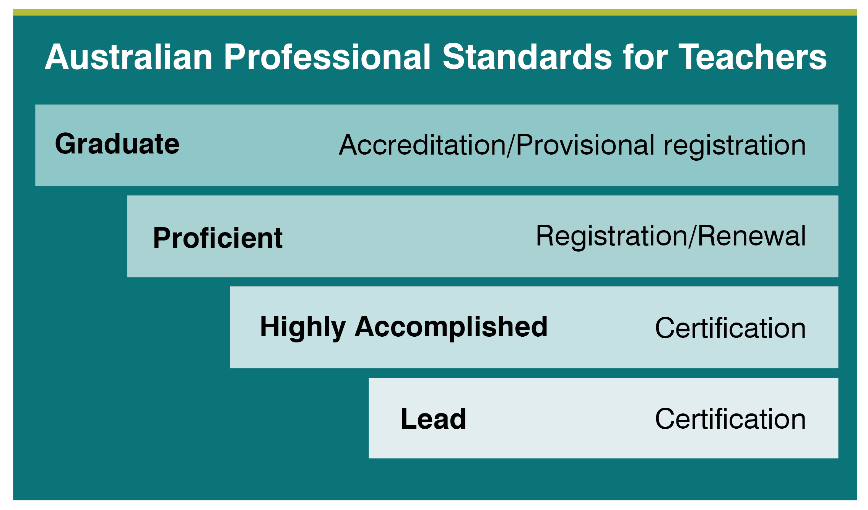
A high-level overview of the Teacher Standards and their interaction with the above career stages is available at Appendix 3.
While the fundamental aim of registration is similar across jurisdictions, some differences exist across States and Territories. The Review provides an opportunity to consider the different approaches (including whether differences are material), in order to identify leading practice and provide input into areas that could be strengthened.
When the teacher registration framework was agreed in 2011, early childhood teachers were not explicitly considered in the Framework. Since then, significant reform has occurred in the early childhood education sector, with early childhood teacher registration being adopted in an increasing number of jurisdictions.
More recently, focus has been placed on vocational and education training (VET) teaching in school settings. There are different arrangements across jurisdictions to facilitate teaching VET in schools, including an authority to teach or equivalent registration category.
About the Review
In September 2017, all State, Territory and Commonwealth Education Ministers agreed to the Review to identify ways to build on and further strengthen teacher registration in Australia.

Conduct of the Review
The Review is being led by an independent Expert Panel (the Panel) which brings both national and international expertise and perspectives.

Table 2: Expert Panel members
Expert Panel Members
Name | Position
Chris Wardlaw (Chair) | Deputy Chair, AITSL Board, Chair, Victorian Curriculum and Assessment Authority
Pitsa Binnion | Principal, McKinnon Secondary College, Melbourne, VIC
Marino D’Ortenzio | Assistant Principal, Epping Secondary College, VIC  Honorary Deputy Vice President (Secondary), Australian Education Union VIC Branch
David Gee | Head, Wesley College, Perth WA
Dr Peter Lind | Registrar, Teachers Registration Board of South Australia
Anthony McClaran | CEO, Tertiary Education Quality and Standards Agency
Emeritus Professor Wendy Patton | Emeritus Professor, Queensland University of Technology  Chair, Queensland College of Teachers
Gabrielle Sinclair | CEO, Australian Children’s Education and Care Quality Agency
Dennis Yarrington | President, Australian Primary Principals Association
Christine Wilkinson | Teacher, St. Joseph’s Catholic College, East Gosford, NSW President, Independent Education Union of Australia NSW/ACT Branch

The Australian Institute for Teaching and School Leadership (AITSL) is tasked with progressing the Review, including establishing the Expert Panel. AITSL is providing secretariat support for the Review, including coordination and facilitation of consultation with stakeholders across Australia.

The Review includes three broad phases, outlined in Table 3 below.

Table 3: Review consultation phases
Consultation Phases
Activity and timeframe | Description
Mapping & Research  February - March 2018 | Mapping of existing teacher registration practices across Australia and research into registration practices in other professions nationally and internationally.
Consultation & Analysis  March - May 2018 | A nationwide consultation seeking input from key stakeholders including teachers and principals, governments, sectors, employers, regulators and national principal, teacher organisations and parents.
Reporting  June - September 2018 | Preparation of a report including findings and recommendations to be submitted to Education Council later in 2018.

Focus of the Review
The Review is considering how the current national registration framework is operating, including all elements of the framework as they relate to consistency and best practice, as well as challenges and barriers to successful implementation. An additional consideration is the extent to which the Teacher Standards are used within regulatory arrangements to drive teacher quality and how this can be further strengthened.
The focus of the Review will also include:
- possible improvements to the current arrangements under which teacher registration operates
- options for implementation of recommendations, considering legislative, regulatory, administrative and resourcing contexts
- expected benefits and success measures for the implementation of the recommended reforms.
The scope of the Review includes consideration of the registration of early childhood teachers as part of a national approach to teacher registration, and how the Teacher Standards could be applied in this context.
The registration of vocational education and training (VET) teachers in school settings is also being considered in the Review, together with the impact of these arrangements on the delivery of quality VET in schools.
The transition of initial teacher education students into the profession is also in scope, including exploring the concept of early engagement in the profession through pre-registration.
The suitability requirement of national teacher registration – and more specifically measures of fit and proper persons – is being considered in the context of recommendations of the Royal Commission into Institutional Responses to Child Sexual Abuse.

Out of scope
The Accreditation of Initial Teacher Education Programs in Australia: Standards and Procedures are out of scope as these were recently reviewed and updated. Similarly, the content and structure of the Teacher Standards themselves are out of scope, as Education Council has not requested that AITSL undertake a review of the Teacher Standards at this stage. It is acknowledged, however, that the application of the Teacher Standards may need to be considered given the focus of the Review including Early Childhood Teachers and VET teachers in schools.

Review outcomes
A report, including Review findings and recommendations, will be provided to Education Council later in 2018.

Areas for discussion
- How is the national teacher registration framework working across Australia?
We know that the biggest in-school effect on student outcomes is the quality of teaching and school leadership.
The national teacher registration framework provides an important mechanism to support ongoing teacher quality and improvement. Underpinned by the Teacher Standards, the Framework (including the eight elements) establishes agreed minimum standards for quality; defines development pathways; communicates expectations between the community and the profession; and ensures the safety of students.
Since the introduction of the Framework in 2013, there have been examples of effective and consistent implementation of the registration arrangements and also examples where there may be scope for greater rigour.
The Review provides an opportunity to consider the implementation of the eight elements of the Framework to identify the processes that are working well, the impact the Framework has had on teacher quality, and opportunities for improvement.
The Terms of Reference for the Review have a particular focus on quality teaching, the Teacher Standards and the role that registration plays in driving quality teaching through the Teacher Standards.
The Teacher Standards are embedded in the Framework through two key elements:
- The initial period of registration, during which teachers are expected to demonstrate evidence of performance at the Proficient career stage of the Teacher Standards to achieve full registration.
- The fixed period of registration, in particular the process for renewal of registration, which includes requirements that proficiency against the Teacher Standards has been maintained, and that a set number of hours of standards-referenced professional learning has been undertaken.
The Review seeks input on the process of moving from provisional to full registration, particularly from the perspective of teachers and principals involved in the process, as well as the evidence requirements and how consistency of decision making is ensured.
The Review also seeks input on how the renewal process both supports and drives ongoing improvement and professional development for teachers, and how a focus on quality teaching could be enhanced through the registration renewal process.
The movement of teachers across state and territory borders in Australia, as well as internationally, is becoming increasingly predominant in the teaching workforce. In support of this, there are now mutual recognition processes in place across all jurisdictions. The Review seeks input on how effectively current mutual recognition processes are working; whether barriers to teacher mobility exist; and whether differences in implementation across jurisdictions mean that inconsistencies remain.

Focus questions

Elements of registration
- How well are the implementation and content of the eight elements of the Framework working? Please consider consistency, best practice and challenges and barriers in your response. You may wish to share examples.

Teacher quality
- How has the embedding of the Teacher Standards in the Framework supported teacher quality? In particular, how have the Teacher Standards influenced the way in which teachers move from provisional to full registration and through renewal of registration?

Improvements
- How could current teacher registration arrangements be improved to strengthen both teacher registration implementation and teacher quality? Are the eight elements of the 2011 Framework relevant and appropriate?
- How could improvements be implemented, acknowledging different legislative, regulatory, administrative and resourcing contexts? What are some expected benefits and success measures?

- Should early childhood teachers be part of a national approach to teacher registration?
Research shows that the early years are critical for laying the foundation for a child’s learning and development. Quality early childhood education and care can make a significant difference in enriching children’s capabilities and development and it is generally acknowledged that highly qualified educators, particularly early childhood teachers, have a measureable positive impact on children.
In support of this, a rigorous national framework that includes regulatory mechanisms to ensure quality, skills and qualifications of early childhood educators has evolved. This includes a new quality standard to improve education and care in early childcare and learning settings across Australia, introduced by the National Quality Framework in 2012.
As part of this broader movement to drive and recognise the professionalism of the early childhood workforce, State and Territory regulatory authorities are increasingly including early childhood teachers in their registration arrangements. This is characterised by differences in practice and application of registration (voluntary and mandatory) and settings in which registration applies (school and non-school settings).
Within the sector, there is an increasing overlap between early childhood and school settings. Early childhood teachers may be employed in early childhood education centres that are situated on school campuses or in a primary school setting where they are likely to have interaction with primary-aged children.
The Review seeks input on the role of teacher registration in supporting quality early childhood teaching in different early childhood settings across jurisdictions.
Focus Questions
- Should nationally consistent approaches to the registration of early childhood education teachers be considered?
- How could a nationally consistent approach to teacher registration support and improve the quality of early childhood teaching in school and non-school settings?
- How could the Teacher Standards be applied for early childhood teacher registration?
3. What role does teacher registration play for VET teachers in school settings?
Schools implement senior secondary programs to meet the needs of all students so they can successfully transition to tertiary education, training, work, or a combination of these.
Preparing Secondary Students for Work: a framework for vocational learning and VET delivered to secondary students was endorsed by all State and Territory Education Ministers in 2014 to provide secondary students with access to quality vocational learning and VET courses. A key aspect of VET quality in a school setting is the delivery and assessment by appropriately qualified teachers (which may include trainers and assessors) with relevant industry experience, who meet relevant standards and have the appropriate accreditation, which may include teacher registration.
Registered training organisations (RTOs) are responsible for ensuring all nationally recognised training complies with the Standards for Registered Training Organisations 2015 (RTO Standards), which include trainer and assessor credential requirements. The way school RTOs manage their registration varies across jurisdictions and school sectors. Some schools register individually, with the school principal acting as the RTO Chief Executive Officer, while other schools register in groups, generally under a State education department or relevant archdiocese. Others have arrangements with public or private RTOs to deliver on their behalf, either on or off school campuses.
Where a school’s nationally-recognised training is delivered by non-registered teachers, such as VET trainers and assessors from public or private RTOs, most jurisdictions provide an authority to teach or equivalent registration category. In some jurisdictions, VET trainers and assessors must be accompanied by a registered teacher when delivering or assessing students, which may have staffing and resourcing implications for schools.
While cognisant of the issue of teacher standards in the context of the broader VET sector, the Review will focus on the issues related to the teaching of VET in schools and explore possible options to improve access and requirements for VET teachers delivering VET in a secondary school environment.

Focus Questions

- Under current teacher registration processes, what are the specific challenges to delivery VET in schools for:
- registered teachers
- VET trainers and assessors
How could these be overcome?
- Is greater flexibility needed to support schools to utilise skilled VET trainers and assessors? How can this be achieved without compromising teacher quality standards and national consistency in teacher registration?
4. How does teacher registration support entry into the teaching profession?
The teaching profession sets the highest expectations of its newest members. Unlike other professions, a new teacher assumes full pedagogical and legal responsibility as soon as he or she enters a classroom or learning environment. This expectation continues throughout a teacher’s career, with a requirement that they continue to increase their expertise and impact on student learning.
As touched on in Discussion Area 1, current teacher registration arrangements use the Graduate career stage of the Teacher Standards as the benchmark for provisionally registered graduates entering the profession, while the Proficient career stage is used as the benchmark for teachers progressing from provisional to full registration. The teacher registration framework sets out broad parameters for a national approach to quality assurance and evidence requirements in the transition from provisional registration to full registration.
There is strong evidence to indicate high quality induction can have significant effect on the transition; that is, induction focused on the professional practice, professional identity and wellbeing of the early career teacher, as well as the formal requirements and informal ways of operating. Induction is a shared responsibility across the profession, with initial teacher educators, systems, sectors and regulatory authorities, educational leaders, teachers and graduates each playing an important role.
Contextual factors may impact on a new teacher seeking registration and employment. For example, two out of three early career teachers in Australia begin their career as short-term casuals, which may impact on accessibility of mentorship and high quality professional learning. This is similar for those new teachers in rural and remote contexts, where distance, isolation and limited resources exist.
The Review provides an opportunity to consider how teacher registration can support the engagement of teachers with the profession at the very beginning of their careers. In most jurisdictions, new teachers formally engage with teacher registration for the first time after they have completed their qualifications as graduate teachers. Earlier engagement with the teacher registration process, for example through a form of pre-registration during study, has been implemented in other professions, with the intent of welcoming the student into the profession and collecting data about the incoming workforce profile.

Focus Questions

- How do current teacher registration processes support graduates:
- seeking provisional registration
- employed in different circumstances (e.g. casual, full-time or permanent)?
- Are there barriers/challenges presented by teacher registration for those entering the teaching profession? How could these be overcome?
- How could the pre-registration of initial teacher education students support entry to the profession? What would be the benefits and implications of such an approach?

- How can we ensure that registered teachers satisfy the fit and proper person requirement?
In many professions where trust and responsibility for the care of a child or young person is a function of a person’s role, standard practice before and during their employment is to satisfy a fit and proper person requirement.
The teaching profession is no different. As part of current registration practice across States and Territories, the teacher regulation authority must be satisfied that the person is a fit and proper person to teach. The national teacher registration framework embeds this requirement within one of the eight elements: Suitability. To meet this requirement a teacher must provide evidence that they are suitable to both work with children and be a teacher, based on character and criminal history. In determining this, regulatory authorities may take into account criminal history checks, information from other registration bodies and/or overseas employers, and analysis of misconduct and other information relevant to an assessment of suitability for registration, such as fitness to teach.
The teaching workforce is becoming increasingly mobile, both nationally and internationally. As a consequence, there is a need to ensure that systems and processes to protect children are rigorous and consistent across jurisdictions.
As regulatory authorities, education systems and sectors across the country consider and develop responses to the recommendations of the Royal Commission into Institutional Responses to Child Sexual Abuse, it is likely that even greater emphasis will be placed on this requirement.
The Review provides an opportunity to consider the effectiveness of current teacher registration processes to satisfy the fit and proper person requirement, and to consider how the nationally consistent framework for teacher registration can support a robust national approach.

Focus Questions
- How do regulatory authorities (within legislated responsibility) ensure the fit and proper person requirement of registered teachers?
- How can teacher registration processes support a nationally consistent approach to satisfying the fit and proper person requirement of registered teachers, at the point of registration and throughout their teaching career?

How to contribute
The Expert Panel invites input to the Review from all stakeholders in education until 29 April 2018 7 May 2018.
During this time, the Panel will consult widely through a combination of targeted and broad strategies including: consultation with key stakeholders in each jurisdiction; a survey of teachers and principals; and online written submissions.
Written submissions
Written submissions responding to the questions set out in the Areas for Discussion (pages 9 – 13) are invited. Respondents are welcome to address all high-level questions or only those of particular relevance or interest.
Examples are welcomed as part of the submissions, however please note that due to privacy legislation, personal information such as names or any identifiable information used in examples, including names of schools, cannot be used.
Each submission is limited to 3,000 words, including a 300 word summary of the key points, provided at the start of the submission.
Submissions will be published on the AITSL website at the conclusion of the consultation process. Submissions marked ‘Confidential’ will not be published.

Submitting a response
To submit a response to the Consultation Paper:
- Upload your submission online www.aitsl.edu.au/teach/national-review-of-teacher-registration/
or
- Email your submission to RegistrationReview@aitsl.edu.au,
or
- Post your submission to:
National Review of Teacher Registration Secretariat,
PO Box 299,
Collins Street West
MELBOURNE VIC 8007

If you choose to submit your response via email or post, please attach the AITSL Cover page to your submission. The cover page is available at: www.aitsl.edu.au/teach/national-review-of-teacher-registration/

Submissions will be accepted until Midnight AEST Sunday 29 April 2018 5.00pm AEST Monday 7 May 2018.

Glossary
Glossary
Term | Description
Alternative authorisation to teach | Provision, in clearly defined circumstances and under specified conditions, for persons who are not eligible for registration to teach in order to renew their registration. There are two categories: to address workforce shortages and pathways to registration.
Australian Children’s Education and Care Quality Authority (ACEQA) | An independent national authority that assists state and territory governments in implementing the National Quality Framework (NQF) for early childhood education and care.  www.acecqa.gov.au
Australian Professional Teacher Standards (Teacher Standards) | A public statement of what constitutes teacher quality. The standards are organised into four career stages: Graduate, Proficient, Highly Accomplished and Lead. The seven standards fall into three teaching domains: Professional Knowledge, Professional Practice and Professional Engagement.
Career stage | Benchmarks that recognise the professional growth of teachers throughout their careers, represented by increasing levels of knowledge, practice and professional judgement. There are four career stages in the Australian Professional Standards for Teachers: Graduate, Proficient, Highly Accomplished and Lead.
Full registration | Full registration is gained when a teacher demonstrates achievement of the Proficient career stage of the Australian Professional Standards for Teachers and all other requirements of teacher registration. A teacher must meet the requirements of full registration within 5 years.
Graduate teacher | A person who has completed a qualification that meets the requirements of a nationally accredited program of initial teacher education. The awarding of the qualification means they have met the Graduate Teacher Standards.
Highly Accomplished teacher | A person who has been certified at the Highly Accomplished career stage of the Australian Professional Standards for Teachers. The teacher is a highly effective and skilled classroom practitioner, and routinely works independently and collaboratively to improve their own practice and the practice of their colleagues.
Initial teacher education | The delivery of an accredited entry level course designed to produce graduates who meet the qualification requirements for teacher registration.
Lead teacher | A person who has been certified at the Lead career stage of the Australian Professional Standards for Teachers. The teacher is recognised and respected by colleagues, parent/carers and community members as an exemplary teacher.
National Quality Framework | A national approach to regulation, assessment and quality improvement for early childhood education and care and outside school hours care services across Australia.
National Teacher Registration Framework | A consistent framework for the registration of teachers in all States and Territories. It has eight key elements.
Pre-registration | Registration of pre-service teachers during their initial teacher education studies, enabling entrants to initial teacher education to be recognised as members of the teaching profession from the beginning of their program. Refer Action Now: Classroom Ready Teachers Report
Pre-service teacher | A student enrolled in an accredited initial teacher education program.
Proficient teacher | A person who has met the requirements of full registration through demonstrated achievement of the Australian Professional Standards for Teachers at the proficient career stage.
Provisional registration | Provisional registration is gained when a teacher demonstrates achievement of the Graduate career stage of the Australian Professional Standards for Teachers.
Registration | Regulatory processes for entry and continued employment in the teaching profession.
Registration renewal | The maximum period of registration is 5 years. To continue to hold full registration, teachers must undergo a periodic process of renewal. Requirements including suitability, professional practice, professional learning against the Teacher Standards must be met. The renewal period varies between States and Territories.
Registered Training Organisation (RTO) | Training providers registered by Australian Skills Quality Authority (ASQA) (or in some cases a State provider) to deliver vocational education and training (VET) services.
School/Early Childhood setting | Any site dedicated to the learning of children and young people, including early childhood settings, primary, middle and/or secondary schools or their equivalent.
Teacher accreditation | The process by which a teacher in New South Wales meets the Australian Professional Standards for Teachers at one or more the following career stages in teaching: Conditional/provisional; Proficient; Highly Accomplished or Lead Teacher. Commonly referred to as teacher registration in other states and territories.
Teacher regulatory authority | An organisation responsible for teacher regulatory functions including teacher registration. It may include various other functions such as accreditation and/or certification within each State or Territory.
Vocational education and training (VET) | Delivery of workplace-specific skills and knowledge for a range of careers and industries including trade and office work, retail, hospitality and technology.

Appendix 1
National Review of Teacher Registration Terms of Reference
The Minister for Education and Training has commissioned a national review of teacher registration to ensure processes are consistent and rigorous, with an emphasis on teacher quality.
Using an evidence-based approach the review will, through comprehensive consultation and research, advise on:
- How the current national registration framework is operating, including consideration of all elements of the framework, in terms of implementation, consistency, best practice and challenges and barriers.
- The extent to which the Australian Professional Standards for Teachers (Teacher Standards) are used to drive teacher quality in the implementation of the 2011national framework, and how this could be further strengthened.
- Recommended improvements to the arrangements for teacher registration in Australia, with a focus on:
- the current arrangements under which registration operates
- any enhancements required to embed the Teacher Standards and strengthen teacher quality.
- Options for implementation of the recommendations, taking into account legislative, regulatory, administrative and resourcing contexts.
- Expected benefits and success measures of implementing the recommended reforms to teacher registration.

Scope
The scope of the review should include consideration of:

- the registration of early childhood teachers as part of a national approach to teacher registration, and how the Teacher Standards should be applied in this context.
- the registration of vocational education and training (VET) teachers in school settings and whether registration requirements create unnecessary barriers to the delivery of quality VET in schools.
- the transition of initial teacher education students into the profession as they are seeking registration and employment; and examine any impediments to pre-registration.
- the current function of regulatory authorities with regard to their legislated responsibility to ensure that registered teachers fulfil the fit and proper person requirement.
The scope of the review should exclude consideration of:

- the appropriateness of the domains, focus areas and careers stage descriptors of the Teacher Standards. These matters will be addressed in a review of the Teacher Standards which is due in 2018.
- consideration of the Accreditation of Initial Teacher Education Programs in Australia: Standards and Procedures (Standards and Procedures). The Standards and Procedures were revised and agreed by ministers in December 2015 following the recommendations of the recent Teacher Education Ministerial Advisory Group review.

Consultation

• The review panel, supported by the Australian Institute for Teaching and School Leadership Secretariat, will undertake comprehensive consultation with key stakeholders in the education sector.

Appendix 2

To view the eight elements of registration please follow the link to: https://www.aitsl.edu.au/docs/default-source/teach-documents/review-teacher-registration/teacher-registration-in-australia-2011.pdf

[Intentionally left blank]

Appendix 3

Australian Professional Standards for Teachers
The Australian Professional Standards for Teachers (the ‘Teacher Standards’) consist of seven standards, which outline what teachers should know and be able to do. The seven standards include:
- Know students and how they learn
- Know the content and how to teach it
- Plan for and implement effective teaching and learning
- Create and maintain supportive and safe learning environments
- Assess, provide feedback and report on student learning
- Engage in professional learning
- Engage professionally with colleagues, parents/carers and the community.
The Teacher Standards are grouped into three domains of teaching: Professional Knowledge, Professional Practice and Professional Engagement. In practice, teaching draws on all three domains.

Career stages
Within each Standard, focus areas provide further illustration of teaching knowledge, practice and professional engagement. These are then separated into descriptors at the four professional career stages.

Link to teacher registration
A teacher must meet and demonstrate achievement of the Graduate Standards to gain provisional registration and demonstrate achievement of the Proficient standards to gain full registration.

For more information

For more information about the Teacher Standards visit: https://www.aitsl.edu.au/teach/standards

https://www.aitsl.edu.au/teach/standards
Full details of the elements are available at https://www.aitsl.edu.au/teach/start-your-career/registration/nationally-consistent-teacher-registration
https://www.childabuseroyalcommission.gov.au
Hattie, J 2003, p.3
Australian Institute for Teaching and School Leadership, Graduate to Proficient: Australian guidelines for teacher induction into the profession, July 2016
Australian Institute for Teaching and School Leadership, Spotlight: Induction of beginning teachers in Australia-What do early career teachers say?, page 11
Ibid

