Lesson Plan
Unit/Topic: Business Innovation Date: March 2nd 2021

Key Learning Area: Designing Business Year Level:12

LESSON OUTCOME:
Know: To know how to create fit within the Value Proposition Canvas
Understand: To understand why and when businesses need to transform
Do: To transform their chosen biscuit and pitch it to the class

LESSON STRUCTURE:

Time | Introduction (Set): | Teaching Approaches
 | Introduction to Business Transformation and change in concepts (Slide 1)  Tom to introduce KUD goals (Slide 2)  Group Activity (slide 3)  Pre-assessment from last lesson – decide on groups. Groups will be similar ability based on their knowledge of the BMC.  GROUPS ARE:  *Names of group members removed  Tom to explain that each person will be grouped, and their group will pick a biscuit that they need to transform. They will need to document their transformed biscuit onto the VPC along with a chosen customer. Tom to explain ‘fit’.  Firstly, though students will ideate.  10 minutes to ideate a change of biscuit – document what it could look and taste like. Students can eat the biscuits.  Each group will choose a biscuit they want to transform.  Students will undertake a 10x10 sketch for ideas.  They will then complete one idea sketch as a group.  Tom to explain VPC – Fit – need picture of fit  Group 1 = low knowledge  Group 2 = mid-range knowledge  Group 3 – high knowledge  Group 1 will receive: guiding questions and a filled in customer map with example (boost juice)  Group 2 will receive: just VPC  Group 3 will receive: BMC with VPC  They will need to explain and detail how it creates FIT for their customer (slide 5)  Groups will need to pitch their biscuit and Value proposition to the class in 1 minute. Sell us your biscuit! (Slide 7)  Tom to make the point –  How many people enjoyed the biscuit before it was transformed? How do we know? (Slide 8)  Link back to start of Business Model Canvas. We will map an existing business model and decide how to transform it. These are our staring points.  VPC to the BMC – explain how this is the start of our business model.  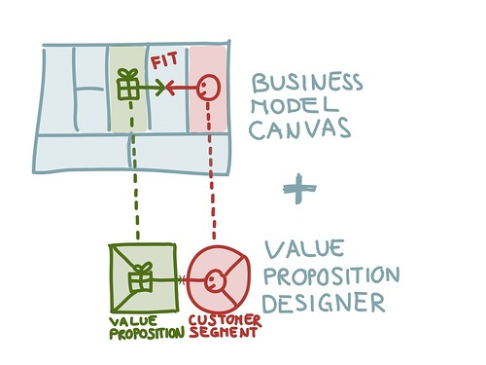  Businesses that needed to transform quicker.  Celebrity heads – this is designed to be challenging  Each girl gets given a business they can’t share  Know they can research in class and then swap pairs, so others don’t know who they had.  The other student wears in on their head and tried to guess the business?  - Blockbuster  - Polaroid  - Toys R us  - Kodak  - Harris Scarfe  - Target  - Napoleon Perdis  - Cosmopolitan Magazine  - Roger David  - Sumo Salad  - Ed Hardy | Differentiation by process and according to readiness  Some groups have varying degree of difficulty and more/less familiar depends on proficiency of learner.  Pre-test to determine groups  Flexible grouping  With scaffolding  Tom to provide an example  Hands on activities to understand concept  Biscuit is differentiation according to learning profile – choice  Print 10x10 and idea sketch for ONE of their final biscuits  Tom will need a list of grouped students before the lesson and final printing  Hands on and group activity  Designed for questioning and inquiry

Time | Main Content: | Teaching Approaches
 | Re-group. Class discussion as to why the businesses struggled or failed?  Make point – businesses need to continually assess when they need to transform. You don’t want to do it too early or when its not necessary, you run the risk of damaging your brand and something people love  Do it too late though, and you won’t survive  Allocate videos for Business Model canvas  Self -determine their own group with video to watch  Level 1 – not much know  Students can then research which business they want to pick and start researching. | Differentiation by content – self dependent. I learnt not to do this in class  Encouraging students to tackle interests

Time | Conclusion: | Teaching Approaches
 | Exit card – questions about BMC?  Think about a business you want to transform. | Exit card to determine next lesson

Resources
(Include equipment required for class and/or for teacher preparation)
- Pre-assessment cards
- Business Model Canvas poster
- Exit cards

Safety Considerations/Materials

Assessment
Complete the poll on SOCS before leaving

REFLECTION

