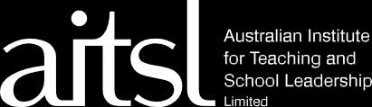

Getting to know the child third party observation template

As the teacher of **{insert child name}** it is important that I observe them over a period of time to collect information about their interests, emotions, preferences and social connections. The information I gain through these observations is used as part of my planning cycle and helps me to reflect on what approaches and strategies might work best for your child.

As part of that process, I would ask you - the child’s family/caregivers or allied health professional supporting the

child - to complete the table below to strengthen my own observations and develop a more holistic view of {insert child name}.

|  |  |  |
| --- | --- | --- |
|  | **Observations by families or allied health professionals** | Name:  Relationship with {child’s name}:  Date: |
| Is attentive when doing these activities… | |  |
| Spends the most time in... | |  |
| Spends the most time with... | |  |
| Exhibits joy and laughter when/with/in | |  |
| Exhibits excitement when/with/in | |  |
| Likes these objects... | |  |
| Becomes distressed when... | |  |
| And these people/activities help him/her feel calm | |  |
| Finds these activities/times/routines difficult | |  |
| And, I try supporting him/her by... | |  |

**aitsl.edu.au**

The content of this template was developed by the AllPlay Learn™ (Deakin University) research team in partnership with AITSL.