Reflection and
goal setting
Ongoing feedback, reflection and review
Professional practice
and learning
Performance
and
Development
Goal setting guide
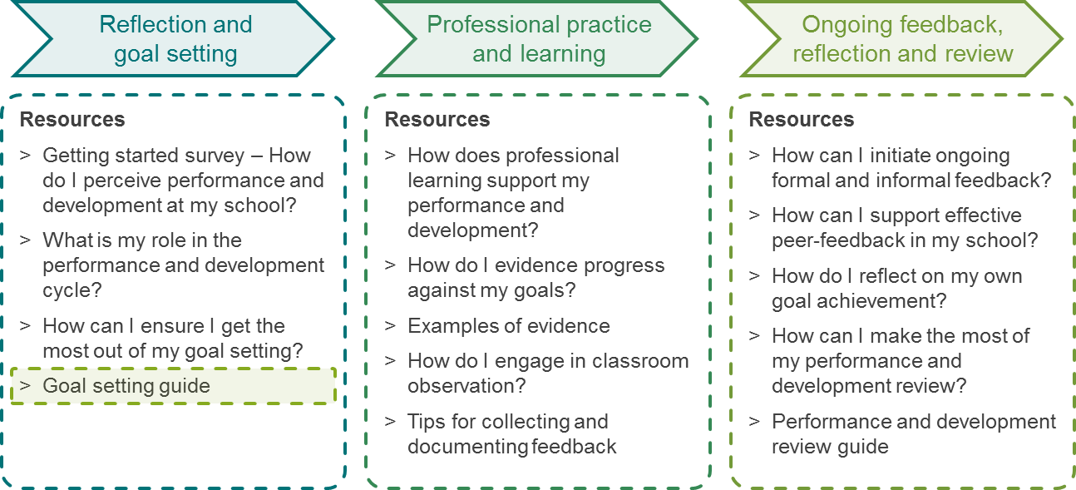
Reflection and
goal setting
Ongoing feedback, reflection and review
Professional practice
and learning
Performance and Development toolkit overview
Performance and Development

Goal setting guide
 | This guide can be used for annual goal setting as part of the formal performance and development cycle. It can also be used for goal setting in the context of a coaching relationship or for shorter-term goal setting resulting from personal reflection, classroom observation or any other feedback.
 | Teacher’s name: |  |  |  | Review period:
 | School leader’s name: |  |  |  | Date completed:
 | SMART Goals are:
 |  | Specific | Measurable | Achievable | Relevant | Time-Phased

# | Performance and development goal to be achieved (stated simply) | Evidence that will be used to demonstrate progression and goal achievement | What actions will I take to achieve the goal? | How does my goal connect to my professional growth, my school’s priorities and my students’ outcomes? | Timeframe within which the goal will be achieved | Support that will be required from the school to achieve the goal | Is the goal SMART?  Yes/No
1 | Improved skills in differentiating classroom activities to meet student needs | Student surveys and school-based assessments (see specific items in year level assessment schedule) | Peer observation, research, collaborative work with colleagues, leading to trialling a range of differentiated activities | I want to ensure I am meeting students’ needs. Student surveys highlighted the need for greater challenge. Appropriately challenging activities should lead to greater student achievement | Within the first two terms | Meetings with teaching and learning leader to improve understanding of strategies for differentiating tasks.  Teaching and learning leader to scaffold development of classroom activities and review planning documents | Yes

