What does an action plan look like?
Coaching
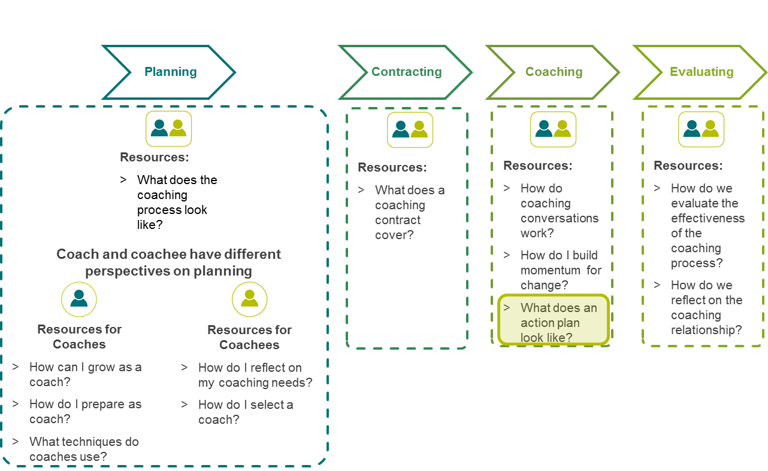
Coaching toolkit overview
Coaching

What does an action plan look like?
- Once you and your coach have agreed a development goal, you may choose to use this action planning tool to assist in stepping out your goal(s).
- The action planning tool is designed to be a living document that you can update, add to and modify to reflect your work with your coach.
- Complete this action planning tool together with your coach as part of the contracting phase, or complete it independently to assist in generating discussion at your first coaching meeting.
- The action planning tool will help you to increase the probability of achieving your coaching goals.
- Break your goal down into 3-5 succinct action steps.
- Respond to the questions in the table for each action step and discuss with your coach any areas of concern or items that require clarification.
- Each time you meet with your coach, you may re-visit your action plan and add to or modify it as needed.
Focus of action plan: I have recently been focussed on differentiating classroom activities. I have made some changes in class, now a group of students are having difficulty or not connecting with the activities and/or the new structure of the classroom. How can I work with my coach to address this?

Step | What specific actions need to be taken to achieve the goal? (in sequence if possible) | What are the possible hurdles to this step? Suggest ways to address these. | Notes to discuss with your coach – Questions? Clarification? Ideas? | By when will you complete this step | Complete  Y/N
1 | Prepare student survey to seek feedback on recent changes made to activities and classroom structure. Ensure the feedback I’m seeking is going to provide the information I want. | Making sure I have enough time to meet with the coach and to make changes before the scheduled implementation.  I’m not sure what I really want to ask the students or how specific to be. | How can I frame the survey questions to provide useful feedback? | End of week 2
2 | Survey all students. | I don’t know if I really want to hear if the students don’t think the changes haven’t been helpful. I’m not sure what I would do if they gave this response. | How will I manage things – the classroom environment and my feelings about the changes - if the students tell me the changes are not working for them? | End of week 3
3 | Seek additional feedback from some students – hold a discussion session with specific students to get more targeted information. | Students may feel they can’t be completely honest when talking with me.  Need strategies to overcome this. | How can I set up the discussion with students so that they feel they can be honest with me about the changes in class?  What can I do/say to encourage honest discussion? | End of week 4

