What does a coaching contract cover?
Coaching
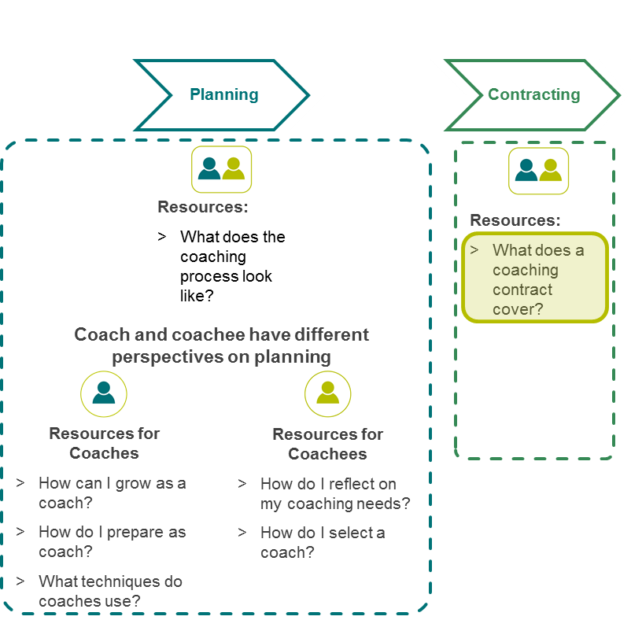
Coaching toolkit overview
Coaching

What does a coaching contract cover?

Introduction
Coaching is a professional learning process or relationship involving a coach and a coachee that can support teachers to improve their professional practice.
Discussing and agreeing on a coaching contract will ensure that the coach and coachee have an agreed understanding of approach and expectations.
Each section of the contract below should be discussed by coach and coachee and agreed protocols recorded that reflect the coaching relationship. Some suggested protocols have been provided, however each coaching relationship is different. The suggestions below should be modified and/or added to as appropriate to reflect your working relationship.

Commitment to the coaching relationship
The coachee commits to: | - taking responsibility for the learning journey  - openness and honesty about abilities as well as thoughts and feelings on practice  - being willing to take risks to change behaviour  - actively implementing agreed actions
The coach commits to: | - building trust and rapport to encourage supported risk-taking  - questioning to clarify development need, challenge assumptions and determine actions  - managing boundaries and maintaining confidentiality  - supporting the coachee in working towards sustained behaviour change
Coach and coachee commit to: | - adhering to the coaching contract (or mutually agreeing to vary it)  - establishing clear goals and to work together to achieve them  - openness and honesty about what works or doesn’t work in the relationship and seeking appropriate solutions  - evaluating the coaching process and progress against goals

Coaching methodology
Prior to every meeting: | - e.g. coachee to collect evidence and consider agenda for meeting. Confirm availability  -
During every meeting: | - e.g. both parties to openly discuss issues, solutions and next steps.  -
At close of each meeting: | - e.g. coachee to write down key points and actions, update action plan as required  -

Frequency and duration of meetings
We agree to meet: | - e.g. once per month for one hour  -

Duration of the coaching relationship
We agree to meet: | - e.g. for 12 months and then we will review whether to continue the relationship  -

Review date
The date to reflect on and evaluate the coaching relationships is: | - e.g. 6 months from starting date.  -

Goals
The coach and coachee jointly aim to: | - e.g. determine appropriate goals for the coachee that will offer challenge and stretch  -

Confidentiality
We agree that all discussions held in the context of the coaching relationship (both formal and informal meetings) will remain confidential unless otherwise agreed by both coach and coachee.
I,_______________________ (coachee’s name) have informed my school leader / lead teacher of this coaching relationship.

Signed
Coach: ____________________________ Date: __________________________

Coachee: __________________________ Date: __________________________

