Reflection and
goal setting
Ongoing feedback, reflection and review
Professional practice
and learning
Performance
and
Development
Performance and development review guide
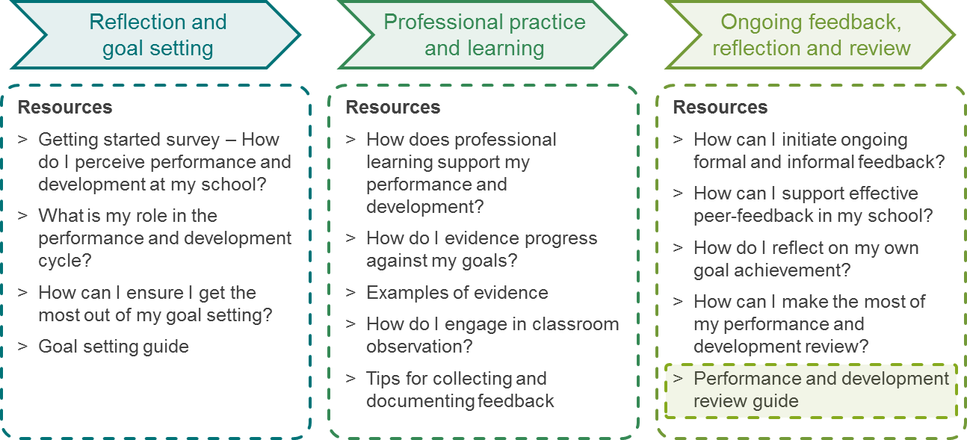
Reflection and
goal setting
Ongoing feedback, reflection and review
Professional practice
and learning
Performance and Development toolkit overview
Performance and Development

Performance and development review guide
 | This guide can be used for annual goal setting as part of the formal performance and development cycle. It can also be used for goal setting in the context of a coaching relationship or for shorter-term goal setting resulting from personal reflection, classroom observation or any other feedback.
 | Teacher’s name: | Review period: | Mid year review ☐  End of year review ☐
 | School leader’s name: | Date completed:
Teacher: Evaluate your own goal progress/achievement prior to the review session. Comment on/bring along evidence supporting your self-evaluation.
Jointly: Discuss the goal progress/achievement in the session. Record your goal progress/achievement from your school leader’s perspective. Document any additional development needs in relation to the goals. At the end-of-year review only, start planning the new performance and development cycle with these development needs in mind.

# | Performance and development goal to be achieved | Self-evaluation:  To what extent has the goal been achieved? How has it been achieved (actions taken and their effectiveness)? | Comment on the evidence that supports your self-evaluation (bring evidence along to the review session) | School leader-evaluation:  To what extent has the goal been achieved? How has it been achieved? | Jointly:  Additional development needs in relation to the goal
1 | Improved skills in facilitating inclusive but challenging classroom activities. | I have improved the level of differentiation when setting learning goals. Observing peers was a very effective way of learning new goal setting techniques. Research, however, was less successful. | Student assessments show an increased level of achievement.  Student surveys show that more students rate my classroom activities as challenging. | The level of achievement has increased. However, the high achievers still report feeling quickly bored according to student surveys. This will need to be addressed. | Additional development will be required in order to ensure that all students feel the learning goals are challenging enough.

