Annual Report 2019–20
Australian Institute for Teaching and School Leadership

Acknowledgement of Country
The Australian Institute for Teaching and School Leadership (AITSL) acknowledges the traditional custodians of the land, sea country and waterways from across Australia. We honour and pay our respects to their Elders past, present and emerging.

© Australian Institute for Teaching and School Leadership Limited (AITSL) 2020
ISSN: 1839-3829
Any material protected by a trademark and where otherwise noted, all material presented in this document is provided under a Creative Commons Attribution 4.0 International (CC BY 4.0) licence.
The details of the relevant licence conditions are available on the Creative Commons website (https://creativecommons.org/licenses/by/4.0/) as is the full legal code for CC BY 4.0 International (https://creativecommons.org/licenses/by/4.0/legalcode).
The document must be attributed as the Australian Institute for Teaching and School Leadership (AITSL) Annual Report 2019–20.

Contact us
AITSL
PO Box 299
Collins Street West
VIC 8007
Australia
Email: info@aitsl.edu.au
Website: aitsl.edu.au
Phone: 03 9944 1200
Online version
Web address for this report: aitsl.edu.au/about-aitsl/governance

AITSL was formed to provide national leadership for the Commonwealth, state and territory governments in promoting excellence in the profession of teaching and school leadership with funding provided by the Australian Government.

Letter of Transmittal
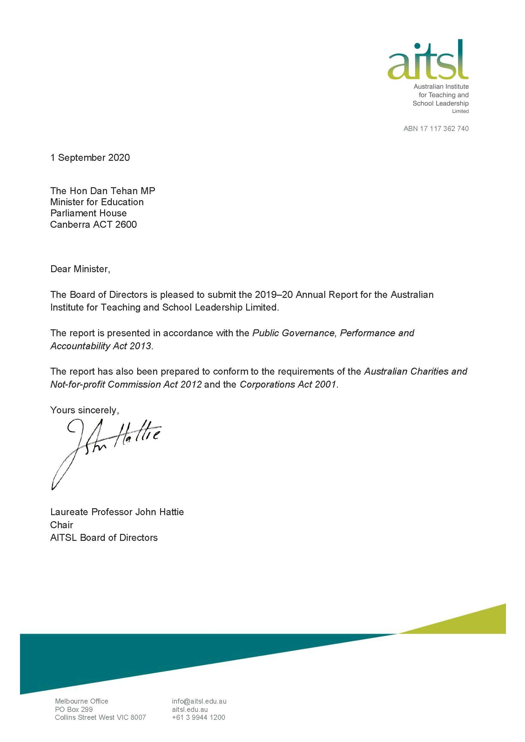

Contents
Letter of Transmittal 2
Contents 3
From the Chair 4
From the CEO 6
About AITSL 8
Performance Measures 2019–20 10
Senior Management 16
Corporate Governance Statement 19
Directors' Report 27
Financial Report for the year ended 30 June 2020 35
Notes to the Financial Statements for the year ended 30 June 2020 45
Appendices 59

From the Chair

During the past 12 months, we have had terrible bushfires in many parts of the nation and, of course, the COVID-19 pandemic. Australia’s response to these significant crises highlights the incredibly important work of teachers in the community.
The way teachers and school leaders have responded so swiftly and professionally to these unwelcome and disrupting developments is, to my mind, a measure of the incredible value of the profession and a tribute to the dedication, expertise and professionalism that characterises the Australian teacher workforce.
It has led to the development of new ways of working and continues to transform education delivery in Australia. It is incumbent on us not to let this moment pass us by and to capture the learnings from this difficult time to energise teaching and learning.
I have been particularly proud of the way AITSL has seized the moment, providing an online hub of practical resources for teachers, producing well-regarded literature on what works and what doesn’t in remote settings, and encouraging teachers to help support each other through new channels, including a Facebook group. Throughout, AITSL has worked closely with our stakeholders to progress our work, mindful of their competing demands at this time.
Such initiatives demonstrate to me that AITSL has the trust of the profession around the nation and is in a unique position to react nimbly to changing circumstances.
Throughout 2019–20, AITSL worked diligently to deliver a wide range of projects, to ensure Australia has a high-quality education system where teachers and leaders have the greatest impact on the educational growth and achievement of every learner.
While AITSL is perhaps best known for the work we do on professional standards, it is only a small part of our story. Over the past year, we worked with the profession on a range of projects such as Indigenous Cultural Competency, implementing the National Review of Teacher Registration, and improving reading instruction, including phonics. Other projects initiated on behalf of the Hon. Dan Tehan MP, Minister for Education, included stemming the abuse of teachers, school leaders, and other school staff, and reducing teacher red tape.
AITSL continues to listen to the needs of the profession and responds with targeted research on topics as broad as remote learning, professional learning for relief teaching, and diversity in school leadership. This research builds on other practical work such as the My Induction app, which helps support and guide beginning teachers as they commence their careers – particularly in regional and rural settings.
AITSL laid the groundwork for several large initiatives that will shape the future of teaching in Australia. These include important data projects such as Australian Teacher Workforce Data (ATWD) and the National Teacher Workforce Strategy (NTWS). Together, these projects have the potential to super-charge what we know about the profession and its many drivers, giving us opportunities to further support the teaching profession.
Our work in moving the Online Formative Assessment Initiative (OFA) from discovery to alpha stage has been done in collaboration with Education Services Australia (ESA) and the Australian Curriculum, Assessment and Reporting Authority (ACARA). Working in partnership underscored the co-operative and innovative way in which the various parts of the national education architecture is working for the benefit of all Australians.
The way in which the three agencies of the national architecture are successfully prosecuting OFA demonstrates the collegiality between our organisations and I welcome further opportunity to collaborate. I also look forward to AITSL working with the National Evidence Institute as it gets on its feet.

In addition to all this, we contributed several significant submissions, including to the NAPLAN review and the Inquiry in Education in Remote and Complex Environments.
By listening to and working with the profession, AITSL continues to adapt to the needs of teachers and school leaders. Our gratitude and thanks go to all our stakeholders for their collaboration and trust.
I would like to use this opportunity to thank my fellow Directors, all of whom bring deep expertise and knowledge to the AITSL Board. My thanks also to our Chief Executive Officer (CEO), Mark Grant, and his committed team who continue to impress me with their uncompromising focus on delivering positive outcomes for Australian students by supporting quality teaching and school leadership.

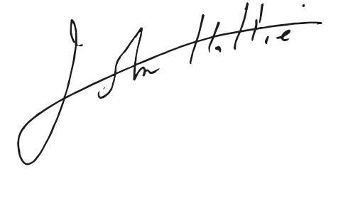
Laureate Professor John Hattie
Chair



From the CEO

This time last year, I was only a few months into the role as CEO but had already experienced first-hand the genuine care and connection AITSL has with the teaching profession.
For 10 years, AITSL has worked hand in hand with teacher employers and the Commonwealth Department of Education, Skills and Employment (DESE), the tertiary sector including universities, principal and other professional associations, teacher regulatory bodies, and the teaching profession as a whole, to support and guide quality teaching and school leadership in Australia.
These relationships, and a collaborative approach, were particularly crucial in the past few months as we have all faced the challenges of COVID-19. I am proud of how we all pivoted to adapt to this testing environment, continuing to look out for each other while progressing our important work using alternate means.
AITSL has a strong track record of working across the education sector to deliver significant national education reform, stemming back to the Australian Professional Standards for Teachers and the subsequent eight national education policies. We have a trusted connection with teachers and school leaders and combine this with policy and research expertise and agility. This allows us to deliver high-quality and timely policy reform when directed by the Commonwealth Minister for Education and Education Council, and in support of all systems, sectors and teacher regulators.
AITSL achieves national reach, working with Education Council and its accompanying bodies and other key stakeholders. AITSL is an ‘honest broker’ for school education, and a genuine consultative approach is the basis for all our work. We lead reform at a system level with national policies and initiatives, and support at a classroom level with tools and resources. The goal of both is to improve learning outcomes for all students.
Over the past year, our work on stemming the abuse of teachers, school leaders and other school staff, reducing red tape, school leadership development, supporting national certification of Highly Accomplished and Lead teachers, and supporting the cultural competency of the teaching workforce in relation to Indigenous education, demonstrates this. We have consulted broadly on each of these projects, listening to the sector and establishing the evidence base that will be the foundation for our work in these areas. We have drafted the National Teacher Workforce Strategy (NTWS), and progress on the Australian Teacher Workforce Data (ATWD) initiative continues on track.
Over the past 10 years, we have led work touching on teachers and leaders at every stage of their careers, from pre-service teachers at university, through the various career stages of teaching, and into leadership. We want every teacher and leader to have the maximum impact on learning in all Australian schools and early childhood settings.
As part of our ongoing work to ensure teaching graduates are classroom ready, Education Council endorsed changes to the Accreditation of initial teacher education programs in Australia policy (Standards and Procedures) to include a focus on reading instruction, including phonics. We also progressed recommendations from the national review of teacher registration, including the transition from provisional to full teacher registration.
We hosted a national roundtable aimed at ensuring effective school leadership across Australia and provided this advice to the Minister. We also commenced consultation as part of a stocktake of the Australian Professional Standards for Teachers, including a focus on trauma-informed learning, with our advice on this due to Education Council in late 2020.
Our unabated progress on national reforms and initiatives was achieved simultaneously with providing practical support to teachers and leaders, including the release of an enhanced version of the My Induction app for beginning teachers. In late 2020, additional app functionality will match beginning teachers with experienced mentors. This will be a lifeline for teachers starting their careers and working in early childhood or rural and remote locations where access to a mentor is rare.
In October 2019, we led celebrations for World Teachers’ Day in Australia with a national campaign focused on the bright future of teaching. The AITSL hashtag #brightfuture had over 1.5 million impressions on Twitter alone, and at its highest, trended at number two in Australia. In late 2019, as part of the UNESCO International Year of Indigenous Languages and our cultural competency work, we released a series of videos profiling effective practices in Indigenous language education.
When COVID-19 closed many schools in March 2020, we rapidly rolled out the Australian Teacher Response campaign. This brought together new AITSL resources, along with those curated from other organisations, to support schools through changing times. An AITSL research summary on what works in online/distance teaching and learning, released as part of this campaign, received over 90,000 views within the first three months.
While the way we worked these past few months has been different, we remain committed to working closely with the sector, consulting on all our work (albeit via technology), and supporting teachers and leaders to maximise their impact on student learning.
AITSL is a small organisation and punches well above its weight. I am particularly proud that our staff and the organisation have maintained such high standards while working from their homes and in many cases, juggling remote learning for their own children.
In closing, I would like to acknowledge and thank the AITSL Board, our many stakeholders across Australia, and AITSL staff – delivering support on behalf of nearly four million students and 330,000 teachers takes a huge team effort.


Mark Grant PSM
Chief Executive Officer



About AITSL

Our vision and mission

Our vision
Australia has a high-quality education system in which teachers and leaders have the greatest
impact on the educational growth and achievement of every learner.

Our mission
Promoting excellence so that teachers and leaders have the maximum impact on learning in all Australian schools and early childhood settings.
AITSL was formed to provide national leadership for the Commonwealth, state, and territory governments in promoting excellence in the profession of teaching and school leadership with funding provided by the Australian Government.

Strategic Plan 2019–2022
Ensuring children receive the very best education is one of the most important things we can do for them. It is also one of the most important government investments made in this country.
AITSL has worked hard to build its reputation, deliver quality work and form strong relationships in the education sector. AITSL’s Strategic Plan 2019–2022 builds on that foundation to develop guiding principles and clear focus areas, actions and goals.
AITSL’s strategic plan purpose is to:
- support planning and scoping of work beyond the yearly funding cycle and work plan
- make clear AITSL’s position within the education landscape
- articulate a plan for how the organisation will support education reform
- set long-term goals.
AITSL's Strategic Plan 2019–2022 includes a one-page outline of AITSL’s goals, focus
areas, guiding principles, areas for action, and a more detailed account of the actions that will
address AITSL’s priorities. The long-term goals articulated in the Strategic Plan have been
developed into short-term and medium-term organisational performance measures. These
measures are reflected in the Corporate Plan 2019–2022.
The AITSL Strategic Plan 2019–2022 can be found at aitsl.edu.au/about-aitsl/governance

Guiding principles underpinning our focus areas and actions
- Every child experiences a quality education.
- Graduate teachers are well-prepared to teach when they enter the profession.
- Improving professional practice is central to maximising impact on learners.
- Leadership is a team effort at all levels.
- Aboriginal and Torres Strait Islander education needs are understood, respected, and supported in all actions.
- Evidence and knowledge drive our decisions and we evaluate and learn as we progress.

Goals and focus areas
Goal 1: Strengthened capability and a shared commitment to professional growth
- Placing impact of initial teacher education (ITE), teaching and leadership at the centre of our work
- Building, enhancing and sustaining effective teaching and leadership at every level

Goal 2: Use of evidence to inform practice and improve learner outcomes
- Advocating for quality and rigour in the design and implementation of national policies, tools and resources
- Supporting the professional education community to make evidence-based decisions

Goal 3: A valued profession
- Affirming the status of the profession

Actions we’re undertaking to achieve our goals
- Promote and support implementation of the Australian Professional Standards for Teachers and the Australian Professional Standard for Principals in partnership with jurisdictions to increase their impact
- Strengthen leadership engagement, broaden participation in leadership and enhance the capability of aspiring and emerging leaders
- Consult with the Indigenous community and stakeholders to identify services to benefit Indigenous teachers and teachers of Indigenous students and studies
- Play a key role in national initiatives to support quality teaching and leadership
- Promote Australian Curriculum-mapped formative and diagnostic tools to better enable teachers and leaders to understand more clearly their impact and support individual learner progress
- Strengthen the evidence base about the teaching profession, sponsor research and support the use of evidence in decision making and professional practice
- Drive and support improvement of excellent initial teacher education
- Develop and implement a strategy to affirm the status of the teaching profession and seek to enhance teacher professionalism through all projects and initiatives
- Provide accurate and efficient skills assessments for teacher migration to Australia
- Strengthen collaboration and cooperation with stakeholders and all educators
- Use new technologies to enhance and strengthen AITSL’s capacity and capabilities
- Consolidate and strengthen our resource base and use resources efficiently to maximise our impact

Working with the education sector
AITSL would not be able to lead national education reform without the expertise and support of committed educators from across Australia. For example, the Australian Professional Standards for Teachers were developed with advice from more than 6,000 educators. A genuinely consultative approach is the basis for all AITSL’s work.
AITSL has a strong connection with the teaching profession and works closely with schools, systems, sectors, regulatory bodies, initial teacher education providers, principal and other professional associations, teachers, and school leaders to develop policies, tools, and resources that support quality teaching and school leadership.

Performance Measures 2019–20
AITSL’s performance measures ensure it delivers on its priorities and has maximum impact. These performance measures for 2019–20 are:
- AITSL plays a key role in successful delivery of programs of work, such as those delivering the Australian Government Response to the Teacher Education Ministerial Advisory Group, as measured through monitoring and evaluation of initiatives that sit within programs of work.
- Awareness, positive attitudes toward, and use of the Australian Professional Standards for Teachers, the Australian Professional Standard for Principals, and other national frameworks, as measured through a stakeholder survey.
- Awareness, use, and perceived usefulness of AITSL’s resources, as measured by traffic to and within the AITSL website, and through a stakeholder survey.
- AITSL delivers its agreed work plan within the available budget, as measured through reporting against the Work Plan and budgetary reports.

- AITSL plays a key role in successful delivery of programs of work, such as those delivering the Australian Government Response to the Teacher Education Ministerial Advisory Group (TEMAG), as measured through monitoring and evaluation of initiatives that sit within programs of work.
AITSL’s work related to the TEMAG covers six key reform areas: selection, quality assurance, robust assessment, induction, professional experience, and national research and workforce planning. Key progress against these programs of work includes:
Selection | As at 30 June 2020, all Australian ITE providers have updated their websites to include information on both academic and non-academic selection criteria in their selection processes. This is an increase from June 2019, when 37 out of 47 ITE providers had updated their websites to include this information.
Quality assurance | AITSL established and convened a Standard Setting Advisory Group, to provide advice on the establishment of the Expert Advisory Group (EAG) and methodologies for accreditation, standard-setting, and teaching performance assessment (TPA) benchmarking.  These ongoing activities will result in revisions to the Guidelines for the accreditation of initial teacher education programs in Australia, and training of ITE accreditation panellists to ensure accreditation panels make more consistent decisions.  AITSL has also developed a methodology to investigate if the passing standard between different TPAs is comparable. This activity will commence in 2021 with TPAs that have been endorsed by the EAG.
Robust assessment | AITSL convened the EAG to provide advice to teacher regulatory authorities on all TPAs used by ITE providers against the requirements of Program Standard 1.2 of the Accreditation of initial teacher education programs in Australia: Standards and Procedures. As of 30 June 2020, four providers have developed a TPA endorsed by the EAG, used by a total of 31 out of 47 ITE providers.

Induction | Data gathered through the 2019 AITSL Stakeholder Survey and reported on in the ITE Data Report 2019 show that induction practices continue to align with all four areas (Professional Practices, Professional Identity, Teacher Wellbeing and Orientation - as outlined in Graduate to Proficient: Australian guidelines for teacher induction into the profession), but support for teacher wellbeing needs to be strengthened.
Professional experience | AITSL produced two videos highlighting professional experience. The first focused on the partnerships between schools and ITE providers, and the second explored the mentoring relationship between a pre-service teacher and a supervising teacher. AITSL is also a member of two groups working to improve the quality of the delivery of professional experience: The Network of Academic Directors of Professional Experience and Transforming the Teaching Profession Taskforce.
Workforce planning | Six jurisdictions provided data to the Australian Teacher Workforce Data (ATWD) initiative in 2019. The remaining two will submit data following the necessary legislative changes. AITSL is also progressing workforce planning work through the National Teacher Workforce Strategy (NTWS).

AITSL has also delivered other successful key programs of work throughout 2019–20. Indicators of success include:
Certification of Highly Accomplished and Lead Teachers | AITSL continued to work with jurisdictions to support national teacher certification which recognises expert teaching practice. As at 30 June 2020:  - 726 teachers have achieved national teacher certification  - Catholic Education Melbourne began certifying teachers in 2020  - Tasmania is planning to undertake a pilot in 2020.  Currently certification is available to teachers in all sectors in the Australian Capital Territory, New South Wales, Northern Territory, Queensland, and South Australia, the Catholic sector in Victoria, and the independent sector in Western Australia.
School Leadership | AITSL convened a School Leadership Roundtable in July 2019. The Roundtable explored issues relating to strengthening school leadership development and principal preparation, bringing together 58 school leadership experts, including:  - practising school leaders  - system and sector representatives  - national principal associations, and  - key academics and researchers.  AITSL used the outcomes from the Roundtable, together with findings from consultation activities and research, to develop a blueprint paper. The paper outlines a series of proposed reforms to enable high-impact school leadership across Australia.
Aboriginal and Torres Strait Islander Education | In February 2019, AITSL was instructed by the Hon. Dan Tehan MP, Minister for Education, to undertake a four-year project to support the improved cultural competency of the existing teacher workforce.  From August to December 2019, AITSL consulted with a range of stakeholders from all states and territories, systems and sectors, state and federal government agencies, Aboriginal education consultative groups, Indigenous education experts, and professional associations.  AITSL conducted an extensive desktop literature review to form a foundation and rationale for cultural competency in the Australian education context. A key part of this process was a thorough review of all jurisdictional policies and strategies to summarise relevant bodies of work currently underway or already embedded.  AITSL developed a research paper to better understand the current context of cultural competency within the Australian education landscape.
High-Quality Professional Learning | AITSL continued to promote its research into high-quality professional learning for teachers, with a particular focus on three cohorts of teachers who typically face challenges to accessing high-quality professional learning:  - casual/relief teachers  - early childhood teachers  - teachers working in regional, rural, and remote locations.  To track the success of the high-quality professional learning initiative as it progresses, AITSL developed a monitoring and evaluation framework.  AITSL has continued to promote supporting resources released in June 2019 via the ‘Improving Teacher Professional Learning’ web page. The web page received over 14,000 visits in 2019–20.  AITSL continued to consult with the profession about what additional resources they need to support access to and implement high-quality professional learning, including targeted consultation with the three cohorts of teachers. This led to:  - the development of additional resources including short animations  - ‘how-to’ guides to support implementation  - practical guides that explore professional learning approaches in greater depth.  AITSL undertook additional consultation on the proposed development of a technical solution to support high-quality professional learning. AITSL will further explore technical requirements in collaboration with jurisdictions in 2020–21.
Reading instruction | In September 2019, the Hon. Dan Tehan MP, Minister for Education, requested AITSL lead the implementation of the election commitment to strengthen the capacity of graduate teachers to teach reading, including phonics. AITSL commenced this work in ITE, establishing a phonics and related reading skills expert group (Expert Group) to provide advice on possible changes to the ITE accreditation requirements.  In addition, and to complement input from the Expert Group, AITSL consulted with ITE providers to propose amendments to the current Program Standards within the Standards and Procedures. In December 2019, Education Council endorsed the proposed amendments to include explicit reference to reading instruction, including phonics, and an increase in the time component allocated to English and literacy within primary ITE programs.

Online Formative Assessment initiative | In December 2019, Education Council endorsed the recommendations from the discovery phase of this initiative and asked AITSL to continue the work alongside ACARA and ESA.  The project is in an ‘alpha’ phase. Prototyping and testing professional learning and technical solutions with teachers, school leaders, students, and parents has begun. The Teacher Practice Reference Group was reconvened in 2020 with 37 representatives from schools across Australia and has met to test prototypes, hold open discussions, and give feedback on content, design, and usability.
National Teacher Workforce Strategy | In June 2019, Education Council tasked AITSL with developing a national teacher workforce strategy in collaboration with the education sector. AITSL continues to progress this work to identify national workforce issues and develop national actions to address them.
Australian Teacher Response campaign | In April 2020, AITSL released an Australian Teacher Response campaign in response to the emergence of COVID-19 in Australia.  AITSL developed a Teacher Resource Hub which hosts over 170 curated online resources to support teachers during changing times. The Hub was accessed by over 5,000 unique users from April to June 2020. AITSL also created a Facebook group for teachers and school leaders to facilitate knowledge sharing. Over 3,000 members joined the group in the first three months of being established.  To translate best practice evidence on setting up online learning, and to provide advice for school leaders to share with teachers, and teachers to share with parents and carers, AITSL developed a research Spotlight titled What Works in Online/Distance Teaching and Learning?. The Spotlight included resources from across Australia, including links to jurisdictional advice. Readership of the Spotlight was extensive, with 90,000 views up to 30 June 2020.


- Awareness, positive attitudes toward, and use of the Australian Professional Standards for Teachers, the Australian Professional Standard for Principals and other national frameworks,
as measured through a stakeholder survey.
The 2019 AITSL Stakeholder Survey revealed an overall high awareness of AITSL’s national frameworks and AITSL was found to maintain high levels of engagement, satisfaction, and performance.
Awareness of the Australian Professional Standards for Teachers
 | 97% | increased from 91% of stakeholders in 2016  to 97% of responders in 2019
Awareness of the Australian Professional Standard for Principals and the Leadership Profiles
 | 62% | was maintained at 62% of responders
Awareness of the Accreditation of initial teacher education programs in Australia:
Standards and Procedures
 | 60% | increased from 46% in 2016 to 60% in 2019
Awareness of the following policies remained high
 | 74% | Graduate to Proficient: Australian Guidelines for Teacher Induction into the Profession
 | 73% | Australian Teacher Performance and Development Framework
 | 73% | Certification of Highly Accomplished and Lead Teachers in Australia
Awareness of the following policies was lower, in part due to specific audiences being targeted
 | 35% | Leading for Impact: Australian Guidelines for School Leadership Development
 | 35% | Australian Charter for Professional Learning
 | 6.4 | AITSL’s performance in supporting all policies was ranked between 6 and 7 out of 10 (mean 6.4) by stakeholders responding to the survey in 2019

- Awareness, use and perceived usefulness of AITSL resources, as measured by traffic to and within the AITSL website, and through a stakeholder survey.
Engagement with AITSL including traffic within the website and use of AITSL’s tools and resources remains high. The statistics below, unless indicated are for all time.
  
  Over 3.8 million unique visitors
  to AITSL’s website (for 2019–20)
  Over 900,000 page views of the
  Teacher Standards (for 2019–20)
  Over 480,000 unique page views of the Illustrations of Practice (for 2019–20)
  The Teacher Self-Assessment Tool
  was used by more than
  33,000 users
  The School Leader Self-Assessment Tool
  was used by more than
  8,700 users
  
  The My Induction app was downloaded over
  4,500 times
  
  Over 188,000 AITSL Mail subscribers (14.5% increase over the last 12 months)
  
  An audience of over 100,000
  across AITSL’s three main social media platforms

Teachers found AITSL’s tools for teaching useful and rated them  7.5 out of 10 on average. | 7.5 out of 10 | 

The highest rated tools in terms of perceived usefulness were:
Feedback resources | 7.9 out of 10 | 
Classroom Practice Continuum | 7.8 out of 10 | 
Illustrations of Practice | 7.8 out of 10

- AITSL delivers its agreed work plan within the available budget, as measured through reporting against the Work Plan and budgetary reports.
Agreed milestones within AITSL’s 2019–20 Work Plan were achieved, except for those delayed due to COVID-19 or where amended timelines have been otherwise agreed.

Senior Management

Senior officers
Mark Grant PSM
Dip Teach BEd MStudEd PCiL MACE
Chief Executive Officer
Mark Grant PSM joined AITSL as CEO in April 2019, bringing a significant breadth and depth of operational experience as a teacher, principal, and executive to the role. During a career dedicated to education, he has maintained a passion for quality teaching and school leadership, and the resulting benefits these bring to students in the classroom.
Prior to joining AITSL, Mark held the position of Executive Director, Leadership and High Performance at the Department of Education, NSW. Mark combines this executive experience with a background in schools as a teacher and leader. During his tenure as principal at three NSW schools, Mark drove improvement initiatives to benefit student growth and outcomes.
Mark has also led complex, integrated strategic work, including school improvement measures; teacher quality, induction, professional development, and leadership support for all school-based staff; and needs-based funding budgets to all schools.
Mark has a deep commitment to making a broad and significant contribution to education, and to the lives of children and young people across the nation.

 | Edmund Misson  BA (Hons) EMPA  Deputy Chief Executive Officer  Edmund Misson is the Deputy CEO of AITSL and is a respected leader in the national education landscape.  Edmund’s considerable experience across education research, policy development and policy implementation has seen him successfully lead AITSL’s work with all jurisdictions to deliver solutions that promote quality teaching and school leadership across Australia.  Since joining AITSL in 2011, Edmund’s focus has been on using evidence to support teachers in all systems and sectors to excel at every stage of their teaching careers.  He has led AITSL’s role in helping to shape national reforms to ITE for graduate teachers, and several of AITSL’s landmark national policies and frameworks now being used by the profession in all states and territories.  Edmund previously held leadership roles with the Victorian Government, advising on a range of education, training, and other social policy issues.  He has a Master’s degree in Public Administration.

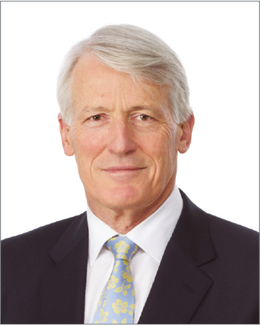 | Donald Abell  BCom GradDip FCA  Chief Financial Officer  Don Abell joined AITSL in 2011. He is a Fellow of the Institute of Chartered Accountants in Australia and holds a Bachelor of Commerce from the University of Melbourne and a Diploma in Taxation Law from Monash University.  Don has over 30 years’ experience in professional accounting, including 25 years as a partner at the chartered accounting firm, KPMG. He has also served as a company director and board chairman for several companies.

 | Dianne Jickell  BA (Hons)  General Manager, Corporate  Dianne Jickell joined AITSL in May 2017. As General Manager, Corporate she leads AITSL’s communications, brand and digital, people and culture, and business services functions.  Dianne provides high-level strategic and operational advice with a focus on strengthening AITSL’s internal engagement and external reach.  Dianne has extensive experience in strategic leadership and change management, marketing, communications, and stakeholder engagement across a wide range of sectors internationally.  Prior to joining AITSL, Dianne was a senior executive at an Australian peak body, Philanthropy Australia. She delivered several key initiatives to support the organisation’s objectives and worked as part of the executive team to design and develop a refreshed direction for the organisation.

 | Lisa Molloy  BSc LLB MPICT GAICD FGIA AMIIA  General Counsel and Company Secretary  Lisa Molloy joined AITSL in April 2017. As General Counsel and Company Secretary, Lisa’s responsibilities include providing legal support and advice to the Board and Executive, ensuring regulatory compliance, managing fraud control and risk, facilitating internal audits, supporting high-quality company policies and operations, and managing the Assessment for Migration function.  Lisa is a legal professional with extensive experience working with boards, and providing legal, risk, fraud management, operational, and strategic advice to government and the private sector.  Prior to joining AITSL, Lisa worked in private practice and for State and Federal Government. Lisa also holds a Bachelor of Science, a Masters of Policing, Intelligence and Counter Terrorism, is a PRINCE 2 Practitioner, and is a graduate of the Australian Institute for Company Directors and Fellow of the Governance Institute of Australia.

 | Danny Pinchas  BEcon PGDipEd  General Manager, Teaching and School Leadership  Danny has more than 10 years’ experience as a leader across the education sector and joined AITSL in 2013.  As General Manager, Teaching and School Leadership, Danny leads AITSL’s important work across ITE reform, quality teaching support, and school leadership development. Danny’s responsibilities involve driving and supporting the development and implementation of a range of policy initiatives and resources to empower teachers and school leaders.  Prior to joining AITSL, Danny held positions at the Victorian Department of Education and Early Childhood Development. Before that, he spent several years in the Kimberley region of Western Australia, working in remote communities as a principal, teacher, and numeracy coach.

 | Xian-Zhi Soon  BA LLB GDLP  General Manager, Evidence and Impact  Zhi joined AITSL as the General Manager, Evidence and Impact in March 2019. He is responsible for building a robust and credible research foundation for developing and delivering evidence-based policy and programs. Zhi also leads AITSL’s work measuring its impact in the sector.  Previously, Zhi worked as Director of Education Policy and a global executive member of the Behavioural Insights Team (BIT), an international research and policy organisation that originated at the heart of the Government of the United Kingdom. At BIT, Zhi also served as the Director of the Behavioural Research Centre for Adult Skills and Knowledge, and as the Director responsible for economic growth, productivity, consumer markets, and environmental sustainability policy.  Zhi has held positions in the Australian Government, including in the Prime Minister’s Office and the Department of Foreign Affairs and Trade as a diplomat. At state level, he has worked at the NSW Department of Premier and Cabinet and as a Board Member on the NSW Board of Studies. He also has private sector experience as a management consultant.

Corporate Governance Statement

Purpose
AITSL was formed to provide national leadership for Commonwealth, state, and territory governments in promoting excellence in the profession of teaching and school leadership with funding provided by the Australian Government.
AITSL plays a key role in leading significant educational reform across Australian governments, and its work program is set in accordance with directions received from the Commonwealth Minister for Education.

Corporate structure and governing legislation
AITSL was registered and commenced operations in January 2010 and is:
- a Commonwealth company as defined in section 89 (1) of the Public Governance, Performance and Accountability Act 2013 (PGPA Act)
- a company subject to the Corporations Act 2001
- operates as a ‘not-for-profit’ subject to the Australian Charities and Not for Profit Commission Act 2012
- wholly owned by the Commonwealth of Australia
- a company limited by guarantee.
The Minister for Education, as the representative for the Commonwealth of Australia, is the sole shareholder of AITSL. During 2019–20, the Minister responsible for this portfolio was the Hon. Dan Tehan MP, Minister for Education.
AITSL regularly reports to the Commonwealth Minister for Education and the Minister for Finance, and the Department of Education, Skills and Employment (DESE) based on the reporting timetable detailed in AITSL’s Grant Agreement and other requests from the ministers. AITSL is also subject to parliamentary scrutiny through the Senate Estimates process.
As AITSL is owned by the Commonwealth of Australia, under section 250 N (4) of the Corporations Act 2001, it is not required to hold an annual general meeting.
AITSL operates under its own constitution with a Board of Directors (AITSL Board) that has decision-making authority. The AITSL Board is responsible for setting the company’s strategic direction and governing its operations and performance.
The AITSL Board is supported by a company headed by a CEO, who is responsible for ongoing management and leadership within the broad framework and strategic direction set by the AITSL Board.
AITSL is committed to meeting high standards of corporate governance, which it considers
essential to its long-term performance and sustainability, and to be in the best interests of its stakeholders.
AITSL’s governance framework is regularly reviewed to ensure it aligns to the government, regulatory, and legislative requirements.
AITSL’s governance practices continue to evolve, having regard to the:
- PGPA Act and Public Governance, Performance and Accountability Rule 2014 (PGPA Rule)
- Corporations Act 2001
- requirements of the Australian Charities and Not for Profit Commission Act 2012.
This statement, which was approved by the AITSL Board, outlines the most significant aspects of AITSL’s corporate governance framework.

The Minister for Education has provided AITSL with two letters of instruction throughout the 2019–20 financial year, expanding its agenda over the forward years to include:
- strengthening the capacity of graduate teachers to teach reading instruction, including phonics
- reducing red tape for teachers
- addressing teacher, school leader, and other school staff abuse
- expanding the scope of the stocktake of the Australian Professional Standards for Teachers and the Australian Professional Standard for Principals to include trauma-informed learning.

The Board
AITSL’s constitution defines the corporate powers of AITSL, which are exercised by the AITSL Board.
The AITSL Board has also adopted a board charter that sets out the AITSL Board’s role and responsibilities and the role and responsibility of the CEO.
The AITSL Board is responsible for:
- setting AITSL’s overall strategic direction and goals
- overseeing and monitoring organisational performance and the achievement of strategic goals and objectives
- monitoring financial performance and accountability
- setting specific limits of authority for management
- reviewing and monitoring AITSL’s risk management and compliance systems
- setting appropriate standards of corporate governance and codes of conduct
- protecting and enhancing AITSL’s reputation.
The AITSL Board has also adopted a code of conduct that sets out the legal requirements and ethical standards that each Director is expected to adhere to.

Appointments
In accordance with AITSL’s constitution, the AITSL Board is to comprise a minimum of three and a maximum of 11 directors.
Directors are appointed by the Minister for Education through an Instrument of Appointment setting out the key terms and conditions of the appointment. The maximum term of office for a Director is for a period of up to three years, with serving Directors eligible for re-appointment on the expiry of their term of office.
Full details of current Directors including names, appointment dates and qualifications are included in the Directors’ Report on page 27.

Expert Board of Directors
AITSL operates under an expert board, and, when appointing Directors, the Minister for Education has regard for their skills and expertise in a number of areas, including:
- teacher education
- regulation and accreditation of initial teacher education courses
- school leadership
- teacher practitioner expertise
- public policy
- governance, including audit, risk, and finance
- government liaison expertise.

Upon appointment, each Director is requested to complete a declaration of personal interests and has an ongoing obligation to keep the AITSL Board informed of any arising interests that could potentially conflict with the interests of AITSL. Any conflicts and related party transactions are dealt with in accordance with the AITSL Board Charter, AITSL’s Procurement Policy, and Conflict of Interest Policy. During 2019–20, there were transactions with related entities with an aggregate value of $232,443. Further information on related party transactions for 2019–20 can be found in note 9 of the Financial Report on page 54.

Independent Advisors
To allow Directors to fulfil their responsibilities and to exercise independent judgment when making decisions, the AITSL Board collectively, and each Director individually, has access to any information in the possession of AITSL. The AITSL Board also has capacity to invite up to two persons with expertise in a specific area to attend a meeting and provide advice to Directors.

Induction
Upon appointment, each Director receives a letter from AITSL confirming their appointment along with key documents, policies, and contact information relevant to their appointment. Meetings with the AITSL Board Chair and other key staff are arranged, as well as training that covers their obligations as a Director.
To improve both their own and the AITSL Board’s performance, Directors are encouraged, where appropriate, to undertake professional development.

Meetings
Details of the number of AITSL Board meetings each Director was eligible to attend and the number of meetings attended during the period from 1 July 2019 to 30 June 2020 are set out in the Directors’ Report on page 33.

Remuneration
The Remuneration Tribunal determines the remuneration and travel allowances payable to Directors. Full details of Directors’ remuneration are on page 24.

Board Committees
To assist in the performance of its responsibilities, the AITSL Board currently has three committees, each governed by a formal charter setting out its purpose, role, responsibilities, composition, structure, and membership. Committee charters are reviewed annually by the committee and any proposed changes must be approved by the AITSL Board. Each committee is chaired by an AITSL Director, who provides an oral or written report to the AITSL Board outlining the matters considered and any actions taken at the committee meeting.
The three committees of the Board are:
- Audit and Risk Committee
- Finance Committee
- Remuneration Committee

Audit and Risk Committee
The primary objectives of the Audit and Risk Committee are to provide independent assurance and assistance to the Board of Directors on AITSL’s risk control and compliance framework and to fulfil the functions required under section 92 of the PGPA Act. The Committee’s charter outlines its composition, purpose, role and responsibilities, and reporting and administrative arrangements. A copy of the Audit and Risk Committee Charter can be found on the Governance page of the AITSL website: https://www.aitsl.edu.au/about-aitsl/governance
​

Membership
- The Chair of the Audit and Risk Committee is Mr Christopher Wardlaw PSM, who is Deputy Chair of the Board, and Members are comprised of Directors Mr Mark Mowbray and Mr Robert Nairn.
- The Audit and Risk Committee also includes an Independent Expert Member, Mrs Jennifer Morison.

Skills, Qualifications, and Experience
- The skills, qualifications, and experience of the Directors who sit on the Audit and Risk Committee can be found in the Directors’ Qualifications and Experience section on page 27.
- Mrs Jennifer Morison FCA, BEc (The University of Sydney), the Independent Expert Member, has 38 years’ broad experience in the accounting profession, commerce, and government. She was a National Board Member of the Chartered Accountants of Australia and New Zealand for four years, Chief Financial Officer of a public company and held senior positions in the major international accounting firms. Mrs Morison founded Morison Consulting Pty Limited in 1996, specialising in government financial reforms, governance and consulting. She was awarded a Centenary medal in 2000 for services to women and accounting. Mrs Morison brings a wealth of experience having held roles as an independent member and chair of Commonwealth audit and risk committees and financial statement sub-committees for large and small government entities for the last 17 years.

Attendance
- Attendance of the Directors who sit on the Audit and Risk Committee can be found in the Board Directors’ Meetings table on page 33.
- The Independent Expert Member attended all five meetings held throughout the financial year.

Remuneration
- Directors are paid for their attendance at Audit and Risk Committee meetings as per the Part-Time Office Determination set by the Remuneration Tribunal. The remuneration received by Directors for the financial year can be found on page 24.
- The Independent Expert Member is remunerated at an hourly rate of $429 (including GST) and was paid a total of $13,728 for her attendance and services rendered during the 2019–20 financial year.

Finance Committee
The primary objective of the Finance Committee is to assist the AITSL Board in its responsibilities for financial oversight and accountability of the company under the Corporations Act 2001 and PGPA Act. The Committee’s charter outlines its composition, purpose, role and responsibilities, and reporting and administrative arrangements.

Remuneration Committee
The Remuneration Committee advises the AITSL Board on the salary, conditions, and performance of the CEO.

Board Advisory Committees
The AITSL Board maintains three expert standing committees which provide policy advice and support to Directors and AITSL to assist in decision-making. Each committee is governed by a formal terms of reference, setting out its purpose, role, responsibilities, composition, structure, and membership. The terms of reference for each committee are reviewed biennially by the committee and any proposed changes must be approved by the AITSL Board. Each committee is chaired by an AITSL Director, who provides an oral or written report to the AITSL Board outlining the matters considered and any actions taken at the committee meeting.
The three expert standing committees are:
- School Leadership and Expert Standing Committee
- Teacher Education Expert Standing Committee
- Teacher Qualifications Expert Standing Committee.

School Leadership and Expert Standing Committee (SLTESC)
SLTESC was established to advise the AITSL Board on work it is progressing to promote excellence in teaching and school leadership to maximise impact on student learning in all Australian schools.
SLTESC advises on, and helps quality assure, the development of policies, resources, and other AITSL-led initiatives that support teachers and school leaders; provides timely advice to AITSL management on the items presented at SLTESC meetings and progressed to the AITSL Board; and gathers advice and opinions from the sector to inform developing work programs.

Teacher Education Expert Standing Committee (TEESC)
TEESC was established to advise the AITSL Board on the implementation, maintenance, and further development of the national approach to accreditation of ITE programs.
TEESC advises the AITSL Board on:
- the implementation, maintenance, and further development of the national approach to the accreditation of ITE
- reports and summaries on the accreditation process received from regulatory authorities
- national responsibilities, such as panel training
- other matters relating to ITE requiring the attention of the AITSL Board.
TEESC also ensures advice to the AITSL Board is informed by relevant stakeholders who are consulted on the operation of the system and major pieces of work.

Teacher Qualifications Expert Standing Committee (TQESC)
TQESC was established to advise the AITSL Board in undertaking the assessment for migration function in a way that furthers the objectives of the skilled migration program, consistent with supporting and advancing the quality of teaching in Australia. TQESC seeks a national approach to skilled migration, while having regard to the responsibilities and requirements of the state and territory teacher regulatory authorities.
TQESC provides:
- information and advice to AITSL to set appropriate criteria for assessment of school teacher occupations for skilled migration, with regard to consistency with requirements across Australia
- information and advice to assist AITSL with its approach to the assessment of overseas teaching qualifications
- a forum for discussion and collaboration on school teacher skills assessment and other matters of common interest as these affect school teacher skills assessment.

Key management personnel remuneration
Key management personnel are those persons having authority and responsibility for planning, directing, and controlling the activities of AITSL, directly or indirectly, including any Director of AITSL.
The number of key management personnel that are included in the following table are four Executive Managers and nine part-time Non-Executive Directors.

Key management personnel remuneration
 |  | Short-term benefits |  |  | Post-employment benefits | Other long-term benefits |  | Termin-ation benefits | Total remuner-ation
Name | Position title | Base salary | Bonus | Other benefits & allowances | Superannuation contributions | Long service leave | Other long- term benefits | Termin-ation benefits | Total remuner-ation
Grant, Mark | Chief Executive | 423,074 | _ | _ | 21,185 | 1,628 | _ | _ | 445,887
Misson, Edmund | Deputy Chief Executive | 326,390 | _ | _ | 25,194 | 5,947 | _ | _ | 357,531
Pinchas, Daniel | GM, Teaching and School Leadership | 281,859 | _ | _ | 26,462 | 5,106 | _ | _ | 313,427
Soon, Xian-Zhi | GM, Evidence & Impact | 246,421 | _ | _ | 22,217 | 995 | _ | _ | 269,633
Total Executive Managers |  | 1,277,744 | 0 | 0 | 95,058 | 13,676 | _ | _ | 1,386,478
Hattie, John | Chair | 102,560 | _ | _ | 9,743 | _ | _ | _ | 112,303
Wardlaw, Christopher | Deputy Chair | 76,920 | _ | _ | 7,307 | _ |  | _ | 84,227
Buckingham, Jennifer | Non-Executive Director | 8,214 | _ | _ | 295 | _ | _ | _ | 8,509
Nairn, Robert | Non-Executive Director | 19,978 | _ | _ | 1,898 | _ | _ | _ | 21,876
Blackwood, Bethlyn | Non-Executive Director | 7,990 | _ | _ | 759 | _ | _ | _ | 8,749
Prendergast, Donna | Non-Executive Director | 11,320 | _ | _ | 1,075 | _ | _ | _ | 12,395
Mowbray, Mark | Non-Executive Director | 10,433 | _ | _ | 991 | _ | _ | _ | 11,424
Lammon, Renez | Non-Executive Director | 12,873 | _ | _ | 1,223 | _ | _ | _ | 14,096
Lind, Peter | Non-Executive Director | 11,542 | _ | _ | 0 | _ | _ | _ | 11,542
Total Part-Time Non-Executive Directors |  | 261,830 | 0 | 0 | 23,292 | 0 | 0 | 0 | 285,122
Total Key Management Personnel |  | 1,539,574 | 0 | 0 | 118,350 | 13,676 | 0 | 0 | 1,671,600

Remuneration for senior executives
 |  | Short-term benefits |  |  | Post-employment benefits | Other long-term benefits |  | Termin-ation benefits | Total remuneration
Total remuner-ation bands | Number of senior execut-ives | Average base salary | Average bonuses | Average other benefits and allow-ances | Average super-annuation contributions | Average long service leave | Average other long-term benefits | Average termination benefits | Average total remuneration
245,000-270,000 | 2 | 241,796 | _ | _ | 22,890 | 3,274 | _ | _ | 267,960
345,000-370,000 | 1 | 331,542 | _ | _ | 31,428 | 5,801 | _ | _ | 368,771

Note: The ‘base salary’ and ‘average base salary’ disclosed as short-term benefits in the two tables above include the movement of the provision for annual leave that has accrued and is due to each employee.

Recognising and managing risk
AITSL’s Risk Management Policy and Framework communicate the principles, tolerance, appetite, and responsibilities regarding risk management throughout AITSL. Risk management has been integrated into AITSL’s governance, planning, and reporting framework.

Internal control framework
The AITSL Board is responsible for the overall internal control framework and for reviewing its effectiveness. The framework is intended to provide assurance that appropriate internal controls have been implemented to identify, evaluate, and manage significant risks to the achievement of AITSL’s objectives. These internal controls cover strategic, financial, operational, information technology, and compliance risk, and take the form of appropriate financial delegations, financial planning and reporting, strategic and operational planning, and internal audit practices.

Risk management
AITSL operates under a risk management policy that is consistent with the Australian Standard: AS ISO 31000:2018 Risk management – Guidelines. The policy allows for the proactive identification, assessment, and management of risks.
The AITSL Board is ultimately accountable for the management of risk and ensuring effective risk management practices are in place across AITSL. To fulfil its risk management responsibilities, the AITSL Board is assisted by the Audit and Risk Committee.
During 2019–20, the Audit and Risk Committee has regularly considered major developments in the external environment, notably the COVID-19 pandemic, and updated AITSL’s Strategic Risk Register accordingly.
To ensure the AITSL risk management framework is not only fit-for-purpose but also meets the requirements of a maturing business, AITSL worked with Deloitte and Comcover to grow and further develop AITSL’s risk management framework.
As part of this process, AITSL will work with Deloitte and the Audit and Risk Committee over the next 18 months to embed risk management in the company and develop a standard framework across the organisation. The initial focus will be on refreshing AITSL’s strategic risks and developing formal risk appetite statements.

Fraud control
AITSL maintains appropriate fraud prevention, detection, investigation, and reporting procedures and processes that are compliant and aligned to section 10 of the PGPA Rule and the Commonwealth Fraud Control Guidelines 2017.
AITSL has made several changes to strengthen its Fraud and Risk Control Plan in line with a 2020 internal audit on fraud control and appointed a Fraud Control Officer. AITSL has an online fraud learning module that must be successfully completed by all staff annually and will be conducting annual fraud investigation surveys with staff.

Internal audit
Internal audit is a key component of AITSL’s governance framework. It provides independent and objective assurance and consulting activities designed to add value and improve AITSL’s operations.
The internal audit function is an independent, outsourced function, overseen by the AITSL Board through the Audit and Risk Committee. Internal audit reports are provided to the Audit and Risk Committee for review in compliance with section 28 of the PGPA Rule. The Audit and Risk Committee then advises the AITSL Board on any recommendations and actions.
At the start of 2020, AITSL conducted a procurement process and appointed RSM Global as its new internal auditor.

External audit
Under section 98 of the PGPA Act, the Auditor-General is responsible for auditing the financial statements of Commonwealth companies.

Governance policies
The Board and employees of AITSL are expected to behave honestly and with integrity in their relationships with all stakeholders and to uphold the good reputation of AITSL. Several governance policies have been developed to assist Directors and employees to understand what is expected of them. Core policies cover:
- standards of conduct
- fraud control
- gifts and hospitality
- instruments of delegations
- privacy
- public interest disclosure
- valuing diversity and inclusion
- work health and safety.
AITSL has also implemented a set of values that underpin and guide AITSL’s work as individuals and an organisation. These values are:
- being up for the challenge
- embracing change
- working together
- being respectful.

Location
AITSL is located in Melbourne, Victoria.

Funding
AITSL is funded by the Australian Government.

Directors' Report

Board of Directors during 2019–20

Directors' qualifications and experience
 | Laureate Professor John Hattie  BEd DipEd Med PhD  Chair, Non-Executive Director  Laureate Professor John Hattie was appointed Chair of the AITSL Board on 1 July 2014, and reappointed effective from 1 July 2020.  Professor Hattie’s work is internationally acclaimed. His influential 2008 book Visible Learning: A synthesis of over 800 meta-analyses relating to achievement is believed to be the world’s largest evidence-based study into the factors that improve student learning. This ground-breaking study involved more than 300 million students from around the world and brought together 50,000 smaller studies.  Through his role as Chair, Professor Hattie provides national leadership in promoting excellence, so teachers and school leaders have maximum impact on learning.  In addition, he is a Laureate Professor, has been a Director of the Melbourne Education Research Institute since 2011, and is also the past president of the International Test Commission.  Professor Hattie was awarded the New Zealand Order of Merit in the 2011 Queen’s Birthday Honours, is a fellow of the Australian Council for Educational Leaders and the American Psychological Association, has published and presented more than 1,200 papers, and supervised over 200 thesis students.

 | Mr Christopher Wardlaw PSM OLY  BEc (Hons) DipEd  Deputy Chair, Non-Executive Director  Mr Christopher Wardlaw PSM OLY was appointed to the AITSL Board as Deputy Chair on 2 May 2016, and reappointed effective from 2 May 2019.  Mr Wardlaw is currently Chair of the Victorian Curriculum and Assessment Authority. With an early career as a teaching fellow at university and then as a secondary teacher, Mr Wardlaw has gained extensive experience relating to curriculum, assessment, and quality assurance for pre-primary, basic, and senior secondary education. He also has vast experience in the government and education sectors from working in senior leadership roles in Australia and Hong Kong.  Mr Wardlaw was awarded the Public Service Medal in the 2013 Queen’s Birthday Honours and was made a Fellow of Monash University in 2013.  Mr Wardlaw also had a parallel career as an Olympian representing Australia in long-distance running in 1976 and 1980. Mr Wardlaw was head coach of the Australian track and field team at the Sydney Olympic Games in 2000 and has coached a range of elite distance runners. In 2000, he was awarded the Australian Sports Medal. He joined the Board of Athletics Australia in 2016.

 | Ms Beth Blackwood  BA DipEd  Non-Executive Director  Ms Beth Blackwood was appointed to the AITSL Board on 17 June 2018.  Ms Blackwood was appointed as the CEO of the Association of Heads of Independent Schools of Australia in 2016. Prior to this, she had a 30-year career in the education sector, as teacher, head, deputy principal, and principal of various schools throughout Australia.  Ms Blackwood is committed to the education and equality of young women, and has served previously as President and Executive Board member of the Alliance of All Girls’ Schools Australasia. She has been a member of many committees and working parties for the Association of Independent Schools of Western Australia. She is currently a Director of the Australian Council on Children and the Media.  Other areas of interest include the education of Indigenous students, international baccalaureate programs, positive psychology, technology as an educational tool, and women’s leadership.

 | Dr Jennifer Buckingham  BSc (Hons) PhD  Non-Executive Director  Dr Jennifer Buckingham was appointed to the AITSL Board on 2 June 2015, and reappointed effective from 2 June 2018.  Dr Buckingham is Director of Strategy and Senior Research Fellow at MultiLit. She is also the founder of the FIVE from FIVE reading project, which aims to bridge the gap between research and practice in reading instruction. She was previously Senior Research Fellow and Head of Education Research at the Centre for Independent Studies.  Dr Buckingham has published papers and articles on literacy, teacher education, school funding, international assessments, NAPLAN and My School, class size, and educational disadvantage. In early 2017, she chaired an expert advisory panel for the Australian Government on the introduction of a national Year 1 literacy and numeracy assessment. Dr Buckingham’s doctoral research focused on literacy and social disadvantage.

 | Mr Tony Cook PSM  BEd DipTeach  Non-Executive Director  Mr Tony Cook PSM was appointed to the AITSL Board on 2 June 2015, and reappointed effective from 2 June 2018. Mr Cook resigned from the AITSL Board on 21 January 2020.  With a background in primary teaching, Mr Cook has worked as a teacher and a deputy principal in schools and preschools in Queensland and the United Kingdom. He has worked in several senior executive education positions, including in the Australian Public Service as the Associate Secretary for Schools and Youth within the Department of Education and Training. Mr Cook has also held Deputy Secretary positions in the Victorian Department of Premier and Cabinet and the Victorian Department of Education and Training. In 2018, he was appointed Director-General of the Queensland Department of Education.  In 2013, Mr Cook was made an honorary Fellow of the Australian Council for Educational Leaders and in 2014 he was awarded a Public Service Medal for driving schools policy and funding reform in Australia.

 | Ms Alex Gordon  BSc MSc  Non-Executive Director  Ms Alex Gordon was appointed to the AITSL Board on 9 November 2018 and resigned from her position on 22 January 2020.  Ms Gordon is the Deputy Secretary of the Schools Group in the Commonwealth of Education, Skills and Employment (DESE).  Since joining DESE in 2010, Ms Gordon has held a number of senior leadership roles driving major reforms in school funding, data collection and analytics, national curriculum and assessment, quality teaching, and preschool.  Ms Gordon has worked across a range of public policy issues within government, community organisations, and the private sector, which has included working on issues of social policy, energy and climate change, water, infrastructure, and regional development.  Ms Gordon holds a Bachelor of Science from the University of Sydney and a Master of Science from the University of Oxford.

 | Ms Renez Lammon  BEd  Non-Executive Director  Ms Renez Lammon was appointed to the AITSL Board on 17 June 2018 and her term expired on 17 June 2020.  Ms Lammon is a nationally certified Highly Accomplished teacher and the Assistant Principal at Casuarina Street Primary School in Katherine in the Northern Territory. Ms Lammon, a Lead Impact Coach, leads teams of teachers and provides coaching and mentoring to support her colleagues.  She has led change at both national and territory levels, promoting the value of Highly Accomplished and Lead teachers and the place of national certification supporting teachers to lead improvement in their own schools.  Ms Lammon is passionate about unleashing the expertise already in place in schools across the country. She also understands the importance of evidence and the national professional standards in supporting teachers to recognise and articulate the impact they are having on their colleagues, their communities, and most importantly, their students.

 | Dr Peter Lind  BEd MA PhD  Non-Executive Director  Dr Peter Lind was appointed to the AITSL Board on 17 June 2018 and his term expired on 17 June 2020.  He was Registrar of the Teachers Registration Board of South Australia from 2014 to February 2020 and brings a wealth of practical and academic experience throughout the education sector. Dr Lind was previously Director of the New Zealand Teachers Council and Director of Teacher Education at Massey University of New Zealand. He started his career as a teacher, primary school principal, and university lecturer.  Dr Lind has extensive international experience, including advising the United Nations Educational, Scientific and Cultural Organization’s International Task Force on Teachers for Education in 2017. He was also a member of an expert panel that reviewed the teacher registration standards for Saudi Arabia in 2016.  Dr Lind is also a key member of the International Forum of Teacher Registration Authorities (IFTRA) and was on the steering committee planning its biennial meeting in Dublin, Ireland in June 2016 and the IFTRA conference held in Wellington, New Zealand in 2018. He is in a similar role for the biennial IFTRA Conference, which was to be held in Edinburgh, Scotland in 2020, but was cancelled due to COVID-19.

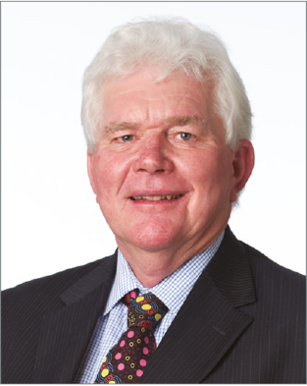 | Mr Mark Mowbray  MEdPol (Intl)  Non-Executive Director  Mr Mark Mowbray was appointed to the AITSL Board on 17 June 2018.  Mr Mowbray recently retired from the teaching profession after forty-two years of teaching, thirty of which he spent in the role of school principal on the Mid North Coast of New South Wales. Mr Mowbray is proud of spending his entire career within schools and their communities.  He also became involved in principal associations, initially in the Maitland/Newcastle Diocese. At state level, Mr Mowbray was the Primary Chair of the Association of Catholic School Principals NSW as well as a commissioner on the Catholic Education Commission. He is the immediate past president of the Australian Catholic Primary Principals Association and was also proud to sit on the Board and National Advisory Council of the Australian Primary Principals Association.  Mr Mowbray is honoured to be a member of AITSL's Board. He brings the lessons and experience of his career and a passion for the role of education within society. He has particular interest in the areas of equity, leadership, and ‘what works’ in education. His most recent study was a Master of Education Policy (International) through Melbourne University.

 | Mr Robert Nairn  BEdDipTeach CF MAICD  Non-Executive Director  Mr Robert Nairn was appointed to the AITSL Board on 1 January 2015, and reappointed on 2 June 2018, with his term expiring on 17 June 2020.  Mr Nairn is Associate Professor at Edith Cowan University, a Churchill Fellow, a Member of the Australian Institute of Company Directors, a Member of the Beyond Blue National Education Initiative Advisory Council, a mentor with Fogarty EDvance Program, and Lead Fellow for Schools Plus teaching fellowship program.  Previously, he was the Executive Director of the Australian Secondary Principal’s Association, Director at Principals Australia Institute, and Executive Member of the International Confederation of Principals. He was also Director of the Asia Education Foundation Advisory Board and a member of The Smith Family Principals Advisory Group.  Mr Nairn has worked in metropolitan and regional senior high schools in Western Australia, particularly in low socioeconomic areas. He is passionate about shaping the direction of educational reform and ensuring every school has a leader providing high-quality education to all young people, regardless of their geographic, social, or personal circumstances.  Mr Nairn was awarded a Churchill Fellowship in 2017 to undertake his research into Leadership Preparation programs.

 | Professor Donna Pendergast  BAppSci GradDipTeach MEd PhD  Non-Executive Director  Professor Donna Pendergast was appointed to the AITSL Board on 17 June 2018.  As Dean and Head, School of Education and Professional Studies at Griffith University, Professor Pendergast is a passionate educator and researcher with a global profile. She leads a dynamic school of teacher and professional educators committed to preparing the next generation of teachers and related professionals through agile and socially just educational practices. She has worked in P-10, secondary schools and colleges as a classroom teacher and administrator.  Professor Pendergast has conducted national research projects of significance and published extensively, including several books of relevance to contemporary teacher work. Her passion lies in school reform and professional learning, working closely with governments in these fields to shape policy and implement practice in settings around Australia. She initiated the Professional Learning Hub at Griffith University, providing a gateway to enable highly efficacious professional learning to thrive and improved student learning.  Professor Pendergast has presented more than 75 invitational international keynote addresses in many countries around the world. She has delivered learning programs in Singapore, Hong Kong, and Japan, and to Saudi Arabian teachers undertaking immersion programs in Australia.  In 2015, Professor Pendergast received the Griffith University Vice Chancellor’s Excellence in Research Supervision Award, and in 2017, a National Commendation from the Australian Council of Graduate Research for Excellence in Graduate Research Supervision. In 2018, she was awarded the Australian Council for Educational Leadership Miller-Grassie Award for Outstanding Leadership in Education.

Company Secretary’s qualifications and experience
For the qualifications of the Company Secretary please refer to page 17.

Board of Directors’ membership
AITSL is governed by an independent expert Board of Directors appointed by the Minister for Education.

Board members as at 30 June 2020
- Laureate Professor John Hattie, Chair/Non-Executive Director
- Mr Christopher Wardlaw PSM, Deputy Chair/Non-Executive Director
- Dr Jennifer Buckingham, Non-Executive Director
- Mr Mark Mowbray, Non-Executive Director
- Professor Donna Pendergast, Non-Executive Director
- Ms Beth Blackwood, Non-Executive Director
AITSL’s organisational structure and AITSL Board committees are reported on page 59.

Board of Directors’ meetings
Director | Board |  | Audit and Risk Committee |  | Finance Committee
Director | Number eligible to attend | Number attended | Number eligible to attend | Number attended | Number eligible to attend | Number attended
Laureate Professor Hattie | 5 | 5 | 0 | 0 | 5 | 4
Mr Wardlaw | 5 | 5 | 5 | 5 | 5 | 5
Ms Blackwood | 5 | 4 | 0 | 0 | 0 | 0
Dr Buckingham | 5 | 5 | 0 | 0 | 5 | 5
Mr Cook (resigned 21 January 2020) | 2 | 1 | 0 | 0 | 2 | 1
Ms Gordon (resigned 22 January 2020) | 2 | 2 | 0 | 0 | 0 | 0
Ms Lammon | 4 | 4 | 0 | 0 | 0 | 0
Dr Lind | 4 | 2 | 0 | 0 | 5 | 3
Mr Mowbray | 5 | 5 | 5 | 5 | 0 | 0
Mr Nairn | 4 | 4 | 5 | 5 | 0 | 0
Professor Pendergast | 5 | 5 | 0 | 0 | 0 | 0
Ms Lammon, Dr Lind, and Mr Nairn also attended the June 2020 Board meeting; however, as their terms of appointment expired before the meeting, they attended as expert advisors and did not have voting rights.
Mrs Jennifer Morison attends the Audit and Risk Committee as an independent external member. Mrs Morison attended five of the five meetings held in 2019–20.
Mr Stephen Elder attends the Finance Committee as an independent external member. Mr Elder attended three of the five meetings held in 2019–20.

Principal activities
The principal activities of AITSL during 2019–20 year were to play a lead role in national work on teacher quality and in promoting excellence in teaching and school leadership for the Commonwealth, state, and territory governments. AITSL does this by leading significant educational reforms to improve the quality of teaching and leadership and to strengthen the professionalism of teaching.

Operating result
The operating result for the year was a deficit of $1,775,106. The statement of comprehensive income on page 41 of the company’s Financial Report provides further information on the operating result.

Significant activities
During 2019–20, there were two resignations and three cessations on the AITSL Board.
The Business Continuity Plan was activated due to COVID-19. Staff transitioned to remote working from March 2020, and there were no redundancies due to COVID-19.
The AITSL Constitution and the Funding Agreement were amended by the DESE.

Board appointments, cessations, resignations, and re-appointments
The following movements on the AITSL Board occurred during 2019–20:
- Ms Alex Gordon (resigned 22 January 2020)
- Mr Tony Cook (resigned 21 January 2020)
- Dr Peter Lind (ceased 17 June 2020)
- Ms Renez Lammon (ceased 17 June 2020)
- Mr Rob Nairn (ceased 17 June 2020).

Auditor’s independence declaration
A copy of the auditor’s independence declaration as required by Division 60 of the Australian Charities and Not-for-profits Commission Act 2012 and section 307C of the Corporations Act 2001 is set out on page 37 of the Financial Report and forms a part of the Directors’ Report for the financial year ended 30 June 2020.

Indemnification and insurance of Directors and Officers
During the year, the company paid insurance premiums to Comcover to indemnify its Directors and Officers for the professional risks associated with their responsibilities and role as director or officer.

Events subsequent to the end of the financial year
No matters or circumstances have arisen since the end of the financial year that significantly affected, or may significantly affect, the operations of the company and the results of those operations.
Signed in accordance with a resolution of the AITSL Board.

Laureate Professor John Hattie
Chair
25 August 2020

Financial Report
For the year ended 30 June 2020
Directors' Declaration 36
Auditor's Independence Declaration 37
Auditor's Report 38
Statement of Comprehensive Income 41
Statement of Financial Position 42
Statement of Changes in Equity 43
Statement of Cash Flows 44
Notes to the financial statements:
Note 1: Objective of the entity 45
Note 2: Basis of preparation 45
Note 3: Significant accounting policies 46
Note 4: Non-current assets 49
Note 5: Fair value measurements 51
Note 6: Provisions 51
Note 7: Cash flow reconciliation 53
Note 8: Key management personnel remuneration 53
Note 9: Related party disclosure 54
Note 10: Financial instruments 54
Note 11: Commitments 56
Note 12: Explanations of major budget variances 56
Note 13: Member's guarantee 58
Note 14: Entity details 58

Directors’ Declaration
For the year ended 30 June 2020
The Directors of the Australian Institute for Teaching and School Leadership Limited declare that:
- The financial statements and accompanying notes, are in accordance with the Australian Charities and Not-for-profits Commission Act 2012 and the Corporations Act 2001 including:
- Giving a true and fair view of the company’s financial position as at 30 June 2020 and of its performance for the year ended on that date.
- Complying with the Australian Accounting Standards - Reduced Disclosure Requirements (including the Australian Accounting Interpretations), the Corporations Regulations 2001 and the Australian Charities and Not-for-profits Commission Regulation 2013; and
- There are reasonable grounds to believe that the company will be able to pay its debts as and when they become due and payable.
This declaration is made on 25 August 2020 in accordance with a resolution of the directors.

 |  | 
Laureate Professor John Hattie  Chair |  | Chris Wardlaw PSM  Deputy Chair

Auditor’s Independence Declaration

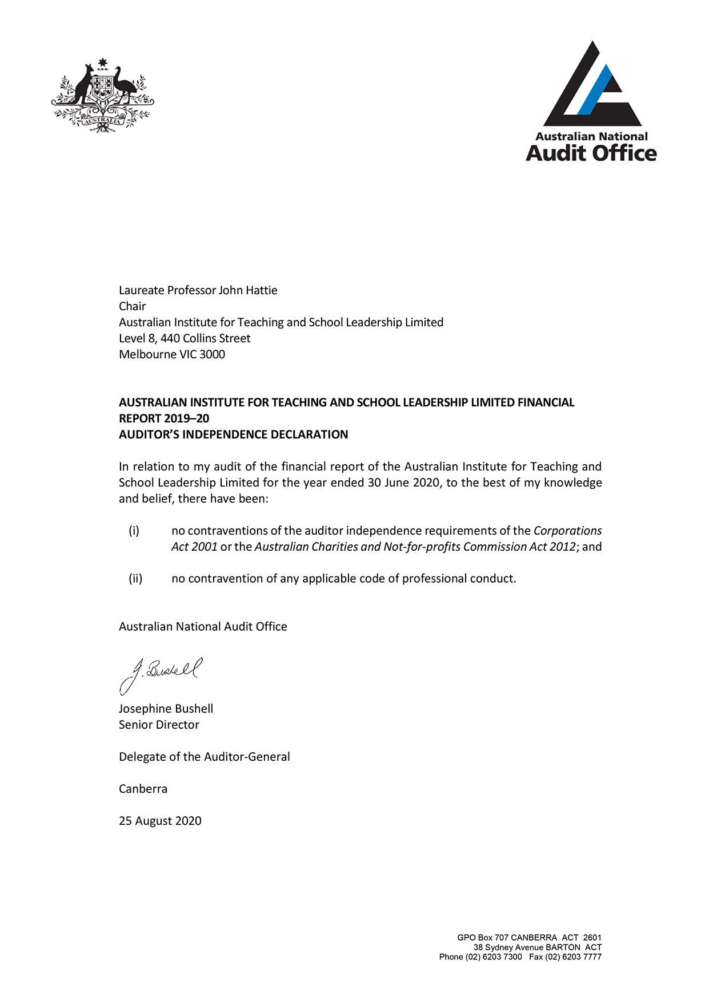

Auditor’s Report
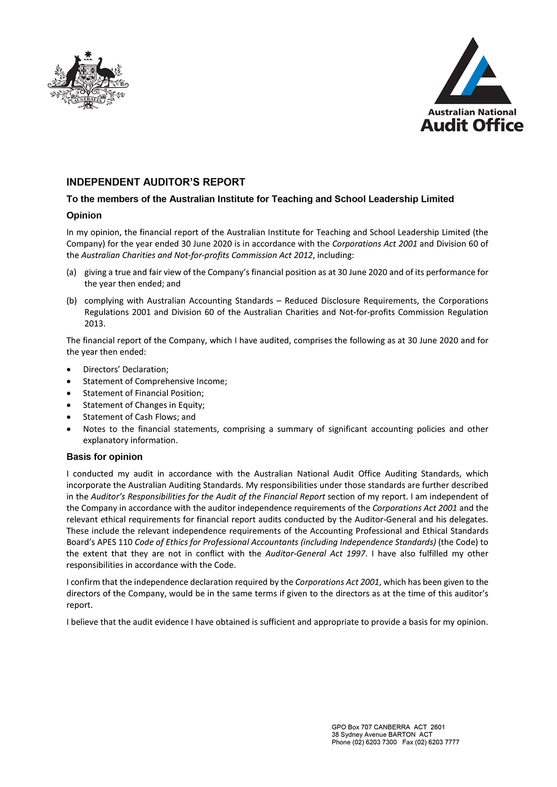
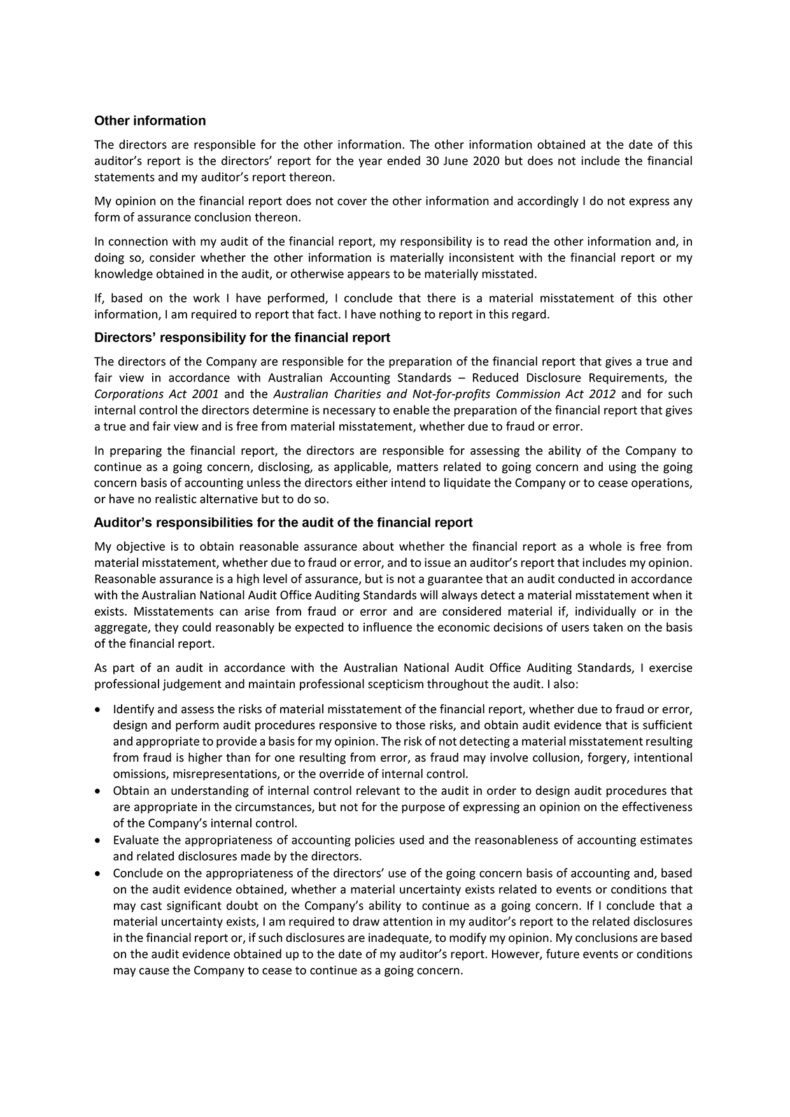

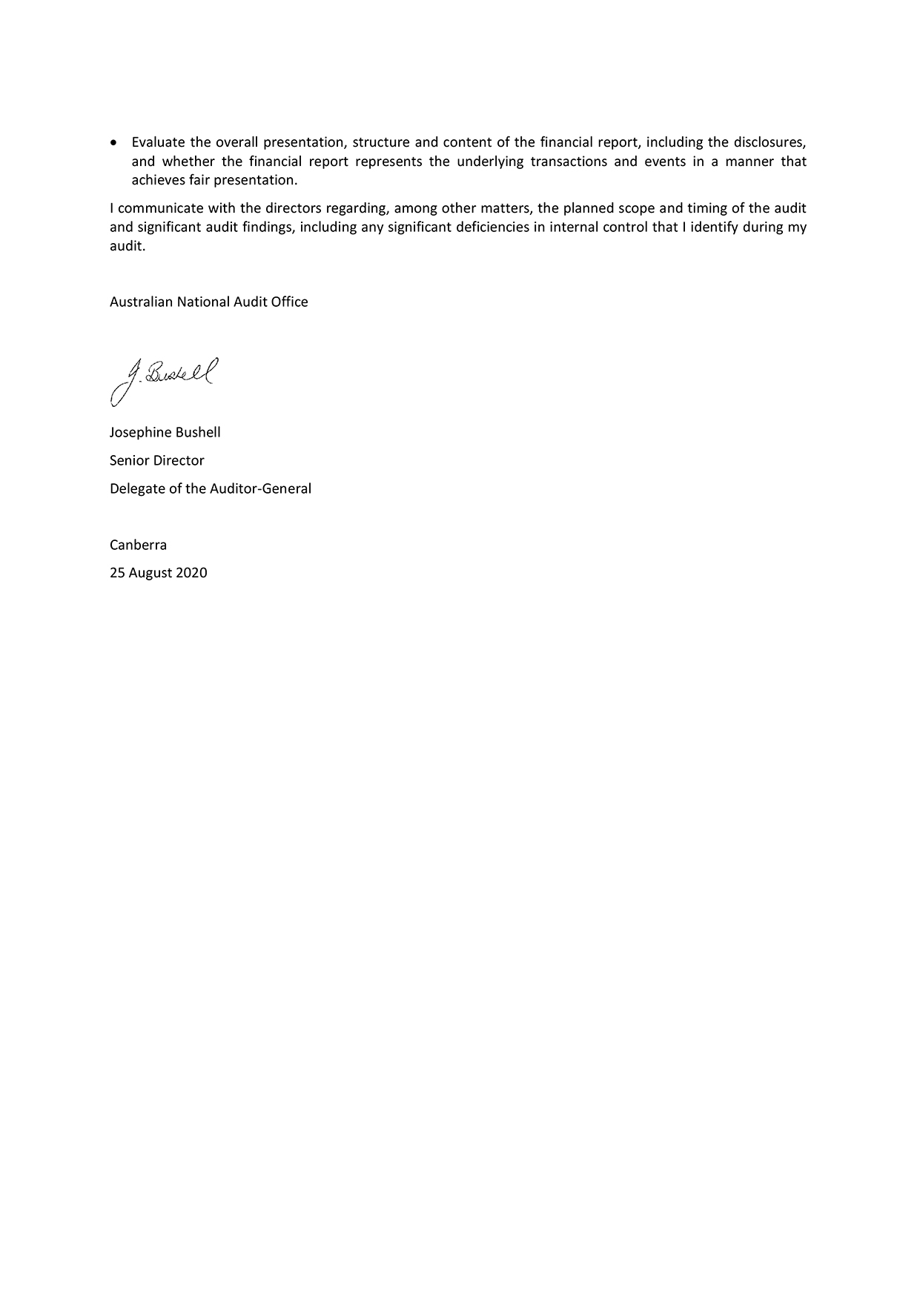

Statement of Comprehensive Income
For the year ended 30 June 2020
 | Notes | 2020  $ | 2019  $ | Original Budget  $
Income
Government funding |  | 13,644,000 | 17,747,000 | 13,644,000
Sales of services |  | 6,283,458 | 2,834,584 | 2,476,000
Interest |  | 182,619 | 102,662 | 230,000
Other revenue |  | - | 55,546 | -
Surplus (loss) on disposal of assets |  | 58 | (4,395) | -
Total Income |  | 20,110,135 | 20,735,397 | 16,350,000
Expenses
Board of Directors |  | 479,299 | 446,930 | 699,000
Employee benefits |  | 10,941,152 | 8,675,646 | 10,215,000
Administration |  | 2,842,681 | 2,653,212 | 3,536,000
Programs |  | 6,582,375 | 4,738,237 | 3,566,000
Depreciation and amortisation | 4 | 1,039,734 | 220,779 | 308,000
Total Expenses |  | 21,885,241 | 16,734,804 | 18,324,000
(Deficit)/Surplus from ordinary activities |  | (1,775,106) | 4,000,593 | (1,974,000)
Total comprehensive (loss)/income for the year |  | (1,775,106) | 4,000,593 | (1,974,000)
The original budget was reported in the 2019–20 Portfolio Budget Statements published in April 2019.
This statement should be read in conjunction with the accompanying notes.
Budget variance commentary
Budget variance explanations are outlined in Note 12.

Statement of Financial Position
As at 30 June 2020
 | Notes | 2020  $ | 2019  $ | Original Budget  $
Assets
Current
Cash and cash equivalents | 7 | 7,570,263 | 6,377,094 | 3,744,000
Financial assets at amortised cost |  | 2,442,951 | 4,478,155 | 6,000,000
Trade and other receivables |  | 569,781 | 206,262 | 152,000
Other assets |  | 77,756 | 141,293 | -
Current assets |  | 10,660,751 | 11,202,804 | 9,896,000
Non-current
Property, furniture and equipment | 3.2 & 4 | 3,525,208 | 967,383 | 763,000
Non-current assets |  | 3,525,208 | 967,383 | 763,000
Total Assets |  | 14,185,959 | 12,170,187 | 10,659,000
Liabilities
Current
Supplier and other payables |  | 1,341,306 | 717,531 | 1,045,000
Employee provisions | 6 | 998,947 | 630,194 | 727,000
Lease liability | 3.2 | 646,704 | - | -
Unearned income | 3.1 | 215,000 | - | -
Current liabilities |  | 3,201,957 | 1,347,725 | 1,772,000
Non-current
Employee provisions | 6 | 126,095 | 154,109 | 196,000
Other provisions | 6 | 361,892 | 367,760 | 344,000
Lease liability | 3.2 | 2,038,744 | -
Non-current liabilities |  | 2,526,731 | 521,869 | 540,000
Total Liabilities |  | 5,728,688 | 1,869,594 | 2,312,000
Net Assets |  | 8,457,271 | 10,300,593 | 8,347,000
Equity
Retained surplus |  | 8,457,271 | 10,300,593 | 8,347,000
Total Equity |  | 8,457,271 | 10,300,593 | 8,347,000
The original budget was reported in the 2019–20 Portfolio Budget Statements published in April 2019.
This statement should be read in conjunction with the accompanying notes.
Budget variance commentary
Budget variance explanations are outlined in Note 12.

Statement of Changes in Equity
For the year ended 30 June 2020
 | Retained earnings |  | Total equity |  | Original Budget
 | 2020  $ | 2019  $ | 2020  $ | 2019  $ | $
Opening Balance at 1 July | 10,300,593 | 6,300,000 | 10,300,593 | 6,300,000 | 10,322,000
Effect of the change in
accounting policies for the initial application of:
- AASB 15 | (122,400) | - | (122,400) | - | -
- AASB 16 | 54,184 | - | 54,184 | - | -
Balance at 1 July restated | 10,232,377 | 6,300,000 | 10,232,377 | 6,300,000 | 10,322,000
Comprehensive Income  (Deficit)/Surplus for the year | (1,775,106) | 4,000,593 | (1,775,106) | 4,000,593 | (1,974,000)
Total Comprehensive Income/(Loss) for the year | (1,775,106) | 4,000,593 | (1,775,106) | 4,000,593 | (1,974,000)
Balance at 30 June | 8,457,271 | 10,300,593 | 8,457,271 | 10,300,593 | 8,348,000
The original budget was reported in the 2019–20 Portfolio Budget Statements published in April 2019.
This statement should be read in conjunction with the accompanying notes.
Budget variance commentary
Budget variance explanations are outlined in Note 12.

Statement of Cash Flows
For the year ended 30 June 2020
 | Notes | 2020  $ | 2019  $ | Original Budget  $
Operating Activities
Cash received
Government funding |  | 13,644,000 | 17,747,000 | 13,644,000
Sales of services |  | 6,349,253 | 2,991,214 | 2,612,000
Interest |  | 182,619 | 102,662 | 230,000
Other |  | 375 | 60,963 | -
Total cash received |  | 20,176,247 | 20,901,839 | 16,486,000
Cash used
Board of Directors |  | (479,299) | (446,930) | (699,000)
Employees |  | (10,596,416) | (8,609,322) | (9,993,000)
Suppliers |  | (9,648,338) | (8,216,321) | (7,857,000)
Net GST paid to the Australian Taxation Office |  | 631,675 | 300,210 | 594,000
Total cash used |  | (20,092,378) | (16,972,363) | (17,955,000)
Net cash provided by operating activities | 7 | 83,869 | 3,929,476 | (1,469,000)
Investing Activities
Cash provided by/(used in)
Purchase of furniture and equipment |  | (270,990) | (390,486) | (150,000)
Disposal of furniture and equipment |  | - | 1,375 | -
Sale (Purchase) of financial assets |  | 2,035,207 | (3,141,774) | 1,987,000
Net cash used in investing activities |  | 1,764,217 | (3,530,885) | 1,837,000
Financing Activities
Cash provided by/(used in)
Repayment of lease liabilities |  | (654,917) | - | -
Net cash used in financing activities |  | (654,917) | - | -
Net increase in cash held |  | 1,193,169 | 398,591 | 368,000
Cash at the beginning of the financial year |  | 6,377,094 | 5,978,503 | 3,376,000
Cash at the end of the financial year | 7 | 7,570,263 | 6,377,094 | 3,744,000
The original budget was reported in the 2019–20 Portfolio Budget Statements published in April 2019.
This statement should be read in conjunction with the accompanying notes.
Budget variance commentary
Budget variance explanations are outlined in Note 12.

Notes to the Financial Statements
For the year ended 30 June 2020

Note 1. Objective of the entity
The objective of the Australian Institute for Teaching and School Leadership (AITSL) is to provide national leadership for the Commonwealth, state and territory governments in promoting excellence in the profession of teaching and school leadership.

Note 2. Basis of preparation

2.1 Statement of compliance
The financial statements are a general purpose financial report prepared in accordance with Australian Accounting Standards Reduced Disclosure Requirements (including the Australian Accounting Interpretations) adopted by the Australian Accounting Standards Board (AASB) that apply for the reporting period, the Australian Charities and Not-for-profit Commission Act 2012 and the Corporations Act 2001.
AITSL has adopted all of the new or amended Accounting Standards and Interpretations issued by the AASB that are mandatory for the current reporting period. These have not had a material impact on the financial statements. New or amended Accounting Standards or Interpretations that are not yet mandatory have not been early adopted.
The financial statements have been prepared on an accrual basis and are in accordance with historical cost convention, except for certain assets, which as noted, are valued at fair value. The financial statements are presented in Australian dollars.
The financial report was approved and authorised for issue by the Board of Directors on 25 August 2020.

2.2 Economic dependency
AITSL is dependent on the Department of Education, Skills and Employment (DESE) for the majority of the revenue used to carry out its ordinary activities. At the date of this report the Board of Directors has no reason to believe that DESE will not continue to support AITSL.

2.3 Use of estimates and judgments
The preparation of financial statements in conformity with Australian Accounting Standards required management to make judgments, estimates and assumptions that affect the application of accounting policies and the reported amounts of assets, liabilities, income and expenses. Actual results may differ from these assumptions.
Estimates and underlying assumptions are reviewed on an ongoing basis. Revisions to accounting estimates are recognised in the period in which estimates are revised and in any future period affected.
No estimate or judgment has made a significant impact on the amounts recorded in the financial statements. No accounting assumptions or estimates have been identified that have a significant risk of causing a material adjustment to the carrying amount of assets and liabilities in the next reporting period.

Note 3. Significant accounting policies

3.1 Revenue

New account standard
AITSL has adopted the new accounting standards AASB 15 Revenue from Contracts with Customers and AASB 1058 Income of Not-for-Profit Entities effective 1 July 2019.
AASB 15 establishes a comprehensive framework for determining whether, how much and when revenue is recognised. It replaces existing revenue recognition guidance including AASB 118 Revenue, AASB 111 Construction Contracts and Interpretation 13 Customer Loyalty Programmes. The core principle of AASB 15 is that an entity recognises revenue to depict the transfer of promised goods and services to customers in an amount that reflects the consideration to which the entity expects to be entitled in exchange for those goods or services.
AASB 1058 is relevant in circumstances where AASB 15 does not apply. AASB 1058 replaces most of the not-for-profit (NFP) provisions of AASB 1004 Contributions.
AITSL adopted AASB 15 and AASB 1058 using the modified retrospective approach, under which the cumulative effect of initial application is recognised in retained earnings at 1 July 2019. Accordingly, the comparative information presented for 2019 is not restated. That is, it is presented as previously reported under the various applicable AASBs and related interpretations.
Under the new income recognition model AITSL shall first determine whether an enforceable agreement exists and whether the promises to transfer goods or services are sufficiently specific. If an enforceable agreement exists and the promises are sufficiently specific (to a transaction or part of a transaction), AITSL applies AASB 15 to determine the appropriate revenue recognition. If these criteria are not met, AITSL shall consider whether AASB 1058 applies.
In relation to AASB 15, AITSL elected to apply the new standard to all new and uncompleted contracts from the date of initial application. AITSL is required to aggregate the effect of all of the contract modifications that occur before the date of initial application.
Application of the new accounting standards to AITSL revenue sources is as follows:

Australian Government
Provisions of the grant agreement do not meet the criteria required by AASB 15. Revenue is therefore recognised in accordance with AASB 1058. The full amount of funding received during the period is recognised as revenue.

Education Council
Provisions of the funding agreement do not meet the criteria required by AASB 15. Revenue is therefore recognised in accordance with AASB 1058. The full amount of funding received during the period is recognised as revenue.

Non-government income
Services provided to non-government customers are subject to commercial terms and in accordance with an agreement with the customer. The agreements meet the criteria required by AASB 15. Income is recognised progressively as services are provided. Income received in advance of the service being provided is included as a liability in the Statement of Financial Position.
Set out below are the amounts by which each financial statement line item is affected for the year ended 30 June 2020 as a result of the adoption of AASB 15 and AASB 1058.The first column shows the amounts prepared under AASB 15 and AASB 1058 and the second column shows what the amounts would have been had AASB 15 and AASB 1058 not been adopted.
 | AASB 15/1058  $ | Previous AAS  $ | Increase/(decrease)  $
Income
Sales of services | 6,283,458 | 6,376,058 | (92,600)
Current liabilities
Unearned income | 215,000 | - | 215,000
Equity
Retained earnings | 8,457,271 | 8,579,671 | (122,400)
Impact on transition
On transition to AASB 15 and AASB 1058 AITSL has recognised an additional liability for unearned income that existed in the opening financial report at 1 July 2019. This has been adjusted against the opening retained earnings at 1 July 2019. The impact on transition is summarised below.
Increase/(decrease)
$
Equity – opening balance adjustment for AASB 15 | (122,400)
Liability – unearned income at 30 June 2019 | 122,400

Interest revenue
Interest revenue is recognised on an accrual basis using the effective interest method.

3.2 Leases

New accounting standard
AITSL has adopted the new accounting standard, AASB 16 Leases effective 1 July 2019.
AASB 16 Leases replaces AASB 117 Leases along with Interpretation 4 Determining whether an Arrangement contains a Lease, Interpretation 115 Operating Leases – Incentives and Interpretation 117 Evaluating the Substance of Transactions Involving the Legal Form of a Lease.
AITSL has only one lease, which is for the office premises it occupies in Melbourne. The adoption of this new standard has resulted in the recognition of a right-of-use asset and related lease liability for the lease of the office premises, which had previously been classified as an operating lease.
The new standard has been applied using the modified retrospective approach, with the cumulative effect of adopting AASB 16 being recognised in the equity as an adjustment to the opening balance of retained earnings for the current period. Prior periods have not been restated.
AITSL has elected not to include indirect costs in the measurement of the right-of-use asset for the operating lease in existence at the date of initial application being 1 July 2019. At this date, AITSL has also elected to measure the right-of-use asset at an amount equal to the lease liability adjusted for any prepaid or accrued lease payments that existed at the date of transition.
Instead of performing an impairment review on the right-of-use asset at the date of initial application, AITSL has relied on its historic assessment as to whether the lease was onerous immediately before the date of initial application of AASB 16.
On transition to AASB 16 the weighted average incremental borrowing rate applied to the lease liability recognised under AASB 16 was 1.85%.

The lease liability recognised at 1 July 2019 is reconciled to the lease commitments disclosed in the financial report at 30 June 2019 as follows:
 | $
Commitment - operating leases at 30 June 2019 | 3,348,813
Less: effect of discounting using the incremental borrowing rate at the date  of the initial application | 57,295
Lease liability adjustment at 1 July 2019 | 3,291,518

Impact on transition
On transition to AASB 16, AITSL has recognised an additional right-of-use asset and an additional lease liability with the difference adjusted to retained earnings. The impact on the opening financial figures at 1 July 2019 is summarised below:
Increase/(decrease)
$
Building – right-of-use asset | 3,345,702
Lease liability | 3,291,518
Equity – opening balance adjustment | 54,184

3.3 Impairment
At each reporting date AITSL reviews the carrying value of its tangible and intangible assets to determine whether there is any indication that those assets have been impaired. If such an indication exists, the recoverable amount of the asset, being the higher of the asset's fair value less costs to sell and value in use, is compared to the asset's carrying value. Any excess of the asset's carrying value over its recoverable amount is expensed to the Statement of Comprehensive Income.

3.4 Taxation
AITSL is exempt from all forms of taxation except Fringe Benefits Tax (FBT) and the Goods and Services Tax (GST).
Revenues, expenses, assets and liabilities are recognised net of GST except:
- where the amount of GST incurred is not recoverable from the Australian Tax Office
- for receivables and payables.

Note 4. Non-current assets
Reconciliation of opening and closing balances (2019–20)
Property, furniture and equipment
 | Building Right-of-use asset  $ | Equipment  $ | Furniture  & fittings  $ | Software  $ | Makegood  $ | Cultural  $ | Total  $
As at 1 July 2019
Gross book value | - | 755,281 | 960,638 | 177,000 | 299,353 | 12,000 | 2,204,272
Accumulated depreciation/ amortisation | - | (453,911) | (571,635) | (24,247) | (187,096) | - | (1,236,889)
Net book value 1 July 2019 | - | 301,370 | 389,003 | 152,753 | 112,257 | 12,000 | 967,383
Recognition of a right-of-use asset on the application of AASB 16 | 3,345,702 | - | - | - | - | - | 3,345,702
Adjusted total at 1 July 2019 | 3,345,702 | 301,370 | 389,003 | 152,753 | 112,257 | 12,000 | 4,313,085
Movements

Purchase of assets | - | 201,632 | 69,358 | - | - | - | 270,990
Assets at depreciated value written off or sold | - | (316) | - | - | - | - | (316)
Present value adjustment | - | - | - | - | (18,817) | - | (18,817)
Depreciation and amortisation expense | (692,214) | (169,089) | (103,138) | (59,000) | (16,293) | - | (1,039,734)
Net book value 30 June 2020 | 2,653,488 | 333,597 | 355,223 | 93,753 | 77,147 | 12,000 | 3,525,208
Net book value as of 30 June 2020 represented by:
Gross book value | 3,345,702 | 954,857 | 1,029,996 | 177,000 | 280,536 | 12,000 | 5,800,091
Accumulated depreciation | (692,214) | (621,260) | (674,773) | (83,247) | (203,389) | - | (2,274,883)
Closing net book value | 2,653,488 | 333,597 | 355,223 | 93,753 | 77,147 | 12,000 | 3,525,208

Accounting policy

Property, furniture and equipment

Capitalisation threshold
Purchases of fixtures, fittings and equipment are recognised in the Statement of Financial Position, except for purchases costing less than $1,000, which are expensed in the year of acquisition, other than where they form part of a group of similar items which are significant in total.

Carrying amount
Fixtures, fittings and equipment are carried at cost less, where applicable, accumulated depreciation and impairment losses. Cultural artwork is carried at fair value.
AITSL holds a lease agreement to occupy premises at 440 Collins Street, Melbourne. The application of accounting standard AASB 16 has resulted in the premises being accounted for as a right-of-use asset. The asset is depreciated over the term of the lease.
The lease agreement contains a clause to make good on the company vacating the premises. These costs include the costs of dismantling and removing an asset and restoring the site on which the asset was created.
Revaluation adjustments are made on a class basis. Any revaluation increment is credited to equity under the heading reserves except to the extent that it reverses a previous revaluation decrement of the same asset class that was previously recognised through surplus and deficit. Revaluation decrements for a class of assets are recognised directly through other comprehensive income except to the extent that they reverse a previous revaluation increment for that class.
Any accumulated depreciation as at the revaluation date is eliminated against the gross carrying amount of the asset and the asset restated to the revalued amount.

Depreciation
The depreciable amount of all fixed assets is depreciated on a straight line basis over the asset's useful life to AITSL commencing from the time the asset is held ready for use. The depreciation rates used for each class of asset are based on the following estimated useful lives for current and comparative periods:

Building – right-of-use asset – 6 years

Fixtures, fittings and equipment
- Computer and office equipment – 3 years
- Furniture and fittings – 10 years
Depreciation methods, useful lives, and residual values are reviewed at each financial year end and adjusted if appropriate.

Cultural
Artworks – Infinite life (2019: Infinite life)
AITSL has two paintings (2019: 2) with an aggregate fair value of $12,000 (2019: $12,000) painted by Australian artists Bessie Sims and Yumutjin Wununmurra. AITSL has classified them as cultural assets as they are primarily held for purposes that relate to their cultural significance. The paintings are deemed to have indefinite useful lives and hence are not depreciated. AITSL is responsible for ensuring the preservation of these assets.

Note 5. Fair value measurements
 | Category | Fair value measurements at the end of the reporting period
 | Category | 2020  $ | 2019  $
Non-financial assets
Cultural | Level 2 | 12,000 | 12,000
Total non-financial assets |  | 12,000 | 12,000
Total fair value measurement of assets in the statement of financial position |  | 12,000 | 12,000
AITSL does not hold any non-financial liabilities.
No assets or liabilities have been transferred between value levels during the year.
The observable inputs used in the fair value measurement of cultural assets are independent valuations dated 26 June 2015, based on recent sales value.

Note 6. Provisions
 | 2020  $ | 2019  $
Employee
Annual leave | 639,794 | 414,453
Long service leave | 485,248 | 369,850
Total employee provisions | 1,125,042 | 784,303
Employee provisions expected to be settled in:
No more than 12 months | 998,947 | 630,194
More than 12 months | 126,095 | 154,109
Total employee provisions | 1,125,042 | 784,303
Other
Provision for make good | 361,892 | 367,760
Total other provisions | 361,892 | 367,760

AITSL currently has an agreement for the leasing of premises at 440 Collins Street, Melbourne. The lease has a clause requiring AITSL to restore the premises to its original condition at the conclusion of the lease.
A provision has been made to reflect the present value of this obligation which is expected to be settled in more than 12 months.
 | Make good
 | 2020  $ | 2019  $
Movements in the other provisions
Opening balance | 367,760 | 344,346
Borrowing cost adjustment | 12,948 | 12,478
Present value adjustment | (18,816) | 10,936
Amortisation of provision | - | -
Balance at 30 June | 361,892 | 367,760

Accounting Policy

Provisions
A provision is recognised if, as a result of a past event, AITSL has a present legal or constructive obligation that can be estimated reliably, and it is probable that an outflow of economic benefits will be required to settle the obligation. Provisions are determined by discounting the expected future cash flows at a rate that reflects current market assessments of the time value of money and the risks specific to the liability. The unwinding of the discount is recognised as a finance cost.

Employee provisions and benefits
Provision is made for benefits accruing to employees in respect of wages and salaries, annual leave and long service leave for services rendered to the reporting date. Provision for ‘short-term employee benefits’ (as defined in AASB 119 Employee Benefits) and termination benefits due within twelve months of the end of reporting period are measured at their nominal amounts.

Leave
The liability for employee benefits includes provision for annual leave and long service leave. No provision has been made for personal or carer leave as all personal and carer leave is non-vesting and the average personal and carer leave taken in future years by employees of the entity is estimated to be less than the annual entitlement.
Long service leave liabilities that are not expected to be settled within 12 months are recognised in the provision for employee benefits as non-current liabilities and are measured at present value of the amounts expected to be paid when the liabilities are settled using the remuneration rate expected to apply at the time of settlement.

Superannuation
Contributions are made by AITSL to employee superannuation funds and are charged as expenses when incurred. AITSL makes contributions to the funds in accordance with the superannuation guarantee legislation.

Note 7. Cash flow reconciliation
 | 2020  $ | 2019  $
Reconciliation of cash per income statement
to statement of cash flows
Cash at year end as per statement of cash flows | 7,570,263 | 6,377,094
Statement of financial position items comprising cash | 7,570,263 | 6,377,094
Difference | - | -
Reconciliation of operating result to net cash
from operating activities
Surplus/(Deficit) for the year | (1,775,106) | 4,000,593
Depreciation and amortisation | 1,039,734 | 220,779
Lease interest | 48,847 | -
Net write-down and sale of non-financial assets | 316 | 5,770
Present value adjustment | 18,817 | (10,936)
Change in assets and liabilities
Decrease (increase) in receivables | (363,518) | (103,627)
Decrease (increase) in other assets | 63,541 | (47,493)
Increase (decrease) in supplier payables | 716,367 | (225,348)
Increase (decrease) in other provisions | (5,868) | 23,414
Increase (decrease) in employee provisions | 340,739 | 66,324
Net cash from operating activities | 83,869 | 3,929,476

Note 8. Key management personnel remuneration
Key management personnel are those persons having authority and responsibility for planning, directing and controlling the activities of AITSL, directly or indirectly, including any Directors of AITSL
Short-term employment benefits | 1,539,574 |  | 1,193,548
Post-employment benefits | 118,350 |  | 89,679
Other long-term benefits | 22,537 |  | 9,947
 | 1,680,461 |  | 1,293,174
The number of key management personnel that are included in the above are four Executive Managers
and nine part-time Directors (2019: five Executive Managers and nine part-time Directors).

Note 9. Related party disclosure
Related parties to AITSL are key management personnel including directors.
Certain directors and key management personnel of AITSL hold positions in other entities that result in them having significant influence over the financial or operating policies of those entities.
A number of those entities transacted with AITSL through the financial year. These transactions may be significant due to the nature of the industry in which AITSL operates and the broad industry representation of the persons nominated to the Board of Directors and employed as key management personnel. All of these transactions are carried out in compliance with the terms of the Procurement Policy and Conflict of Interest Policy approved by the Board of Directors and on terms and conditions that were no more favourable than those available, or which might reasonably be expected to be available, on similar transactions to non-related entities.
The aggregate value of transactions and outstanding balances, including commitments, relating to entities over which related parties have significant influence were as follows:
 | 2020  $ | 2019  $
Purchase of goods and services
Transaction value as at 30 June | 234,553 | 110,209
Balance outstanding as at 30 June | 23,210 | -

Note 10. Financial instruments
 | 2020  $ | 2019  $
Categories of financial instruments
Financial assets
Loans and receivables
- Cash at bank | 7,570,263 | 6,377,094
- Trade and other receivables | 569,781 | 206,262
Financial assets at amortised cost | 2,442,951 | 4,478,155
Carrying amount of financial assets | 10,582,995 | 11,061,511
Financial liabilities
Financial liabilities
- Trade creditors | 1,182,747 | 648,837
- Lease liability | 2,685,448 | -
Carrying amount of financial liabilities | 3,868,195 | 648,837
Financial assets and liabilities are measured at amortised cost.
Net income and expense from financial assets
Loans and receivables
- Interest revenue | 182,619 | 102,662
Net income from financial assets | 182,619 | 102,662
Net income and expense from financial liabilities
Lease liability
- Interest expense | 48,847 | -
Net expense from financial liabilities | 48,847 | -

Recognition, initial measurement and derecognition
Financial assets and financial liabilities are recognised when AITSL becomes a party to the contractual provisions of the financial instrument, and are measured initially at fair value adjusted by transaction costs, except for those carried at fair value through profit or loss, which are measured initially at fair value. Subsequent measurement of financial assets and financial liabilities are described below.
Financial assets are derecognised when the contractual rights to the cash flows from the financial asset expire, or when the financial asset and all substantial risks and rewards are transferred. A financial liability is derecognised when it is extinguished, discharged, cancelled or expires.

Classification and subsequent measurement of financial assets
Except for those trade receivables that do not contain a significant financing component and are measured at the transaction price, all financial assets are initially measured at fair value adjusted for transaction costs (where applicable).
For the purpose of subsequent measurement, financial assets other than those designated and effective as hedging instruments are classified into the following categories upon initial recognition:
- amortised cost
- fair value through profit or loss (FVPL)
- equity instruments at fair value through other comprehensive income (FVOCI).

Classification and measurement of financial liabilities
The financial liabilities include trade and other payables.
Financial liabilities are initially measured at fair value and, where applicable, adjusted for transaction costs unless the liability is designated a financial liability at fair value through the profit or loss. Subsequently, financial liabilities are measured at amortised cost using the effective interest method.

Financial assets at amortised cost
Financial assets are measured at amortised cost if the assets meet the following conditions (and are not designated FVPL):
- They are held within a business model which has the objective to hold the financial assets and collect its contractual cash flows.
- The contractual terms of the financial assets give rise to cash flows that are solely payments of principal and interest on the principal amount outstanding.
After initial recognition, these are measured at amortised cost using the effective interest method. Discounting is omitted where the effect of discounting is immaterial. The cash and cash equivalents, trade and other receivables fall into this category of financial instruments as well as term deposits that were previously classified as held-to-maturity under AASB 139.

Cash and cash equivalents
Cash and cash equivalents comprise cash balances and call deposits with original maturities of three months or less from acquisition date, that are subject to an insignificant risk of changes in their fair value and are held by AITSL in the management of its short-term commitments.

Note 11. Commitments
 | 2020  $ | 2019  $
Contracts for services
- Not more than 12 months | 1,976,315 | 1,720,669
- Greater than 12 months but not later than 5 years | 561,423 | 592,849
Total contracts for services commitments | 2,537,738 | 2,313,518
Net contracts for services commitments | 2,537,738 | 2,313,518

Accounting Policy

Commitments
Commitments include those operating, capital and other outsourcing commitments arising from non-cancellable contractual or statutory sources and are disclosed at their nominal value inclusive of GST payable or receivable.

Note 12. Explanations of major budget variances
The following tables provide explanations of variances between the original budget as presented in the
2019–20 Portfolio Budget Statements (PBS) and the 2019–20 final outcome as presented in accordance
with Australian Accounting Standards for AITSL. The Budget is not audited.
Variances are considered to be major based on the following criteria:
- the variance between the PBS and the final result is greater than 10% of the original budget for a line item, and
- the variance between the PBS and the final result is greater than $300,000, or
- the item is below the threshold but is considered important for the reader's understanding or is relevant to an assessment of the discharge of accountability and to an analysis of the company's performance.

Note 12 - Explanations of Major Budget Variances Continued
Explanation of major variances | Affected statement line items
Sales of services and expenses
AITSL was tasked with a number of additional projects through the year. To undertake the work AITSL was provided with further income of $3,729,000 from Federal and state and territory governments.  The majority of the additional work was completed during the year to 30 June 2020 and has required an increase in expenditure for both employees and programs. | Statement of Comprehensive Income  - Sales of services  - Employee benefits and programs expenses  Statement of Cash Flows  - Sales of services  - Employees  - Suppliers
Supplier and other payables
The additional tasks undertaken by AITSL together with the unexpected impact of the COVID-19 virus caused some expenditure to be incurred later in the year than had been planned. This has resulted in an increase in the supplier and other payables at year end. | Statement of Financial Position  - Supplier and other payables  Statement of Cash Flows  - Suppliers  - Net increase in cash held
Cash and financial assets
Interest rates offered on bank term deposits have reduced considerably throughout the 2019–20 year. AITSL has been able to earn higher interest from bank deposits and has moved its funds into the bank accounts as term deposits matured. | Statement of Financial Position  - Cash and cash equivalents  - Financial assets at amortised cost  Statement of Cash Flows  Investing activities  - Sale (Purchase) of financial assets
Property, furniture and equipment
AITSL has adopted the new accounting standard AASB 16 for the first time in the current year.  The detail of the new standard and its impact is explained in Note 3.2 to the Financial Statements. | Statement of Financial Position  - Property, furniture, equipment  - Lease liability  Statement of Comprehensive Income  - Depreciation and amortisation  - Administration expenses  Statement of Cash Flows  Financing activities  - Repayment of lease liabilities

Note 13. Member's guarantee
Australian Institute for Teaching and School Leadership Limited is incorporated under the Australian Charities and Not-for-profit Commission Act 2012 and the Corporations Act 2001 and is an entity limited
by guarantee. If the entity is wound up, the constitution states that each member is required to contribute
a maximum of $20 toward meeting any obligations of the entity. At 30 June 2020 the number of members was one.

Note 14. Entity details
Australian Institute for Teaching and School Leadership Limited has its head office and principal place of business located at Level 8, 440 Collins Street, Melbourne, Victoria. AITSL is a not-for-profit company limited by Guarantee.

Appendices

Appendix 1: AITSL organisational structure
As at 30 June 2020
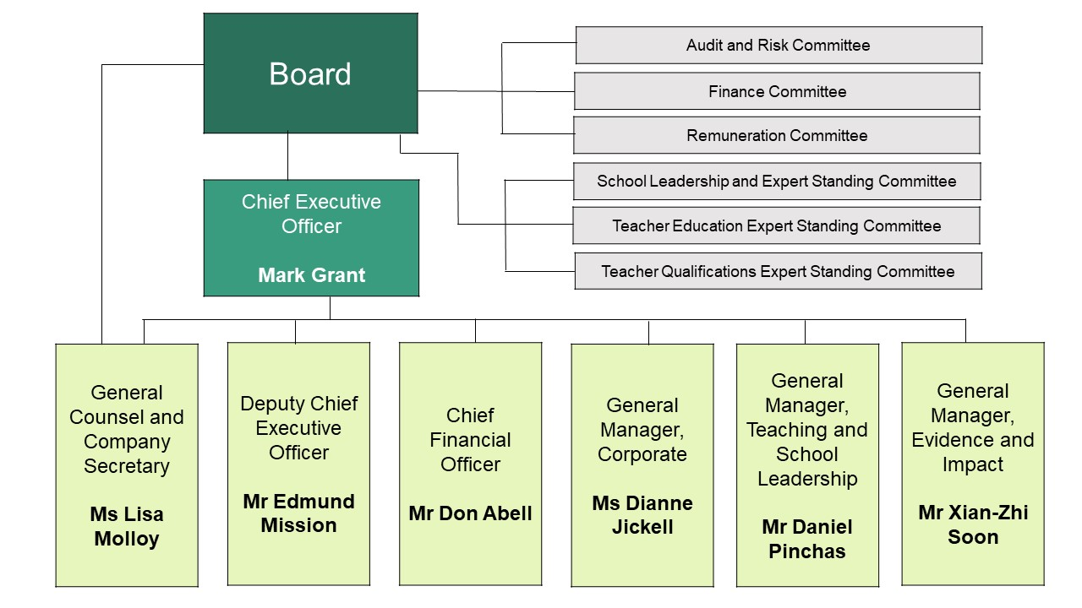
During the 2019–20 financial year there were no changes to AITSL’s organisational structure.
Staffing as at 30 June 2020:
- Total head count: 87
- Full-time equivalent: 72.61
- Full-time employees: 58
- Part-time employees: 14
- Casual employees: 0
- Gender: 60 females (68.97%); 27 males (31.03%)
- Staff locations: Two staff members work remotely, one from the Northern Territory and one from South Australia. All remaining staff are based in Melbourne.

Appendix 2: Consultancies and funding contracts
AITSL engages consultants with specialist expertise to assist with the fulfilment of the organisation’s responsibilities.
During 2019–20, 15 new consultancy contracts were entered into involving total actual expenditure of $1,265,613.12 (inclusive of GST). In addition, two ongoing consultancy contracts were active during
2019–20, involving a total actual expenditure of $17,545 (inclusive of GST).

​Appendix 3: Summary of compliance
Under the PGPA Rule, AITSL is required to provide an index of the mandatory annual report requirements from section 28E. Below is an index that provides the location of these mandatory requirements within this
annual report.

PGPA Rule Reference | Description | Location | Page
28E(a) | The purposes of the company as included in the company’s corporate plan for the reporting period. | Corporate Governance Statement | 19
28E(aa) | The results of a measurement and assessment of the company’s performance during the reporting period, including the results of a measurement and assessment of the company’s performance against any performance measures and any targets included in the company’s corporate plan for the reporting period. | Performance Measures 2019–20 | 10
28E(b) | The names of the persons holding the position of responsible Minister or responsible Ministers during the reporting period, and the titles of those responsible Ministers. | Corporate Governance Statement | 19
28E(c) | Any directions given to the entity by a Minister under the company’s constitution, an Act or an instrument during the reporting period. | Corporate Governance Statement | 20
28E(d) | Any government policy order that applied in relation to the company during the reporting period under section 93 of the PGPA Act. | N/A | N/A
28E(e) | Particulars of non-compliance with:  (a) a direction given to the entity by the Minister under the company’s constitution, an Act or instrument during the reporting period; or  (b) a government policy order that applied in relation to the company during the reporting period under section 93 of the PGPA Act. | N/A | N/A
28E(f) | Information on each director of the company during the reporting period. | Directors’ Report | 27
28E(g) | An outline of the organisational structure of the company (including any subsidiaries of the company). | Appendix 1: AITSL Organisational Structure | 59
28E(ga) | Statistics on the entity’s employees on an ongoing and non-ongoing basis, including the following:  (a) statistics on full-time employees;  (b) statistics on part-time employees;  (c) statistics on gender;  (d) statistics on staff location. | Appendix 1: AITSL Organisational Structure | 59
28E(h) | An outline of the location (whether or not in Australia) of major activities or facilities of the company. | Corporate Governance Statement | 26
28E(i) | Information in relation to the main corporate governance practices used by the company during the reporting period. | Corporate Governance Statement | 19
28E(j), 28E(k) | For transactions with a related Commonwealth entity or related company where the value of the transaction, or if there is more than one transaction, the aggregate of those transactions, is more than $10,000 (inclusive of GST):  (a) the decision-making process undertaken by the directors of the company for making a decision to approve the company paying for a good or service from, or providing a grant to, the related Commonwealth entity or related company; and  (b) the value of the transaction, or if there is more than one transaction, the number of transactions and the aggregate of value of the transactions. | Financial Report (Note 9) | 54
28E(l) | Any significant activities or changes that affected the operations or structure of the company during the reporting period. | Corporate Governance Statement | 20
28E(m) | Particulars of judicial decisions or decisions of administrative tribunals that may have a significant effect on the operations of the company. | Corporate Governance Statement | 21
28E(n) | Particulars of any reports on the company given by:  (a) the Auditor-General, or  (b) a Parliamentary Committee, or  (c) the Commonwealth Ombudsman; or  (d) the Office of the Australian Information Commissioner; or  (e) the Australian Securities and Investments Commission. | N/A | N/A
28E(o) | An explanation of information not obtained from a subsidiary of the company and the effect of not having the information on the annual report. | N/A | N/A
28E(oa) | Information about executive remuneration. | Corporate Governance Statement | N/A
28E(ob) | The following information about the audit committee for the company:  (a) a direct electronic address of the charter determining the functions of the audit committee;  (b) the name of each member of the audit committee;  (c) the qualifications, knowledge, skills or experience of each member of the audit committee;  (d) information about each member’s attendance at meetings of the audit committee;  (e) the remuneration of each member of the audit committee. | Corporate Governance Statement | 21



