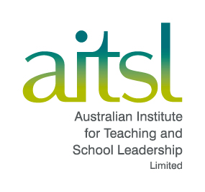

Developing, esteeming, and investing in expertise:
The second decade of AITSL
A discussion paper (DRAFT)
September 2021

Contents
- Introduction 3
- Part A | The development and focus of AITSL 5
  - A1. Governance 5
  - A2. 10 Years of Impact 7
  - A3. Context 8
- Part B | The fundamental role of educator expertise 10
  - B1. Enhancing the esteem of the profession 11
  - B2. The structure of the profession based on expertise 17
  - B3. Examples of AITSL work developing and esteeming expertise 20
- Part C | The power of the collective impact of educators contributing to policy 22
  - C1. Teaching need not be a lonely profession 22
  - C2. The connectedness of educators through social media 23
- Next Steps 26

Introduction
There is much to debate about schooling and early childhood education across Australia. The impacts of COVID provide a massive disruption and thus, an opportunity to ask questions about what is ‘normal’. These questions include what we can learn from COVID experiences in schools and early childhood education, and how can we create an even better schooling for every Australian child. This paper highlights some of the critical issues and is an invitation to discuss and debate the optimal ways to ensure a world class schooling system in Australia.
AITSL has accomplished much since its establishment a decade ago, providing a strong platform for enhancing AITSL’s impact over the next 10 years. This paper outlines two major themes underpinning AITSL’s work that could serve as signposts for the next 10 years and assist in leading to a highly esteemed profession that collectively continues to have major impact on the lives of ALL learners: elevating the expertise of educators; and harnessing their views of policy. In this way we can ensure the profession has a major role at the high table of governance, and continued ownership of its standards, future, and advancement of its expertise.
There are many people intrinsically involved in education across Australia; AITSL cannot do this work alone. Support is needed from federal, state and territory governments, Independent and Catholic governors, unions, the many educator organisations, the initial teacher education (ITE) providers, the state and territory regulators, the leaders, the many peak bodies relating to schooling, teachers, parents/carers, and learners. AITSL is one part of the machinery of government and thus, is one part of the many who think and work in education.
AITSL is in a unique position. We have a direct channel both from the education system to the profession and from the teaching profession to the education system. We operate nationally and interact with the teaching profession on a day-to-day basis, supporting teachers and school leaders as they teach and lead.
The Mparntwe Education Declaration, updating the goals of education, was released in December 2019. This is the first time a national government report has been titled with an Aboriginal language name. It highlights how important culture is for us all and including for Aboriginal and Torres Strait Islander peoples. Our cultures guide our individual and collective identities and influence all aspects of our lives. Teachers have an important role to play in cultural understanding. When we have education success for all Aboriginal and Torres Strait Islander learners, we will know we have the basis of a first-class education system.
The Mparntwe Declaration starts with the undeniable truth that ‘education has the power to transform lives. It supports young people to realise their potential by providing skills they need to participate in the economy and in society and contributing to every aspect of their wellbeing’. The vision is for a ‘world class education system that encourages and supports every student to be the very best they can be, no matter where they live or what kind of learning challenges they may face’. Right now, Australia’s education system is slipping in world class comparisons. Too many children and students do not see learning as worthwhile to them, and many encounter challenges that limit their sense of what they comprehend as “the very best they can be”. But there is much to applaud, and this paper is premised not on identifying failure and fixing it, but on identifying success and scaling it up for all.
This discussion paper has been divided into three parts:
- Part A outlines the overarching themes of the development and focus of AITSL.
- Part B proposes a major theme for the next 10 years of AITSL; that is, developing, esteeming, and investing in teacher and leader expertise.
- Part C invites all involved in education to join our community with the aim of furthering the improvements in schools and early childhood settings.

Part A | The development and focus of AITSL

A1. Governance
AITSL is a Commonwealth company and not-for-profit funded by the Australian Government. The Australian Government is the sole member of the company, represented by the Minister for Education. It thus reports directly to the Minister but also works cooperatively with the Federal Department of Education, Skills and Employment; regularly reports to and does work commissioned by Education Ministers’ Meetings (all state, territory, and Federal Ministers); and works directly with state and territory departments and Catholic and Independent sectors, as well as the state and territory regulators.
A Board of Directors appointed by the Federal Minister oversees the governance. The current membership includes experts with skills and experience in leadership, teaching, academia, teacher education, governance, as well as contributing perspectives of Aboriginal and Torres Strait Islander peoples’ and from all three sectors of education. The AITSL Board has continually advocated for an expert in union matters to be restored as a Board member, but this has not yet eventuated.
Over the past decade, many reviews have been conducted that reflected on the governance and existence of AITSL, as well as the other agencies in the ‘machinery of government’— the Australian Curriculum, Assessment and Reporting Authority (ACARA); Education Services Australia (ESA); and now the Australian Education Research Organisation (AERO). There have been recommendations for abolition, changing constitution, merging, and much more. Many of these reviews ask how an agency can exist with no regulation powers or funding levers. This is not a weakness and has been turned into a strength. It means AITSL’s impact depends on its skill to consult and carry good ideas through to those with the levers of influence. As is asked at most AITSL Board meetings: Who would miss us if we were gone? The best answer to date is: The profession would miss us, but only if we keep doing the work that the profession wants. This is what provides our legitimacy.
Throughout the machinery of government, particularly in taking proposals to Education Ministers Meetings where all the ministers discuss and make decisions that impact the profession, there is no designated place at the table for the voices of the profession. Now, this is a critical role for AITSL—to know, be aware, and represent the views of teachers and leaders. This is why so much attention is paid to extensive consultation with systems, sectors, and associations. This is one of the power levers of AITSL—it does listen to the profession and thus adds additional value to those in governance positions (of course, noting that all members of the Education Ministers Meetings also have extensive consultation with the profession).
As you consider AITSL’s achievements and work plan, it is worth noting that AITSL has only 50 to 100 staff at any time. Enormous success is achieved by relatively few employees, and it reflects their expertise and willingness to work together, consult, and ensure high quality work. As stated earlier, AITSL does not do this work alone, but rather, collaborates with federal, state and territory governments, Independent and Catholic governors, unions, educator organisations, ITE providers, state and territory regulators and leaders, as well as the many peak bodies relating to schooling, teachers, parents/carers and learners.
AITSL’s first CEO, Margery Evans, built the basis of AITSL’s successes, and we especially note the work she and the first Chair, Tony Mackay, accomplished to enable the national professional standards to become enacted. The second CEO, Lisa Rodgers, spread our wings and developed excellent relations with Ministers, Department heads, and leaders across the profession. There are many organisations, professional associations, and agencies involved with schools and early childhood settings. Lisa was superb at honouring, listening to, and bringing their views and voices into the work of AITSL. Our current CEO, Mark Grant, has continued to reach out, adding his deep and rich knowledge of the Australian education sector. Mark’s extensive contacts across education and the machineries of government ensure AITSL’s work is informed and has desirable consequences.
AITSL’s work is determined by the Federal Minister via Letters of Instruction, or is commissioned at Education Ministers Meetings, individual states and territories, and Catholic and Independent sectors, and there is no reason to believe this will not continue. This paper outlines underlying themes and connectedness in the work that has been asked of AITSL and provides a context for future work.

A2. 10 Years of Impact
AITSL is now 10 years old, and while AITSL’s reputation rests on its past successes, there is much more to do in the next 10 years.
Today’s five-year-olds will graduate in about 2035, and many will become parents who will bring up children who will be among those preparing for education in the twenty-second century. The learners of today will be defining their future. We all need to ensure their education now reflects the values, dispositions, and precious learnings we wish them to use in building this future. This is our most powerful influence. Educators indeed have a massive responsibility, and we all can, and have, delivered much success in schooling and early childhood for many decades.
The pressure to improve, add more to the agenda of schools and early childhood settings, and our skills managing increasing diversity are now the norm. There has been a continual focus on improvement and scaling up success.
AITSL exists to actively improve teaching and leadership across all Australian schools and early childhood settings. It is the national government body with countrywide reach in education. Our work is grounded fundamentally in the combination of evidence and professional practice, and our mantra is to reach out, listen, and involve the profession if we want good things to happen in schools and early childhood settings.
AITSL intends to continue to help shape national teaching, leadership, and ITE reforms, which are the biggest driver of system improvement. It does this by:
- working collaboratively with all our key stakeholders
- building and leveraging educational expertise.
- undertaking extensive consultation with the profession to develop a deep understanding and ensure its work is well informed.
- enabling governments to both learn from and shape education setting and classroom practice, which is crucial to improving system outcomes.
AITSL aims to assist all those involved in education to improve practice. It provides resources and initiatives for teachers and leaders who are the most important influence on student learning in early education and schools. It does this by:
- setting the gold standard for practice through the Australian Professional Standards for Teachers (Teacher Standards) and the Australian Professional Standard for Principals (Principal Standard), and through quality assurance for ITE providers. This helps teachers and leaders to understand and strive for professional excellence.
- collaborating with education stakeholders to design tools and resources based on the best available research. This collaborative approach helps ensure AITSL’s work is trusted, relevant, practical, and accessible to all.
- working with states and territories to ensure all ITE programs align with the nationally agreed standards. These accreditation requirements ensure teachers who enter the profession are classroom-ready from their first day.
AITSL aims to be an effective lever for improving teachers and leaders, and its functions are not collectively replicated elsewhere in our education system.
- AITSL has an unmatched ability to convene all levels of the education profession.
- AITSL speaks directly with teachers, leaders, systems and sector leaders, higher education providers, regulators, professional associations, the early childhood sector, unions, Aboriginal and Torres Strait Islander educators and organisations, and other government agencies.
- AITSL is a critical conduit for national and cross-sector collaboration. Because AITSL’s tools and resources are grounded in national standards, they ensure equitable access for all educators, regardless of context.
- AITSL actively facilitates knowledge sharing and innovation within the education profession, which aims to improve performance in all school systems and sectors.
- AITSL positively shapes stakeholder thinking and improves the development of national reform and its implementation due to its uniquely strong and trusted reputation as an ‘honest broker’.
- AITSL can supplement system and sectors’ existing capability as needed, amplify the work that is already being done, or share insights from across jurisdictions to inform their approaches.
AITSL complements and adds value to states and territories’ own initiatives in two ways:
- AITSL works flexibly with all school systems and sectors (including Catholic and Independent), complementing and supporting them in their own efforts to achieve strategic priorities.
- AITSL’s reach means it does so cost-effectively and adds value to existing capability, within its purview.
AITSL’s current Strategic Plan, Increasing our Impact (2019–2022), outlines the principles, focus areas, strategic actions, and goals that are guiding the organisation over the current three-year period. It outlines a plan to secure a high-quality education system, where the learning of Australian children and students come first. The plan seeks to improve teaching expertise, build strong leadership in schools and early childhood settings, and ensures the sector can evaluate its impact and make evidence-based decisions.
AITSL is now looking toward its next strategic plan. The conversations and discussions stimulated by this discussion paper will help form what AITSL focuses on over the next 4 years and beyond.

A3. Context
There have been many discussions on Australia’s slide down the Programme for International Student Assessment (PISA) rankings in both relative and absolute term; although, the Australian average score on NAPLAN has barely changed over the past 12 years (See Figure 1 noting the increase in Years 3 to 5, and there are similar results in NAPLAN Writing and Numeracy). These results must be anchored in a wider debate about the appropriate and optimal set of indicators that we consider relates to the success in schools and early childhood settings (Hattie, 2015).
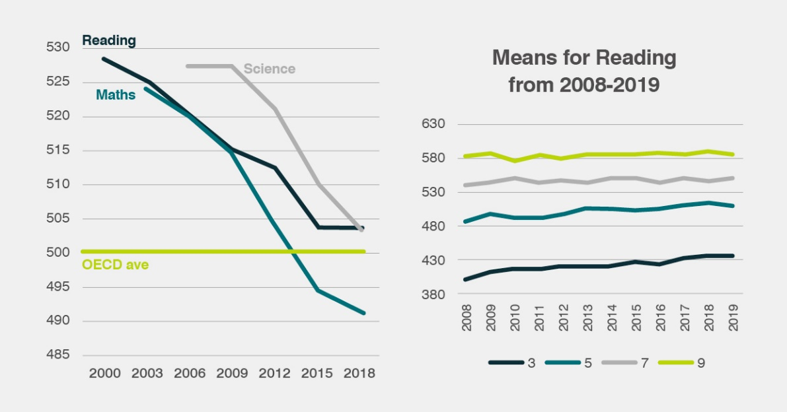
Figure 1: Means across years on PISA Reading, Maths and Science, and NAPLAN Reading
That there has been little change in the NAPLAN means for 12 years, but this does not mean failure. At minimum, the steady state shows that educators have made similar growth in learning (say from Year 3 to 5) systematically 12 years in a row. Impressive, but more growth is needed if we are to improve overall compared to similar countries (compared to the OECD average, for example). The greatest improvement over the past 20 years nationwide is with Year 3 learners, with Queensland, the Northern Territory, and Western Australia leading this growth. This demonstrates that major system-wide improvements can and are being accomplished.
The recent reports and debates about creating a “learning profile” across many school and early childhood outcomes measures may be a necessary place to continue our pursuit of excellence. There needs to be a robust debate about what should be within this profile (e.g., achievement, progress, climate, teacher, and student measures etc.). Implementation also needs to be sensitive to the many adverse impacts from misusing public information. A major focus may be to use these indicators to better understand the impact of state-wide and national policies – and this can also include expansion in our knowledge about how children learn, the increasing expectation of evidence-based practice, and the changing nature of the relationship between teachers and parents.

Part B | The fundamental role of educator expertise
We know the major reason for any improvement in the education system is investment in expertise by educators (Rickards et al, 2021). All else is supportive (although the other factors, especially time, resources, salary, and professional learning are not to be underestimated). But the challenge is scaling up the numbers of educators who have marked impacts on their learners because of their expertise. Indeed, a major plank of AITSL’s future must be related to scaling up this expertise. Australian educators, policy makers, and politicians need to be greater advocates for basing the esteem of our profession and the future of education on this notion of expertise.
The evidence across Australia is that many educators are already exhibiting the expertise we value. They are teaching in schools and early childhood settings where most learners are making more than a year’s growth for a year’s input. We need to esteem and listen to these educators and form a coalition of success including them if our system is to advance in the direction we all desire.
Despite many saying the education system needs to continue to evolve slowly, educators have shown remarkable adaptive and responsive skills to COVID (and some school and early childhood settings have made this transition and some struggled). COVID has shown that teachers and leaders can adapt. We have seen educators lead the change to new models of teaching. We need to build evidence from this change in teaching and learn from it. It is important that we understand and capitalise on the positive influences (see Jensen, 2020).
The question for debate and action is how to harness this expertise to be at the centre of policies and directions for improving the quality of education across Australia.
AITSL is keen to support this debate and enactment. This would require education systems, sectors, and the profession moving from primarily being concerned with the structures, management, policies, and curricula matters, to focusing also on identifying, esteeming, and privileging expertise based around impact on student learning. This must start with considerable investment in time and opportunity for debate, acknowledging the intellect of the profession, and educators agreeing to acknowledge and esteem their expertise. AITSL can assist in furthering this discussion and consequential actions to bring this expertise much more to the fore.

B1. Enhancing the esteem of the profession
There are many indicators of esteem of educators. These include:
- high achievement and communication skills of those entering and graduating from ITE.
- qualifications held by educators.
- measures of trust in teachers compared to other vocations.
- number of teachers and leaders recognised through the Australian system of honours (e.g., Order of Australia, Public Service Medal).
- perceptions of meaningfulness of work and level of competence of teachers.
- starting and ongoing salaries compared to other professions.
- teacher and leader salary steps based on demonstrated expertise (e.g., through national teacher certification), rather than mainly experience.
- working conditions.
- retention by career stage (early career 0–5 years, mid-career 6–15 years, late career 16–40 years) as compared with other professions.
We need, as noted above regarding schools and early childhood settings, to build profiles of these measures. In order to raise the status of the profession, it is critical to dependably identify (through standards-based assessment), esteem, and privilege expertise amongst educators—especially by the profession itself.
In AITSL’s submission to the Senate Inquiry (2019), it identified 7 directions for enhancing the esteem of the profession.
Direction 1 | A profession, not a vocation
A profession is characterised by:
- a defined and specialised knowledge base.
- extensive formal training and life-long learning.
- admission to practice within the profession by holding appropriate qualifications.
- a clear, agreed set of standards.
- a code of ethics that the profession should own, and oversee the criteria of excellence for entry into, and promotion within, teaching. The profession should also be involved in accounting for its impact on student learning.
The recently completed stocktake of the Teacher Standards and Principal Standard provide an opportunity to enhance the excellent work already completed making Australia one of the few (if not, the only) country to legislate professional standards as the bedrock of the teaching profession.
The recent National Review of Teacher Registration noted that teachers tend to focus on the compliance elements of registration. It also found there is scope to engage teachers in the broader concepts and value of registration. A stronger understanding of registration would support teachers’ perceptions of themselves as part of a profession. The Report of this Review, One Teaching Profession: Teacher Registration in Australia (2018), recommended that teachers employed in early childhood teacher roles across Australia be required to be registered. Current arrangements for the registration of early childhood teachers vary by jurisdiction and the type of early childhood service the teacher works in. Including all early childhood teachers in registration would encourage them to engage with the Teacher Standards, which themselves can be improved to be more applicable for early childhood teachers. This would be a strong contributor to the professionalisation and status of this important part of the teaching workforce.

Direction 2 | Excellence and expertise should be embedded into career structures for teachers and principals
In Australia, explicit and supported career pathways are increasingly being offered to teachers and leaders; however, this is rarely systemic. The current national teacher certification is a standards-based measure of teaching expertise and instructional leadership against the higher career stages of the Teacher Standards. There is more to accomplish with the nationally certified Highly Accomplished and Lead teachers (HALTs) and their network is active in recommending new directions.
One option (introduced by the South Australian Department for Education) is to fund schools and early childhood settings to advertise and appoint these credentialled teachers (e.g., HALTs) with appropriate remuneration while they remain in these schools, thus spreading the excellence to harder-to-staff schools and early childhood settings, such as rural and some curricula areas. We raise this as a discussion issue; employment issues are not part of AITSL’s remit but initiating debates and research about such options to esteem expertise are.
Similarly, we raise the debate about the merits of introducing a ‘model of expertise’ into Australian jurisdictions where after 5+ years in the class, teachers can choose to become more proficient in teaching (leading to HALTs), leadership, or specialisms (e.g. reading, STEM, assessment, socioemotional learning) (and see p.13). Providing opportunities for enhanced expertise to be built into the structures of schools and early childhood settings could include leading curriculum areas or teaching teams, teacher-coach positions, mentoring pre-service and beginning teachers, and other instructional leadership roles.

Direction 3 | Entry to and preparation for the profession must be more rigorous
There is much variance (as indicated in individual ITE provider annual reports published in the annual AITSL ITE Data Report) in the entry standards into teaching, and the debate too often focuses on only one of the entry dimensions—the Australian Tertiary Admission Rank (ATAR). While outside AITSL’s remit, we note discussion about the future of ATAR and the move to consider learner profiles, which will help the debate about entry to teaching. It should not be a binary—high achievement or not—but a profile across prior achievement in schools and early childhood settings, communication, social sensitivity, liking to teach, and promoting appropriately high standards for this collective.
The reforms the ITE sector has successfully implemented where all entry criteria are now publicly available, the strengthening of the entry requirements, and the evidence that 90%+ pass the Literacy and Numeracy test all help to promote the notion of defensible standards for entry. The Teaching Performance Assessments (TPAs) are a hallmark innovation, and most ITE providers have developed these, which include cross-institution moderation, such that the profession is implicitly involved in setting its standards for graduation. More work is needed on ensuring successful implementation of high-quality TPAs in all ITE programs and building the evidence of the effectiveness of these programs to graduate classroom ready teachers. Fully implemented TPA will permit the professionals in the ITE programs to provide the evidence and be critical in determining the standards through cross-institutional moderation.
There is always a demand for more teachers as the populations of learners increase. There are also demands for teachers to reflect this population of learners who are likely to be more culturally and ethnically diverse. The overall profile of teachers is becoming younger on average, with more entering at an older age but not staying until retirement (Ingersoll, 2014). Teachers are more likely to:
- leave after 10 years (where the salary flattens).
- enter from other professions (although the barriers are high for people aged over 40 who wish to change professions).
- have stronger expectations to be promoted based on expertise rather than experience.
- be more collaborative with colleagues in teaching.
Many current HALTs became excellent mainly through their own investment in professional learning. Nonetheless, the current socially wired generation want to learn and grow collaboratively and are unlikely to stay in a lonely profession where age on the job matters more than expertise. We talk about how young people now will change professions often. This is a great threat to our future workforce if we do not make teaching more collaborative and based on expertise.
It might be time across Australia to consider moving from the more usual placement of pre-service teachers in schools and early childhood settings to a registrar or internship model as part of ITE programs (as commenced recently in Victoria and New South Wales). This would require a closer partnership with state and territory, Independent and Catholic authorities, and may make entering teaching more attractive, particularly in fields/setting with short supply. The recent move to two-year graduate programs, for example, has led to a marked and worrying decrease in applicants. The average age for entering teaching is 26 years, so two years of foregone earnings seems to be a barrier too high for too many.

Direction 4 | Support for success for all teachers, at all career stages
Induction of early career teachers plays a critical role in supporting teachers’ development and encouraging retention in the profession. AITSL’s My Induction app is a major success and the forerunner for many initiatives to create a community of educators supporting other teachers within and across schools.
In the 2019 AITSL Stakeholder Survey, 86 per cent of responding leaders believed early career teachers on a permanent contract (full- or part-time) received formal induction, while only 50 per cent of early career respondents on a permanent contract indicated they did. The My Induction app allows beginning teachers to access the expertise of the Australia-wide community of HALTs. My Induction has over 21,000 app sessions a month.
Professional learning throughout a teacher’s career is essential to support their development, but the power of such learning is variable. It seems ironic we demand learners come to school for professional learning and then conversely make claims that such learning for teachers is not necessary. It is worth exploring a social and crowd-sourced app to engage teachers and leaders to have major input as to the effectiveness of various professional learning opportunities. AITSL is actively investing in these possibilities.
In the United Kingdom, there are now more teacher assistants (TAs) and support staff than teachers in schools and early childhood settings. In the United States, TAs and support people are identified as the fastest growing of all vocation groups over the next 10 years. In New Zealand, close to 30 per cent of the salary budget is spent on TAs. It is impossible to track the growth of TAs across Australia; although, the new Australian Teacher Workforce Data collection could open this possibility, noting it currently only collects data from ITE programs and registered teachers. Blatchford (2012) has shown TAs have a zero to negative impact on learning, especially when associated with learners with special needs. The Evidence for Learning’s analysis suggests TAs have minimal impact (additional 1 month of learning growth over a 12 month period) but come with relative high costs. AITSL could be requested to take a major stand on improving the impact of TAs, and given they are unlikely to be removed from schools and early childhood settings, we need to learn how use TAs optimally to support teachers to maximise their impact on learning.
Similarly, there is an opportunity to investigate the role, growth, and professional learning of casual teachers. Across Australia, there are an estimated 70,000 casual teachers, or approximately 20 per cent of the workforce. Over the course of a learner’s education, they will be taught by casual teachers for approximately 10 to 15 per cent of their education. These teachers often miss out on opportunities for ongoing professional learning and development, and as a result, risk becoming disengaged or losing the currency of their skills.

Direction 5 | The right tools to allow teachers to focus on their professional role
Teachers are professionals who are focused on the learning and progress of their children and students. The right tools allow teachers to focus their finite time and energy on targeting their teaching to an individual student’s needs. The National School Reform Agreement has identified the development of opt-in online learning assessment tools to assist teachers as a key reform area. The development of Spindle, by AITSL, ACARA, and ESA is exciting (see Box 1).
Box 1
The Online Formative Assessment Initiative is being jointly progressed by AITSL, ACARA, and ESA. The initiative is following a co-design methodology with the teaching profession, with the representative Teacher Practice Reference Group (TPRG) and teacher volunteers helping shape the work.
- ‘Spindle’ is the current name for the technical ecosystem being tested during the alpha (prototyping) phase. Spindle will help teachers determine where children and students are in their learning and what they should focus on next; supporting teacher judgements and providing resources aligned to the Australian Curriculum.
- In the alpha phase, professional learning materials have been produced as low-fidelity prototypes to test the validity and content.
- These prototypes are currently being tested by teachers across Australia.
- In the beta phase and beyond, these validated professional learning materials will be included within the platform to build teachers’ formative assessment knowledge and practices and support leaders to implement whole-school change and apply High-Quality Professional Learning (HQPL) practices to embed formative assessment practices in their schools and early childhood settings.
- They will learn from experts and from each other, with case studies highlighting formative assessment practice across Australia and Teacher Collaboration Guides supporting teachers to examine their practice to improve learner outcomes.
The beta phase (being scoped for 2021) will include more teacher input through user research, surveys and collaborative TPRG meetings.
Direction 6 | An Australian teacher workforce dataset that looks to the future
The National School Reform Agreement has identified a national teacher workforce strategy as a key direction. AITSL is leading the development of this data project, designed to provide a comprehensive picture of teaching in Australia—from entry into the profession (at ITE stage) through to exit from the profession. The dataset will deliver critical insights about the teaching workforce that will allow a deeper understanding of the challenges and opportunities teachers face as a collective, and the issues we need to address together to better support the profession. With increased mobility of teachers, and especially because nearly 25 per cent of pre-service teachers are completing their course online, teachers are living and intending to work in a state or territory but completing a course accredited in another jurisdiction. There is discussion about how to ensure Australia-wide standards that all jurisdictions, educators, and the public can have confidence.

Direction 7 | Excellence and expertise in the profession must be publicly esteemed
The public reputation of the teaching profession must be increased so that the societal contribution of educators is valued and understood. There are untapped opportunities to elevate the profile and promote the value of teaching in Australian public life. The positive contribution that teachers make should be recognised within and outside of the education community. Introducing a national and education-specific honours and awards function or division, like that run by the Department of Defence, would allow for recognition of current and former members of the profession as well as provide advice to the Government on honours and awards issues. Public recognition beyond education would be supported by more educators sitting on established public service honour panels, including those that determine Australia Day and the Queen’s Birthday honours.
There is opportunity for AITSL to do more in promoting the esteem of the profession, working with states, territories, Catholic, Independents, the unions, early childhood agencies, and all wanting to actively promote the initiatives to raise the esteem.
High esteem for the profession is most likely to occur when the profession itself advocates that it should be based on the power of its evaluative expertise, not from seeing the profession as a job or vocation. When calling for more money, autonomy, and time, it should promote what this money autonomy and time is for—to develop, esteem, and privilege expertise. The profession needs to be much more effective at taking credit for and not denying this expertise.
As a benchmark, consider the OECD Teaching and Learning International Survey (TALIS) involving more than 100,000 upper primary and lower secondary teachers across the developed world. On the question as to whether teachers feel valued, Australia, with about 40 per cent ‘Agreeing or Strongly Agreeing’ was ranked 11th (behind Malaysia, Korea, Singapore, Abu Dhabi (UAE), Finland, Cyprus, Mexico, Alberta, Flanders, Netherlands) and ahead of England (12), USA (16), Sweden (34). There is much room to improve.

B2. The structure of the profession based on expertise
The Review to Achieve Education Excellence in Australian Schools (led by David Gonski) had a premise that teaching must become a high-status profession of expert educators (Finding 9). It argued for better induction, a deeper understanding of the supply and demand of teachers, caution about the casualisation of teachers, having multiple pathways into teaching, and recommended that there be a comprehensive national teacher workforce strategy to better match supply with workforce demands, including skill and capability requirements. As critical, Recommendation 15 specified that there is a major need to ‘create and provide opportunities for implementation of structured career pathways for teachers with clearly defined roles and development streams that allow for accelerated progression and provide the opportunity for remuneration, recognition and allocation of responsibilities based on expertise’.
The current advancement of teachers is too much an experience-based model. While teaching is among the top five graduate salaried positions, the curve of increase is gradual until about 10 years as a teacher then quite flat after that. The percentage increase from starting top of the salary is similar in Australia for pre-primary, primary, lower, and upper secondary, and is markedly different from most OECD economies.
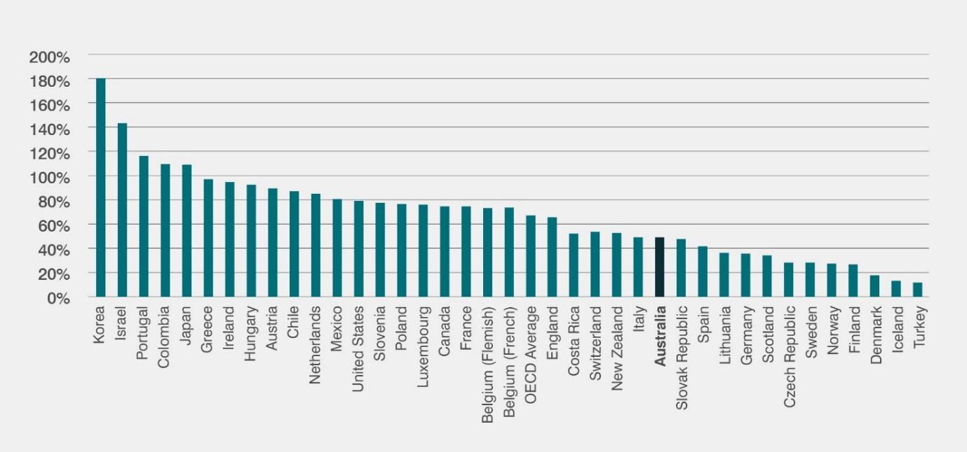
Figure 2: Average ratio of top of scale to starting salary across pre-primary, primary, lower secondary, & upper secondary
Compared to other professions such as Medicine (144% increase), Law (114%), and Engineering (110%), teachers rapidly fall behind in earning power. This leads to teachers being paid less, on average, than most other graduates and often less than those with no degree at all. One conjecture is this is because the salary structure for teachers is based more on experience than expertise, and for leaders on the size of schools. Furthermore, the major increase in teacher expertise occurs in the first few years and less so after this time, and we shy from discussions about identifying teacher expertise.
This is not advocacy for performance pay—it does not work and has not worked in teaching. The effect size on achievement from performance pay is an extremely low d = .02 (Pham et al., 2020). Instead, as in almost all professions, evidence of expertise becomes a condition of roles and positions, to which higher remuneration is attached. Consider, for example, the South Australian Department for Education’s initiative with HALTs. Higher salary allocation is provided to learning settings (e.g., hard to staff, in areas of high disadvantage) and a teacher can apply for these positions provided they have the HALTs qualification. Similarly, a doctorate does not guarantee a position or an increased salary but makes it possible to apply for positions demanding a doctorate as an essential criterion.
The Review to Achieve Education Excellence in Australian Schools report outlines a model of promotion and salary, with expertise centre to increased teaching career pathways. A future model could see teachers provided with options on career tracks including a focus on pedagogical excellence, a focus on leadership or a specialist focus such as curriculum design or educational testing and measurement.
Teachers would have the flexibility for lateral movement across tracks, and extensive professional learning provided to advance on the track. Rather than waiting many years, investment in building expertise starts very early in one’s career, whereas in Australia, the average number of years from becoming a teacher to becoming a principal is 25 to 28 years, noting that 85 per cent of deputies do not want to become principals; although, 75 per cent of principals enjoy their job (Principal Health and Welfare Report, 2019).
One possible model for debate could be as depicted in Figure 3. While AITSL is not involved in employment bargaining and career structures, it can invite debate about alternative models to esteem expertise and encourage multiple ways to recognise expertise especially in terms of educators’ impacts on learners.
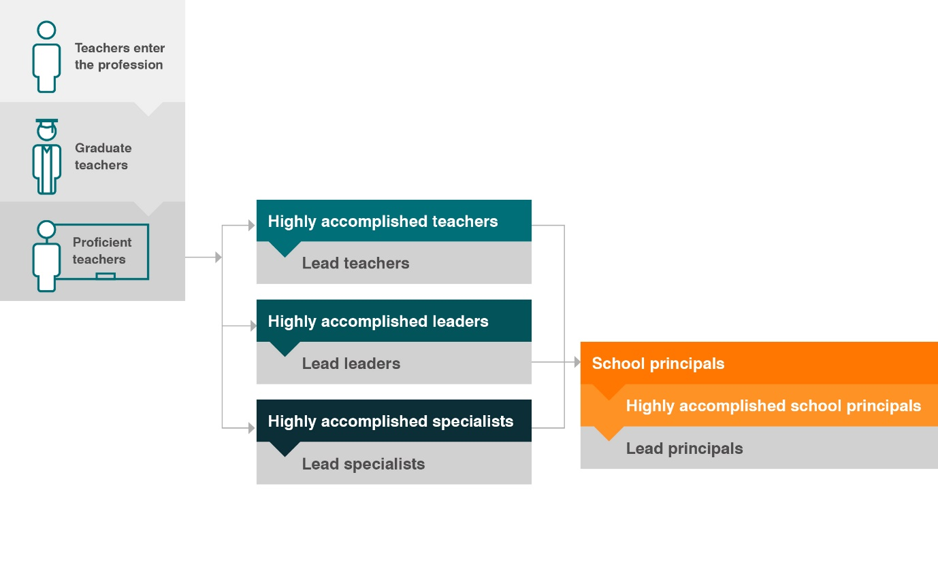
Figure 3: A possible model for advancement of educators
It is noticeable that Australia has engaged in many, many curriculum reforms usually under the imperative that there is too much in it. We have state variations of national curriculum, the current Australian curriculum if printed is quite lengthy, and when teachers spend much time deciding on lesson plans, they may be aligned with curriculum. One major evidence-based resource would be a compendium of lesson resources that has ratings of the a) alignment to the curriculum, b) level of rigour, and c) quality and efficiency of impact.
Such lessons would be worthwhile starting points for teachers to adapt and would save endless hours of discovering, modifying, and creating individual lessons, especially for teachers in their early years of the profession. EdReports is one such US-based site that already undertakes steps a) and b), and a worthwhile addition would be to use social media to engage Australian teachers rating the quality of impact after they used the resources and thus capturing the evaluative expertise of teachers on these critical matters of interpreting the curricula, ensuring rigour, and maximising impact.

B3. Examples of AITSL work developing and esteeming expertise
Figures 4 presents an overview of AITSL’s work developing and esteeming expertise.
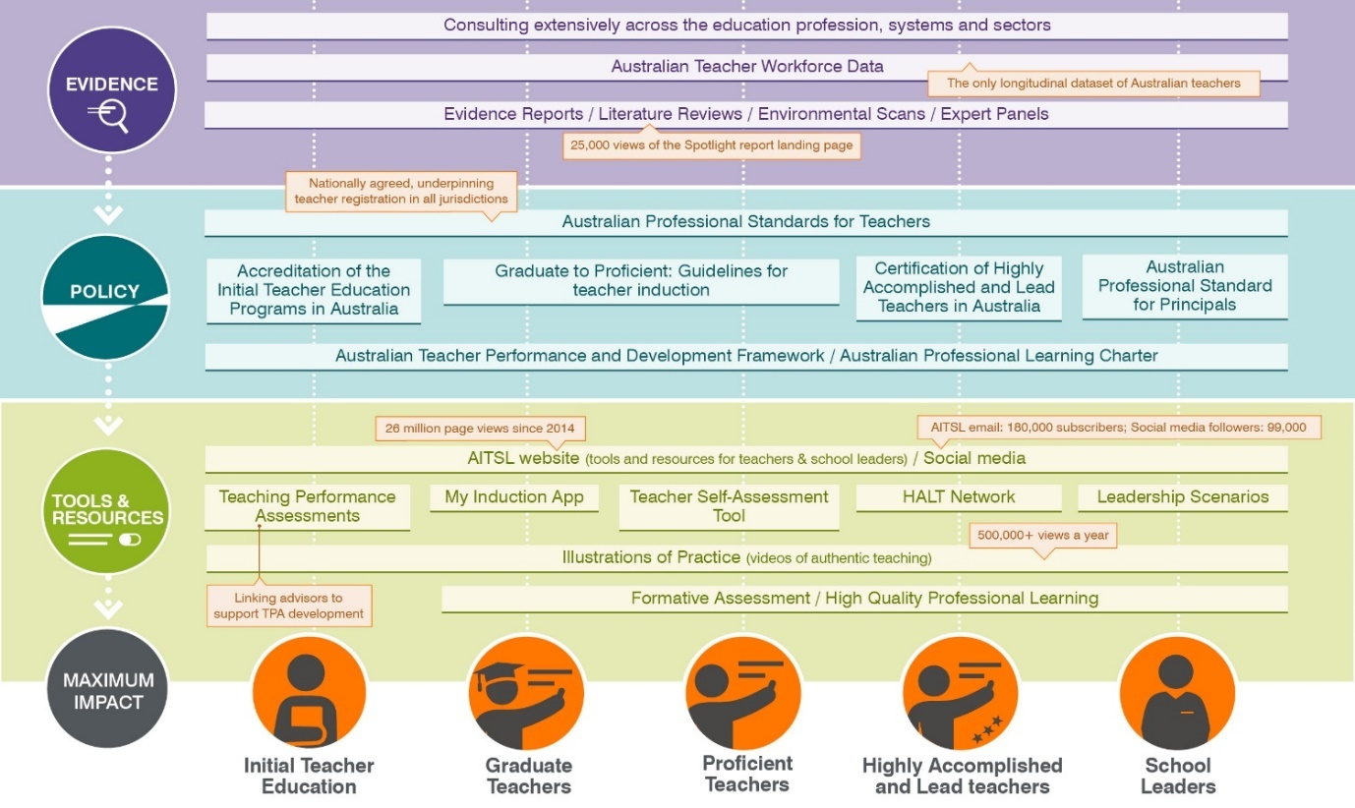
Figure 4: AITSL impact across the professional lifecycle (as at February 2021)
There are many more initiatives under way to complement these actions. For example:
- The next generation of AITSL’s Illustrations of Practice (IoPs). AITSL’s online collection of over 300 IoPs demonstrate what the Teacher Standards look like in action, lifting them from policy words on a page to identifiable actions, knowledges, and behaviours that teachers can put into practice. They have been viewed over 1.5 million times. New IoPs will move from a focus on the Standards to illustrating the multiple ways teachers impact on student learning with options to hear teachers and learners thinking aloud during the lesson. The new IoPs will show why the teacher used the intervention, why they pivoted during the lesson, and what their interactions with learners are informing them about their impact. They will also include student artefacts of the lesson.
- Closer attention to teachers of vocational education and training (VET). In 2019, there were 235,800 VET in-school students. Of this number, 17,100 students were undertaking a school-based apprenticeship or traineeship. There are several delivery methods available to schools to ensure the availability of VET programs and an essential component for in-school delivery of VET is a high-quality sustainable teacher and VET Trainer and Assessor workforce. In 2020, AITSL was commissioned by Education Council with progressing the implementation of recommendations from the One Teaching Profession review. The work will aim for greater alignment of requirements for Teacher registration and VET Trainers and Assessors to support teachers who seek to obtain and maintain both qualifications. It will also explore the development of pathways to ITE that recognise qualifications required to deliver vocational education and training, prior learning and the experience of VET Trainers and Assessors, and identification of ways to make pathways to ITE available to VET Trainers and Assessors.
- Understanding the workforce. The Australian Teacher Workforce Data initiative (ATWD) is linking data on all educators to provide a comprehensive picture of the teacher workforce nationally across all systems and sectors, from entry into the profession to the end of a teaching career. The initiative will vastly improve our understanding of supply through ITE and national and local workforce trends in demand, challenges, and opportunities (see the first report – National Initial Teacher Education Pipeline: Australian Teacher Workforce Data Report 1.
- Teaching Futures: The National Teacher Workforce Strategy (NTWS). The NTWS will complement the ATWD, building a comprehensive national teacher labour market model to provide a national view of teacher workforce supply and demand, including trends and predictions of shortage and surplus.
- Advancing ITE. Since 2014, AITSL has been overseeing the implementation of the major recommendations from the Teacher Education Ministerial Advisory Group (TEMAG) including:
  - ensuring all 47 ITE providers apply academic and non-academic selection criteria to ensure entrants to ITE programs possess the appropriate skills to become successful teachers.
  - the ITE Standards and Procedures are effectively and consistently applied across Australia including the implementation of cross-institution moderated TPAs.
- Indigenous cultural competency in the Australian teacher workforce. AITSL is currently seeking input on development of a set of resources to enhance the cultural competency of teachers and increase cultural safety in schools. This work not only supports schools and teachers to implement Focus Areas 1.4 and 2.4 of the Teacher Standards regarding working with Aboriginal and Torres Strait Islander learners but will help teachers have a lens of cultural capability in their teaching practice.
- HQPL Online Community. The proposed HQPL online community would help educators to:
  - find high-quality professional learning targeted to their needs.
  - record their professional learning in a one-stop web app.
  - evaluate the impact of their professional learning on student outcomes.
  - share their evaluations with their colleagues, creating a powerful repository of professional learning with information about what works, for whom, and in what context.
- The Standards Stocktake included a focus on the Principal Standard. Currently, there are about 25 years (TALIS, 2018: Australian Report pp.39–40) between becoming a teacher and becoming a principal. Too many deputies do not want to make that last step, and not enough leadership professional learning is focused on developing leaders early in their career (AITSL, Spotlight, 2019). The ‘expertise model’ noted above starts the process within the first years of becoming a teacher. A major rethink about a longer-term policy to identify and develop leaders is needed in Australia.

Part C | The power of the collective impact of educators contributing to policy
We have a policy environment where Ministers (previously at Education Council and now at Education Ministers Meeting) agree on national directions and initiatives, and at that table there is currently no place for the views of teachers or leaders. A major debate needs to occur to find ways to get policy recommendations from educators to these high tables. This new authorising environment would not pretend that educators speak with a common voice, but the aim would be to find ways to augment policies coming down from above with recommendations for policies to be created from schools. This would both improve the initiatives needed to enhance the impact of early childhood and school settings and increase the probability that policies are implemented in them.

C1. Teaching need not be a lonely profession
Teaching can be a ‘lonely’ profession, as there is often but one teacher in a class for many hours. Teachers more often prepare alone for their class, and mark and grade alone. Many experienced teachers became high impact teachers by their own initiatives and through involvement in professional learning and their own learning. This demonstrates the initiative and dedication to invest in one’s learning, but it is unreasonable to put all the onus on the individual teacher to be responsible for their improvement.
The new generation of teachers has been brought up in a socially connected world, preferring to work in teams to develop expertise. They want to work in a collaborative profession, working together to problem solve, share success, explore dilemmas, plan, review impact, and together grow in expertise. Moreover, employers of today want communicators, team players, and translators of expertise to others. If learners are not exposed to these attributes from their teachers, there is less likelihood they will improve their own collaborative and social interaction skills as core to their own learning.
Hence, a major direction to realise the Mparntwe Declaration is to enhance the collective expertise of the profession, and ensuring their voices are engaged in improving, esteeming, and advocating for the Australian education system.
Consider (as noted above) what has occurred since COVID hit schools and early childhood settings with force. Educators were required to abandon their current in-class teaching and move to at-home, then some came back and most stayed out, then all came back, and then all went back to at-home (with variations across the country). Teachers undertook a huge workload to reinvest in how they taught, and the first evaluations (AHSH, 2020; Jensen, 2020) show the incredible ways teachers found solutions to ensure that learning was maximised, regardless of the in-classroom or at-home context. (Again, recognising the many adverse impacts on family economies, parents and teachers working from home, and in-home disruptions.) We should be proud of the expertise that has been exhibited in these monumental shifts in teaching and learning, where the profession put the advancement of child and student learning, wellbeing, and making the education setting an inviting place to come and learn together.
It was the educators who led this work. The profession collectively found solutions to optimal teaching and learning. It was the leaders who found ways to attend to the collective interests and wellbeing of teachers to make this happen, to create the communication channels between teachers, with learners, and with parents/carers. It was leaders working in communities with other leaders to discover optimal solutions. It was a true educator-led solution.

C2. The connectedness of educators
The question is how to optimise this collective power of educator expertise, particularly when it is noted that the voices of this collective have been accelerated with the use of social media and the internet. Digital 2000 reports on the extensive amount of time Australians spend on internet-related communications. On average, each person spends an average of 6 hours and 43 minutes online each day. The typical user now spends more than 40 per cent of their waking life using technology and one-third of this time is spent on social media. It is now the norm. It has long been known that educators are big users of social media (Cuban, 2001) and this is most evident across Australia given the interactions already with AITSL resources.
The AITSL website has had approximately 30 million page views since it launched. Figure 5 shows the reach of some of AITSL’s tools and resources, and the involvement of educators. If other education sites have similar results to AITSL’s, it would show the enormous engagement of the teaching profession via social media.
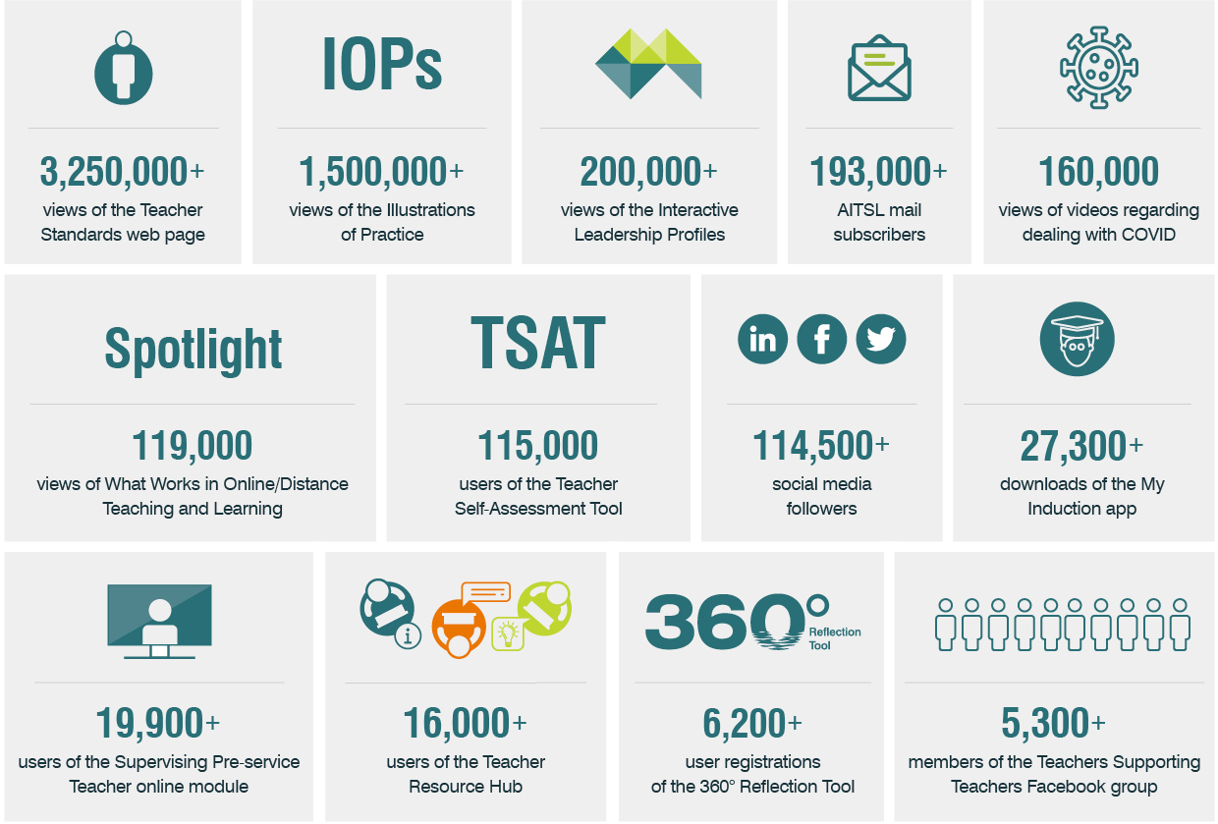
Figure 5: AITSL’s reach into and with the profession (as at February 2021)
Over the next decade, we need to be smarter about how we connect teachers and leaders in their sharing of expertise within and across schools, and how to harness these enormous assets to improve the quality of the teaching across the nation. We will never improve one teacher or one in-school or early childhood setting at a time but harnessing the collective of educators can help lead to widespread improvements.
The Online Formative Assessment Tool (under development) will be linked to teaching resources and schools could be involved in creating these. There are already many examples of the generosity of educators to share resources and ideas such as:
- Marsden Road Public School has an entire set of lesson plans for every year; and,
- Blue Haven Public School has slide decks for phonics instruction, and other educators could comment on their use and impact of these resources.
This will entail some adjustments to the current power structures of schools and early childhood settings to allow for implementing new innovations, and for sharing expertise not just within but across settings. This will entail new skills, especially among leaders to “come out” of their education settings to work with other leaders to improve their own impact and expertise. New South Wales, Western Australia, and Queensland have explored creating a layer between leaders and Departments to a) help with implementing policies and b) informing, initiating, and adapting policies. The aim is to create a more seamless and agile system, but the power of social media to involve many more in these processes is still unrealised.
AITSL can play an important role to help this connectedness and build on its current expertise in consultation with the profession. Most importantly, AITSL could lead a national discussion about ways to harness the collective power of educators to contribute to the initiation, development, and implementation of policy.

Next Steps
A future focus for AITSL, along with its current agenda and responsibilities, is developing, esteeming, and investing in the expertise of educators and creating a national wide collective debate among educators to advance the Mparntwe Declaration. An intent is to co-design the vision and strategy with the profession, engaging with them to ascertain what they think is important for the future of education.
The invitation is to engage in discussion about the ideas in this paper, as the purpose is to raise debate and assist in providing directions.
- What are the major foci that AITSL needs to continue to focus on, from the first 10 years?
- How can AITSL promote a positive dialogue about the role of educator expertise?
- How can AITSL help harness the policy views of educators to ensure the profession has continued ownership of its standards, its future and advancement of expertise?
- What are the major drivers of educational improvement that AITSL is best placed to engage with?
The AITSL Board would appreciate hearing your responses to the 4 discussion points raised above. It is intended that all responses to the discussion paper will be considered in the development of the 2022–2026 AITSL Strategic Plan.
Please provide your responses to the AITSL Board by clicking here or accessing the link from the Consultation webpage. Deadline for responses is Friday 1 October 2021.
aitsl.edu.au
Telephone: +61 3 9944 1200
Email: info@aitsl.edu.au
AITSL is funded by the Australian Government

